**DELHI SKILL AND ENTERPRENEURSHIP UNIVERSITY**



**INSTITUTE OF INNOVATION IN TECHNOLOGY & MANAGEMENT**

**Information Technology**

***PRACTICAL FILE***

**BCA-1**

Submitted To: Submitted By:

Dr.Shilpa Bahl Name: Sachin Rajbhar

(Professor) Class: BCA 1A

Enrolment No: 41221139

|  |  |  |  |
| --- | --- | --- | --- |
| **Practical No** | **Objective** | **PRACTICALs** | **Sign** |
| P1 | To tell them about the various bars available like title bar, status bar, tabs, groups etc in Ms-Word. | Create a Document containing text that should be properly aligned with proper format. Use the “Replace All” option in Find and Replace to replace each instance of some word. Save and Protect your document |  |
| P2 | To introduce them to the formatting groups and the available formatting tools. | List down different components of computer along with their functionality & then sort its sequence & apply at least 5 different styles. |  |
| P3 | To introduce them to the usage & functionality of header and footer | Create a document containing computers basic including advantages, disadvantages using header, footer, indentation etc. |  |
| P4 | To illustrate the use of clip-art facility | Create an invitation card for the fresher’s party using the clip art facility of MS-Word |  |
| P5 | To demonstrate the use of shapes facility available. | Create the Block diagram of Computer using drawing facility of MS Word. |  |
| P6 | To demonstrate the use of table group. | Insert a 7-column,6-row table to create a calendar for the current month and do:  *Enter the names of the days of the week in the first row of the table.  *Centre the day names horizontally and vertically.  *Change the font and font size as desired.  *Insert a row at the top of the table.  *Merge the cells in the row and enter the current month and year using a large font size.  *Shade the row.  *Enter and right-align the dates for the month in the appropriate cells of the table.  *Change the outside border to a more decorative border. Identify two important dates in the calendar and shade them. |  |
| P7 | To illustrate the use of table group. | Create a table in MS-Word with the following entries: S.No, Name, M1M2,M3,M4,M5 and apply the following operations on it  *Calculate the minimum marks in M1 & M3.  *Calculate the maximum marks in M2 & M5.  *Find the sum of total marks obtained in Each subject.  *Insert a new column named grade in the Table.  *Sort the table with respect to the column M6.  *Covert the table into text. |  |
| P8 | To show the functionality of bookmarks & hyperlinks. | Create a 5-page document. Use hyperlinks. Insert Bookmarks. |  |
| P9 | To show the functionality of symbols group. | Write 10 mathematics equations. |  |
| P10 | To impart the usage & importance of Page Layout Tab & References Tab. | Create the resume using the resume Template facility and write down the steps for the same. |  |
| P11 | Make a table of contents of unit-I of the subject Introduction to Information Technology. |  |
| P12 | To demonstrate the use of Mailings tab. | Send the Fresher’s Party Invitation Card created above to 5 different People using Mail Merge. Write steps corresponding to it. |  |
| P13 | To demonstrate the use of Review tab. | Count the number of character, words, pages, paragraph and lines using word count facility of MS Word |  |
| P14 | To demonstrate the use of View tab. | Create a macro using toolbar. Write the steps for the same. |  |
| P15 | To demonstrate the use of Review tab. | Check the spelling and grammar in an existing document and it should be properly aligned. |  |
| P16 | To tell them about the various bars available like title bar, status bar, tabs, groups etc in Ms-Excel. | Create a spreadsheet of the purchases made by a customer in a super mart having the following fields:.   * S.no * Product ID * Product Name * Product type(food, clothes, toys etc) * Quantity * Price per unit   Note: All the field names should be bold and underlined. Also Insert Borders to the spreadsheet. |  |
| P17 | For the spreadsheet created above, find the total bill, using the auto sum facility of Ms Excel. |  |
| P18 | To demonstrate the use of home tab for conditional formatting. | Create a student performance report using Conditional formatting in M.S. Excel the following specifications:   * Greater than * Less than * Equal to * Between * Data bar * Colour Scales |  |
| P19 | To explain the use of home tab for editing, sort, find & replace. | Create a record of ten students consisting of S.no, name and marks in two subjects(M1,M2) and perform the following operations:   * Sort the records in ascending order of marks M1 * Sort the records in descending order of marks M2 * Sort the record according to descending order of names * Find the minimum marks and replace it by the text “put more efforts”. |  |
| P20 | To demonstrate the use of Insert tab for column chart. | Create the Column Chart for the sales report of the ABC Pvt Ltd. Apply the following properties of Column Chart such as:   * Fill Color * Border colour * Border Style * Size |  |
| P21 | To demonstrate the use of Insert tab for column chart. | Create a Column Chart for record of 3 years for 5 item |  |
| P22 | To demonstrate the use of Insert tab for Pie chart. | Draw the Pie Chart for the sales report of the ABC Pvt. Ltd for last 3 years in M.S. Excel and explore the properties such as add Label, Color etc |  |
| P23 | To demonstrate the use of Insert tab for bar chart. | Create a Bar graph for 5 states for 3 years depicting the literacy rate.  For the graph created above perform the following   * Switch Row/column, * fill colour * add borders * change size |  |
| P24 |  | Now using the conditional formatting fill the A grade as -pink ,B grade as blue, C grade as yellow and D grade as Red. |  |
| P25 | Create the student record consisting of the following entries :   * s.no * name * marks in M1,M2,M3,M4,M5   Now for the table perform the following functions:   * Find the maximum marks in M2 * Find the minimum marks in M5 * Find the total marks obtained by each student * Find the average marks of each student * Sort the table according to total marks.   Create a new field named "percentage" and calculate it. |  |
| P26 | To illustrate the use of Data Validation | Create a record of BBA (1ST Sem) consisting of the following fields:   * S.no * Name * Date of birth * Age * Marks * Remarks   For the above record, apply the appropriate data validation. |  |
| P27 | To elucidate the use of external commands like: Label, CHDISK, Disk Copy,XCOPY, MORE, Xcopy, doskey, FORMAT, attrib, diskcomp, Wildcard Characters (? And *) | * Write a command to check the total disk space, files, indexex,bad sectors in d: drive. * Create a duplicate of “Course name” Directory as subject name. * Change the label name of D: drive as IITM. * Write a command to check the D: drive Page wise using more command. * Create a command to hide the IIT file * Write a command to list all files upto 3 characters long. * Write a command to list all files which start with ‘i‘ and end with ‘t’. |  |
| P28 | To explain about the various bars available like title bar, status bar, tabs, groups etc in Ms-PowerPoint. | Create a presentation on Types of Memory having a table for the Types of Memory and then create hyperlinks on the types of Memory in the master slide that opens new slides for it. |  |
| P29 | To elucidate about the design tab consisting of page setup & background styles. | Create a presentation on types of Operating Systems with different themes and apply the animation effects on it. |  |
| P30 | To brief about the slideshow tab & review tab. | For the presentation created in the previous class apply the different slide show options and protect the presentation to restrict unauthorized access. |  |

Practical 1

Q: CREATE A DOCUMENT CONTAINING TEXT THAT SHOULD BE PROPERLY ALIGNED WITH PROPER FORMAT. USE THE REPLACE ALL OPTION IN FIND & REPLACE TO REPLACE EACH INSTANCE OF SOME WORD. SAVE & PROTECT YOUR DOCUMENT.

1. ENTER THE TEXT AND USE JUSTIFY BUTTON IN PARAGRAPH

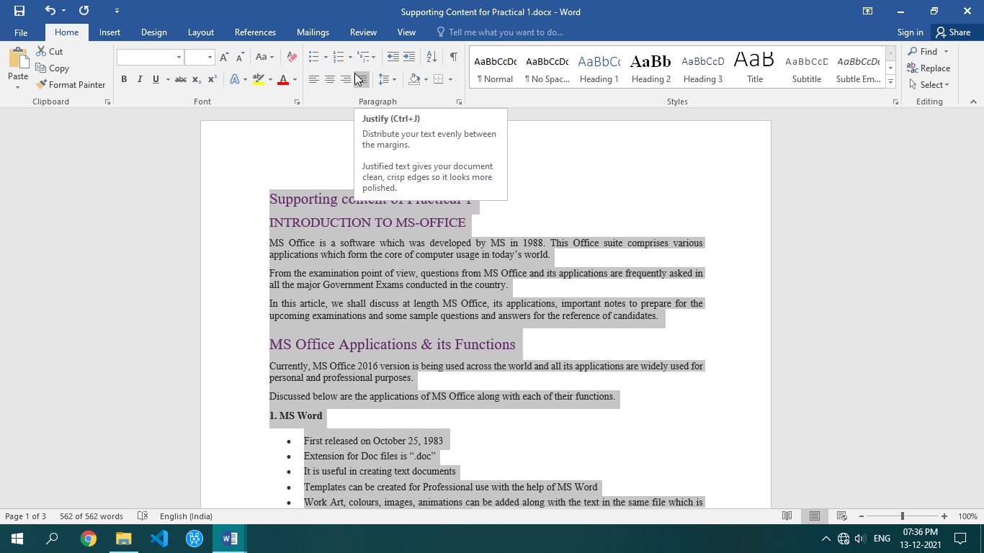

2. USE REPLACE BUTTON IN EDITIN GROUP AND REPLACE MS WITH (MICROSOFT)

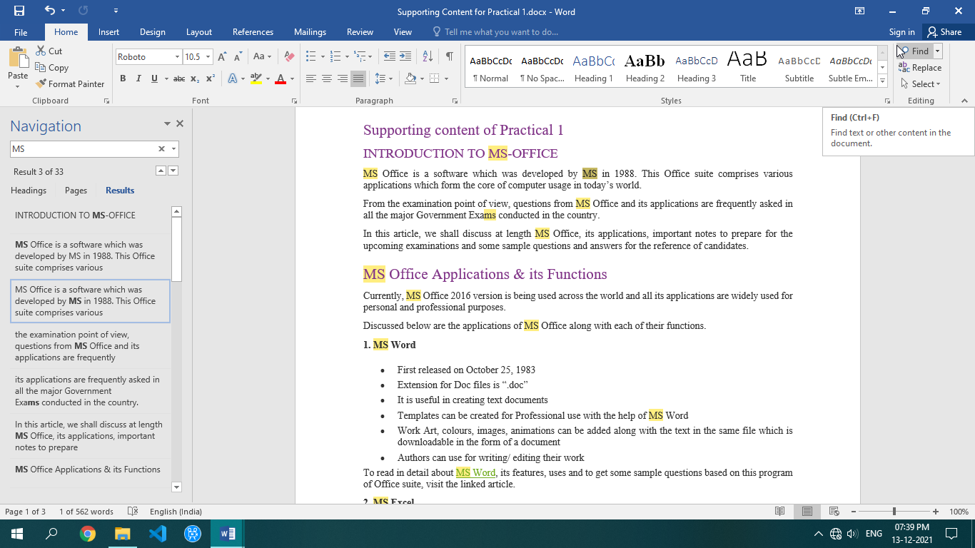

3. FIND OPTION FOR SEARCHING A WORD IN THE DOCUMENT

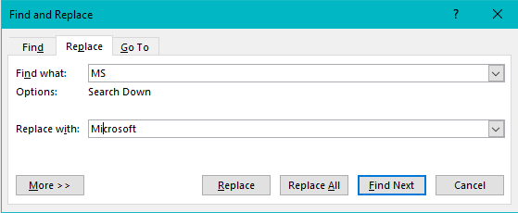

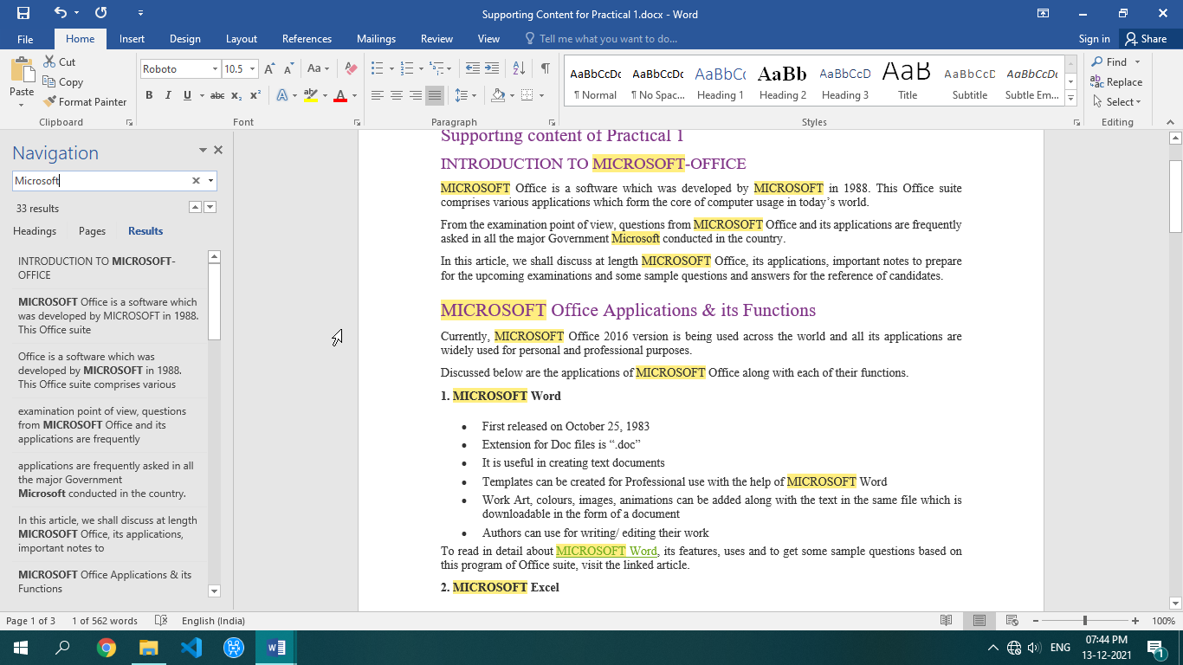

SAVING A DOCUMENT

1. Click on Office button.
2. Then click on Save.
3. Set the desired Location and File name.
4. Press ok.

PROTECTING YOUR DOCUMENT

1. Click on Tools options in Save window.
2. In tools click on general options.
3. Create password for open document
4. Also enter password for modify the document and click ok

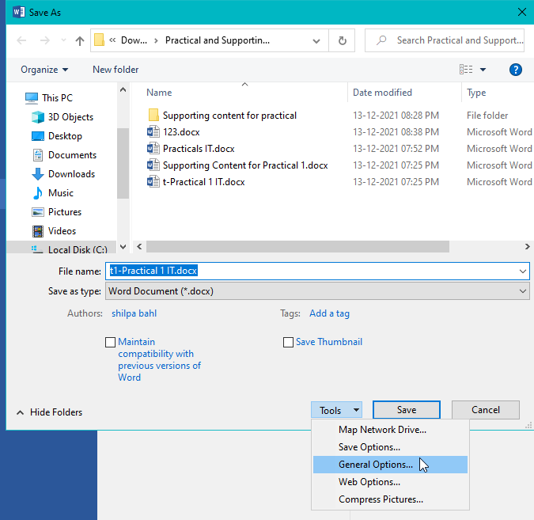

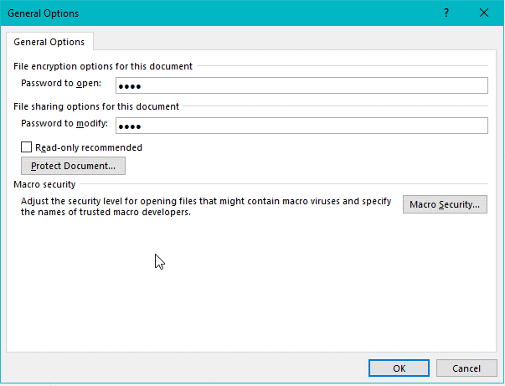

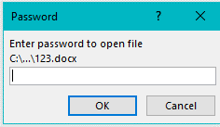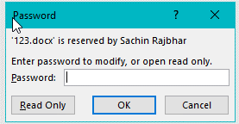

Practical 2

Q: LIST DOWN DIFFERENT COMPONENTS OF COMPUTER ALONG WITH THEIR FUNCTIONALITY & THEN ITS SEQUENCE & APPLY ATLEAST 5 DIFFERENT STYLES.

**STEPS FOR APPLYING STYLES:**

1. Select the text to which style has to be applied.
2. Under the home tab, click on style group.
3. You will get various style options.
4. Select on any desired style.
5. Repeat the steps for applying different styles

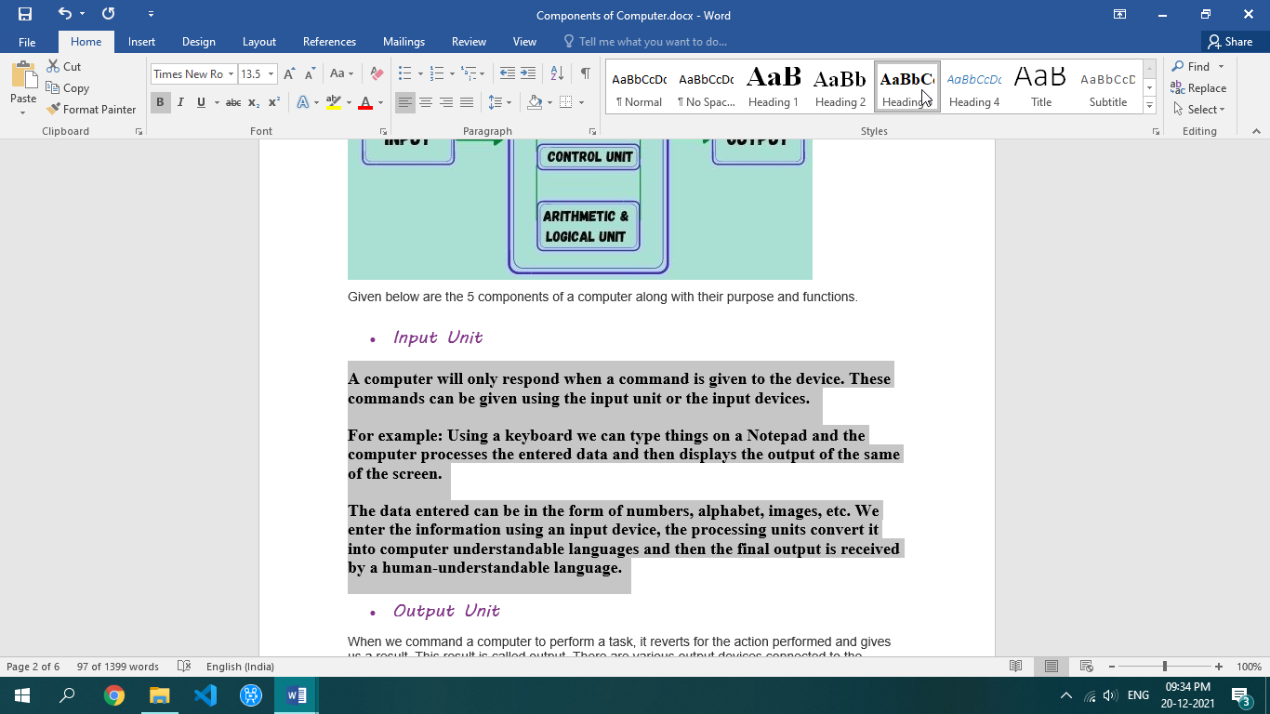

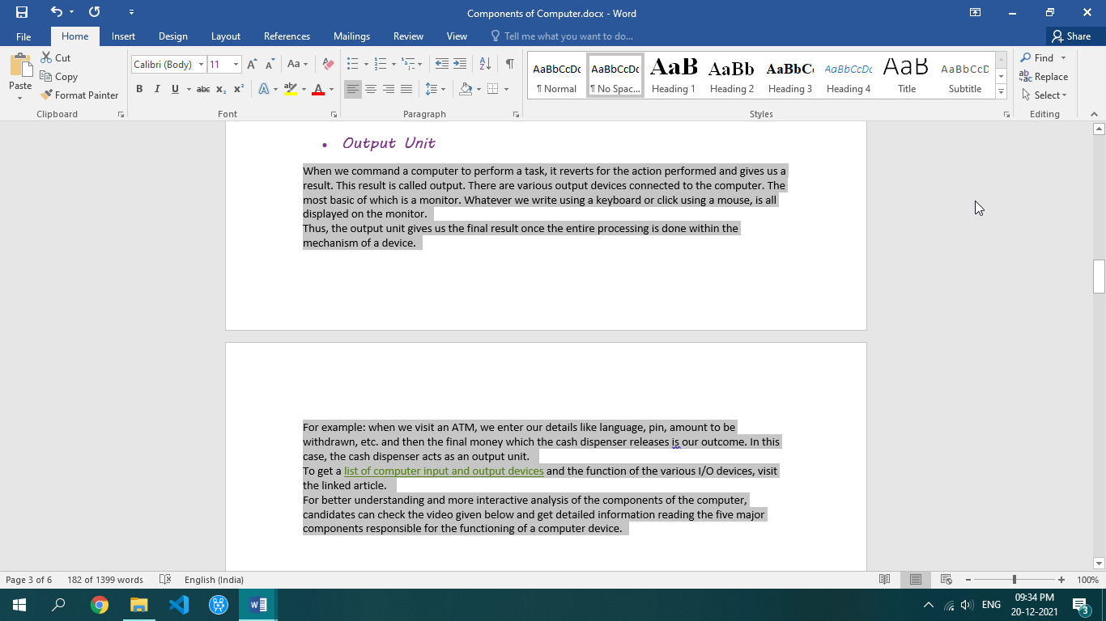

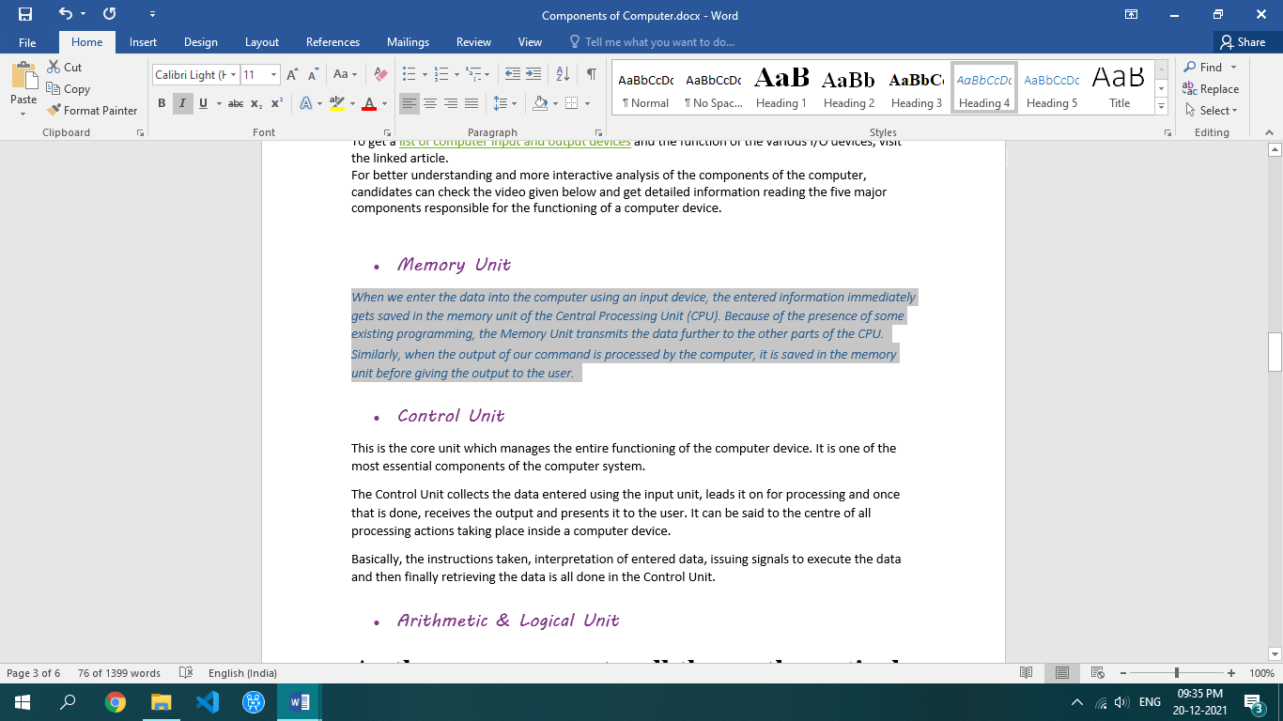

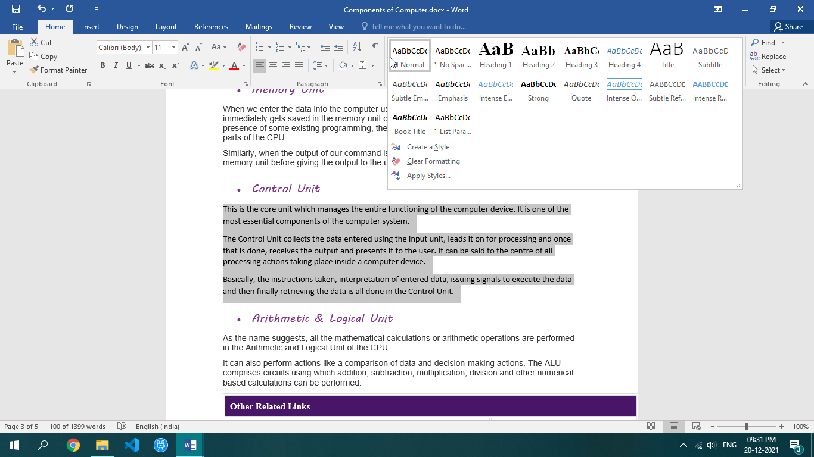

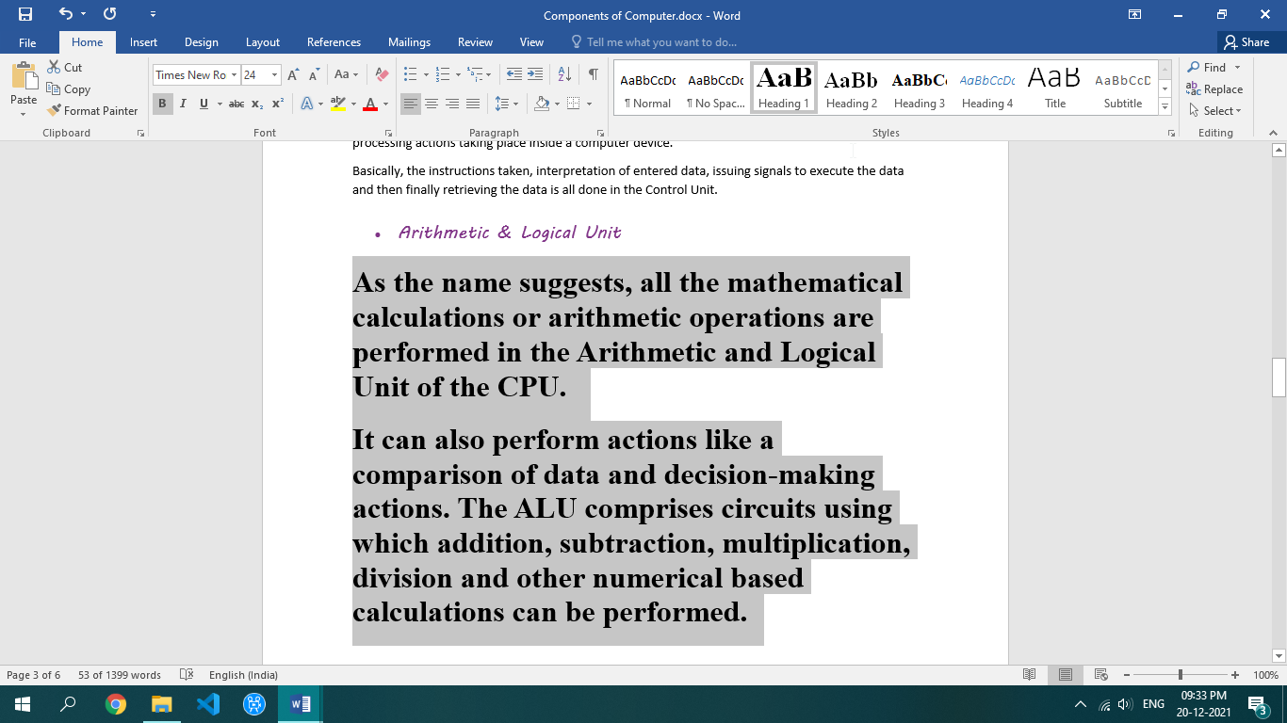

Practical 3

Q: CREATE A DOCUMENT CONTAINING COMPUTER BASICS INCLUDING ADVANTAGES, DISADVANTAGES, USING HEADER, FOOTER INDENTATION ETC.

**Header**

* Open MS-word.
* Go to insert tab.
* Click on header.

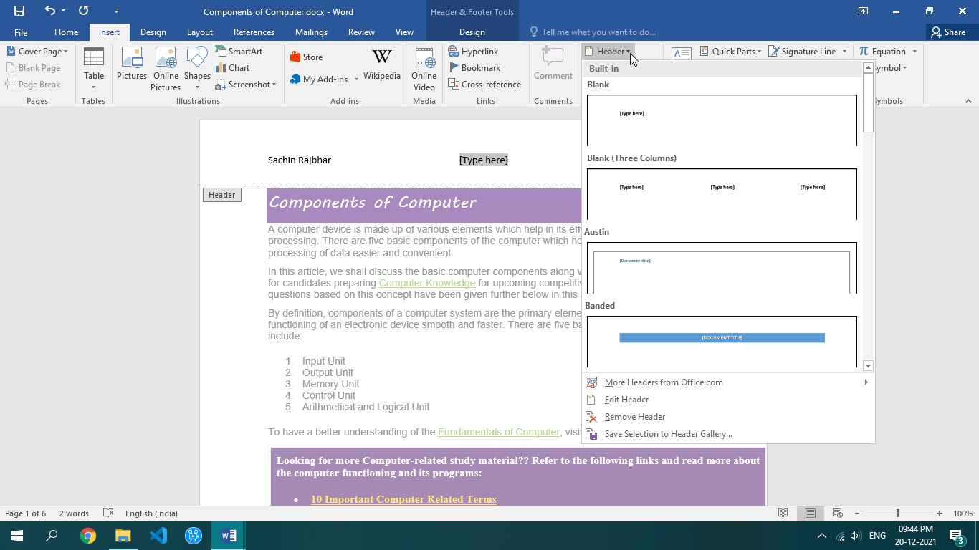

**Footer**

* Open MS-word.
* Go to insert tab.
* Click on footer.

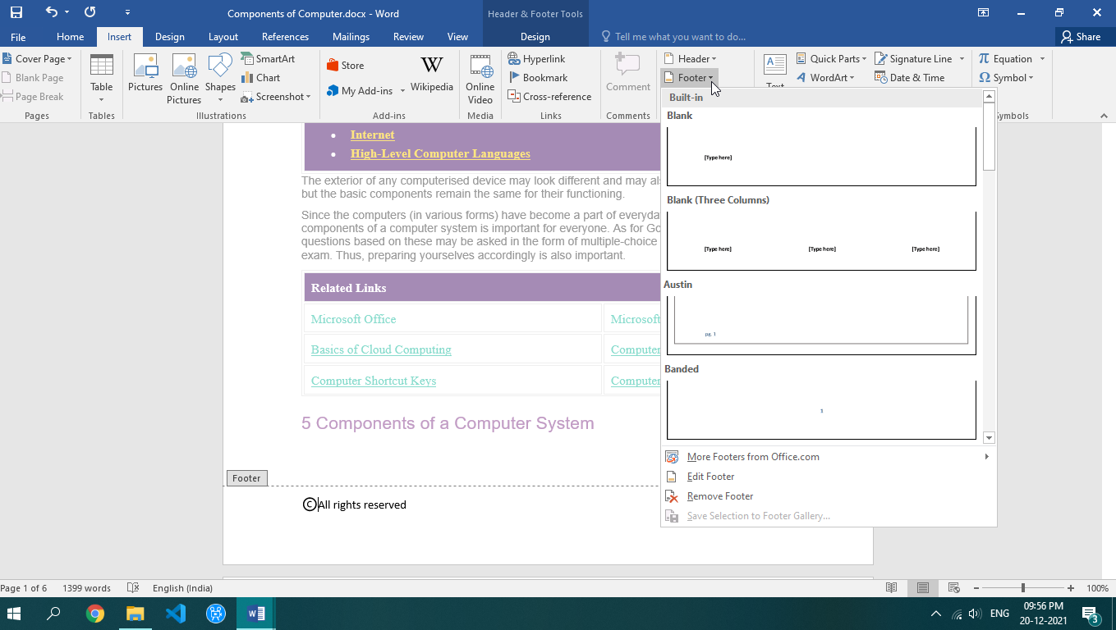

**Page Numbers**

* Open MS-word.
* Go to insert tab.
* Click on Page Number.

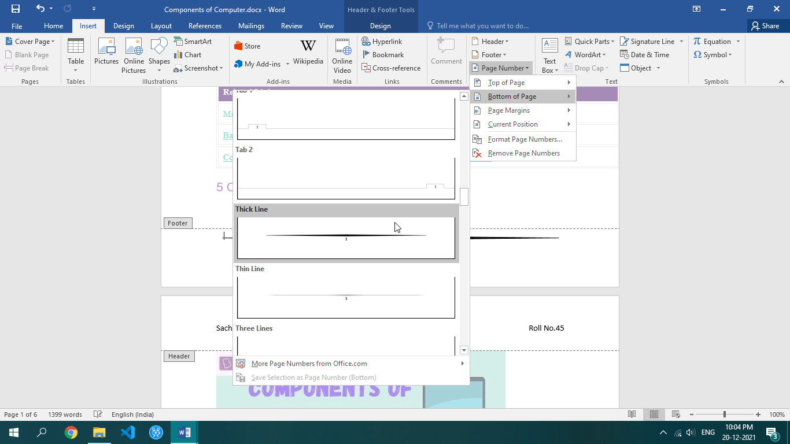

Practical 4

Q: CREATE AN INVITATION CARD FOR NEW YEAR USING INSERT PICTURES OR CLIPART FACILITY



**Hello Everyone!**

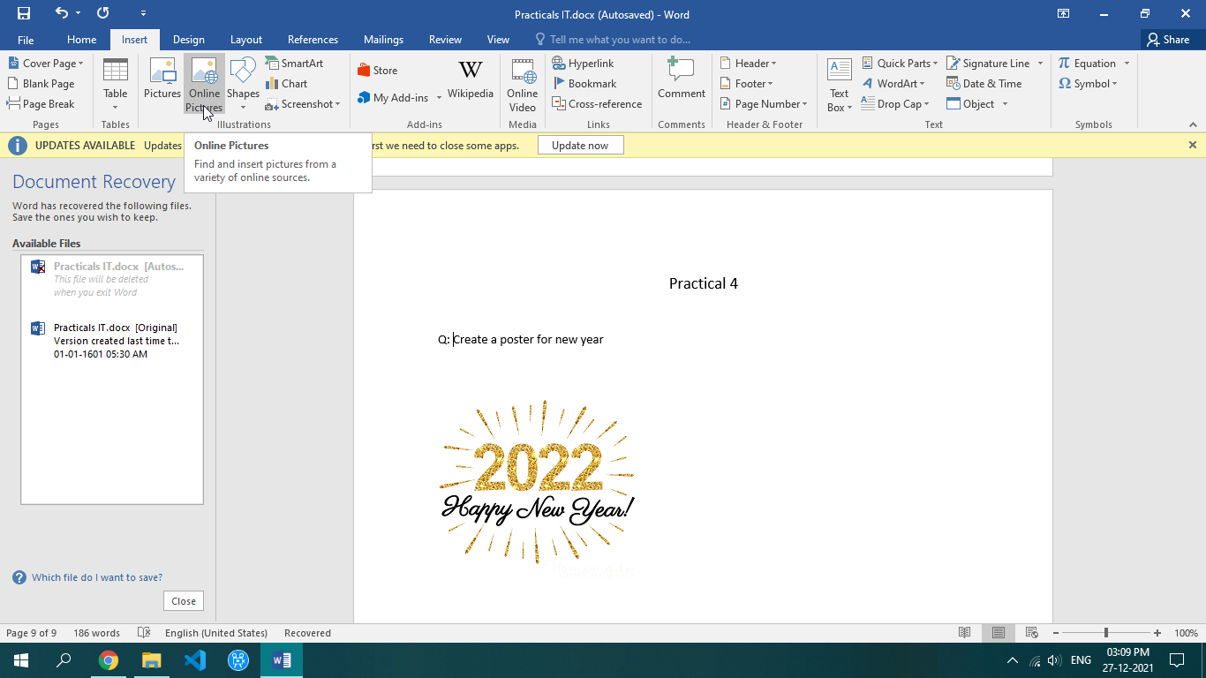

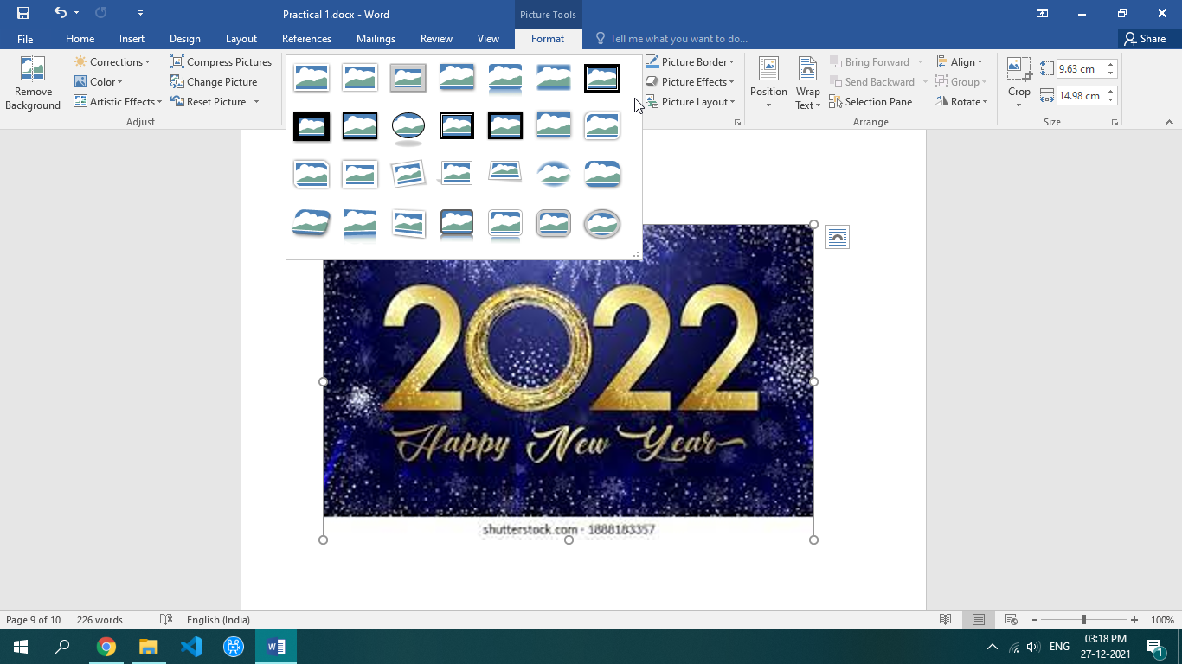

**STEPS:**

1. Go to insert tab
2. Click on the pictures option
3. Select either your device picture or click on online pictures for creating an invitation card
4. Double click on the picture to open picture formatting toolbar

Practical 5

Q: CREATE A BLOCK DIAGRAM OF COMPUTER USING THE DRAWING FACILITY OF MS- WORD.

CONTROL UNIT

REGISTERS

ALU

CACHE MEMORY

PRIMARY MEMORY

RAM

ROM

HARD DISK

FLOPPY DISK

SECONDARY MEMORY

INPUT

UNIT

OUTPUT

UNIT

CENTRAL PROCESSING UNIT

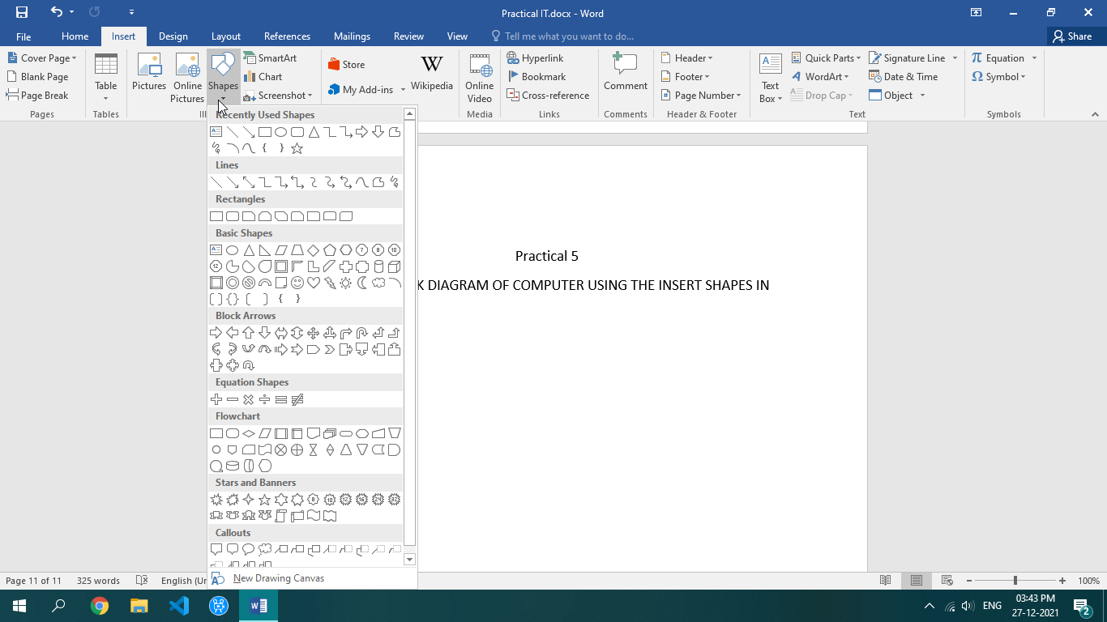

**Steps:**

1. Go to insert tab
2. Go to shapes option in insert tab
3. Pick a desired shape to create the block diagram

Practical 6

Q: INSERT A 7COLUMN, 6 ROWS TABLE TO CREATE A CALENDAR FOR THE CURRENT MONTH

Enter the names of the days of the week.

> Centre the day names horizontally & vertically.

> Change the font & font size as desired.

> Insert a row at the top of the table.

> Merge the cells in the row and enter the current month & year using a large font size.

> Shade the row.

> Enter & right align the dates for the month in the appropriate cells of the table.

> Change the outside border to a more decorative border. Identify two important dates in the calendar and shade them

Steps:

1. Go to insert tab
2. Click table option and select the no of rows and columns in a table

|  |  |  |  |  |  |  |
| --- | --- | --- | --- | --- | --- | --- |
| January 2022 | | | | | | |
| SUNDAY | **MONDAY** | **TUESDAY** | **WEDNESDAY** | **THRUSDAY** | **FRIDAY** | **SATURDAY** |
| 30 | 31 |  |  |  |  | 1 |
| 2 | 3 | 4 | 5 | 6 | 7 | 8 |
| 9 | 10 | 11 | 12 | 13 | 14 | 15 |
| 16 | 17 | 18 | 19 | 20 | 21 | 22 |
| 23 | 24 | 25 | 26 | 27 | 28 | 29 |

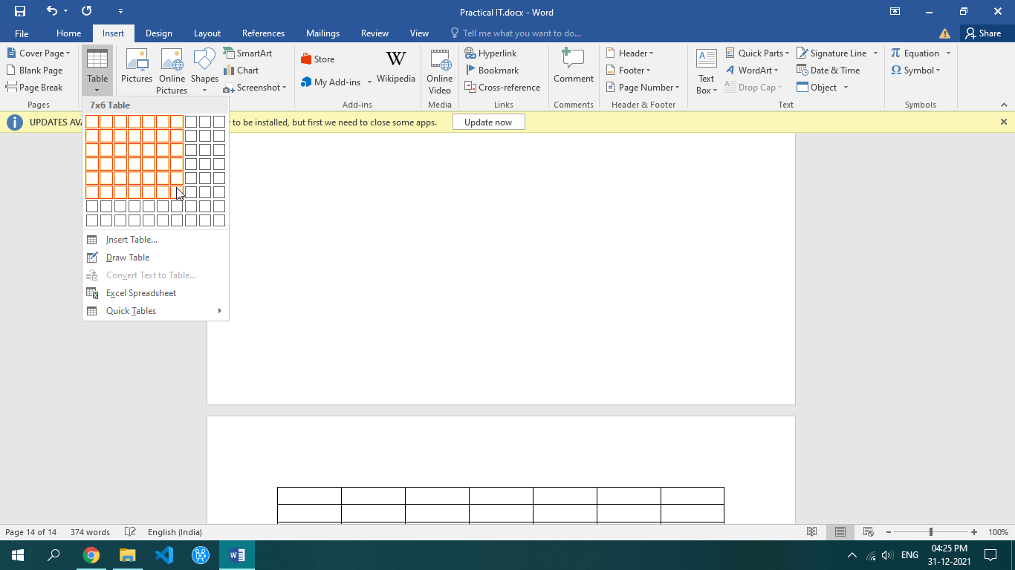

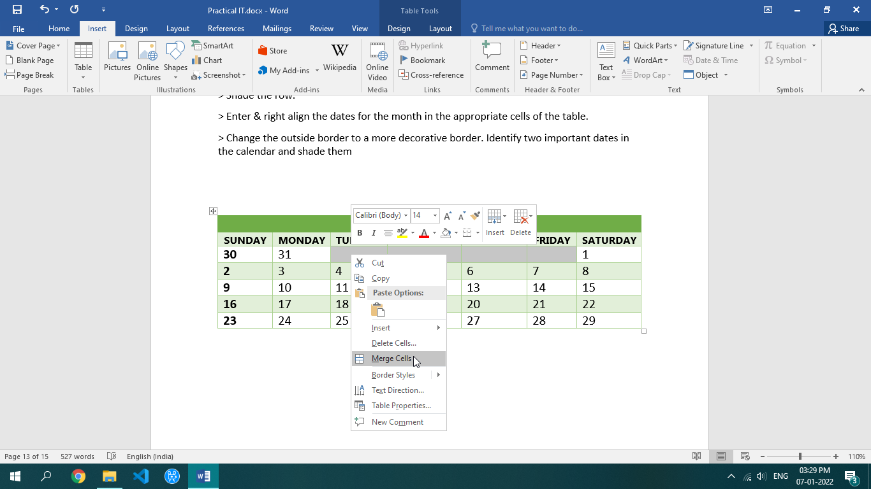

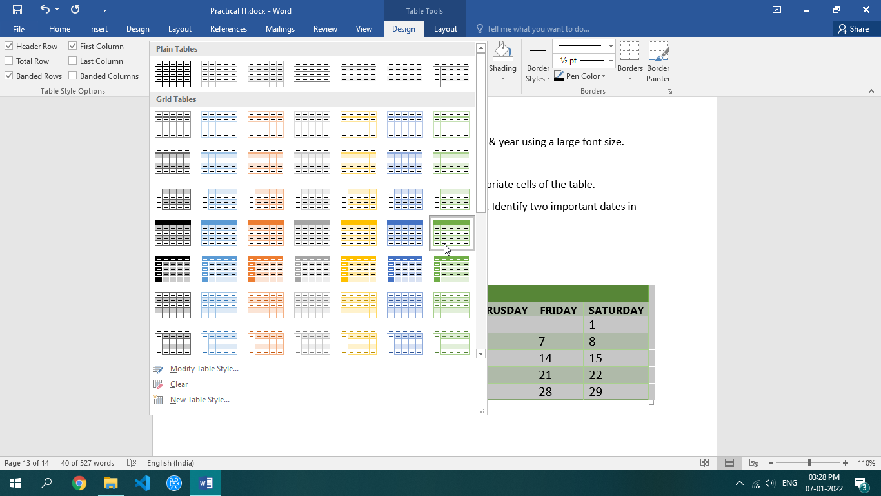

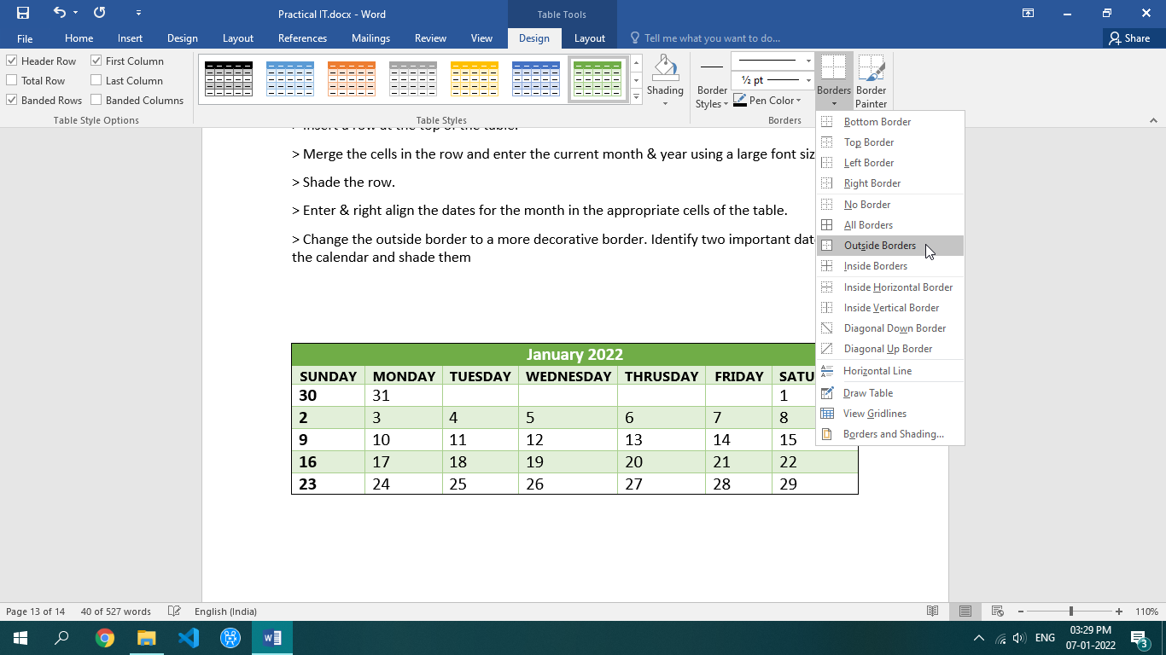

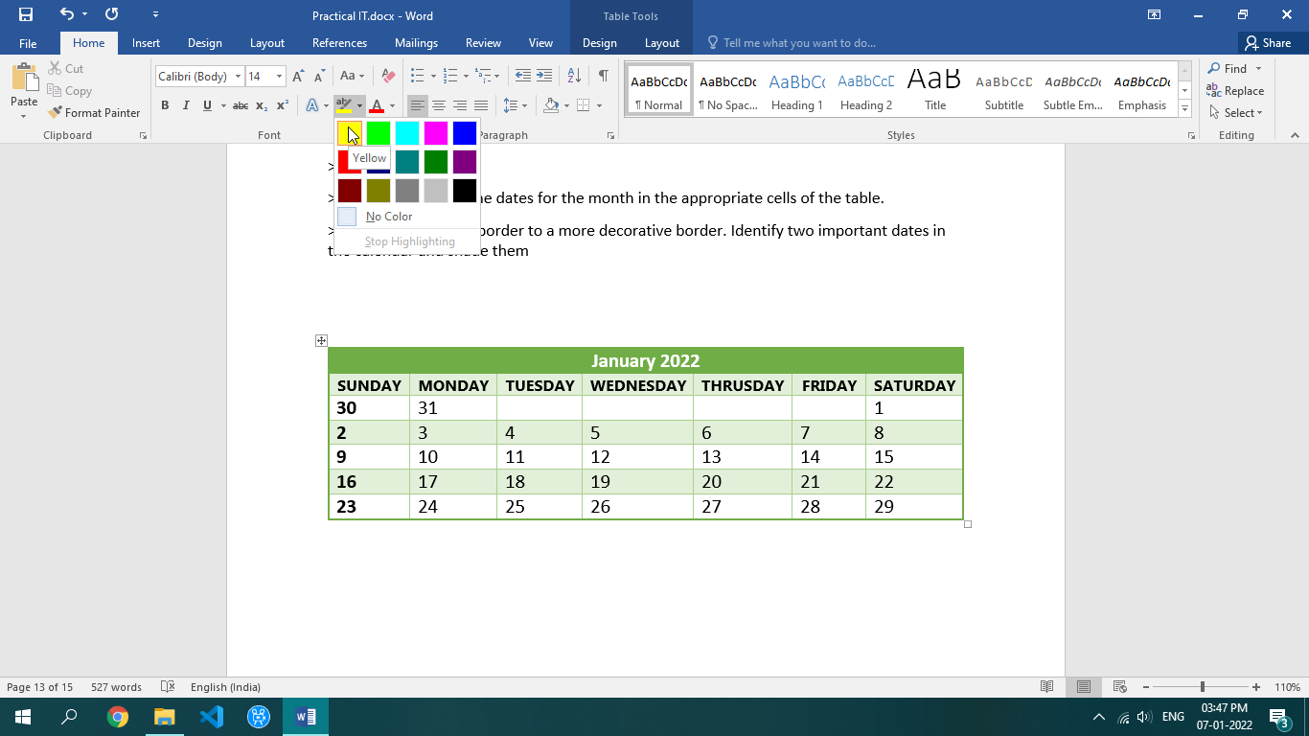

Practical 7

Q: CREATE A TABLE IN MS-WORD WITH THE FOLLOWING ENTIRES

SNO. NAME, M1, M2, M3, M4, M5

* Calculate the min marks in m1 & m3.
* Calculate the max marks in m2 & m5.
* Find the sum of total marks obtained in each subject.
* Insert a new column named grade in the table.
* Sort the table into text.

Steps:

* Click on insert, table, and insert table.
* Provide the input like number of column and rows required.

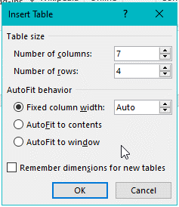

* Insert the S.No. Name m1 m2 m3 m4 m5.

|  |  |  |  |  |  |  |
| --- | --- | --- | --- | --- | --- | --- |
| S.no | Name | M1 | M2 | M3 | M4 | M5 |
| 1 | Sachin | 95 | 89 | 78 | 87 | 95 |
| 2 | Tushar | 98 | 94 | 85 | 99 | 88 |
| 3 | Amit | 98 | 75 | 85 | 56 | 89 |

* . Click on any box and then go to insert and insert column to the right.

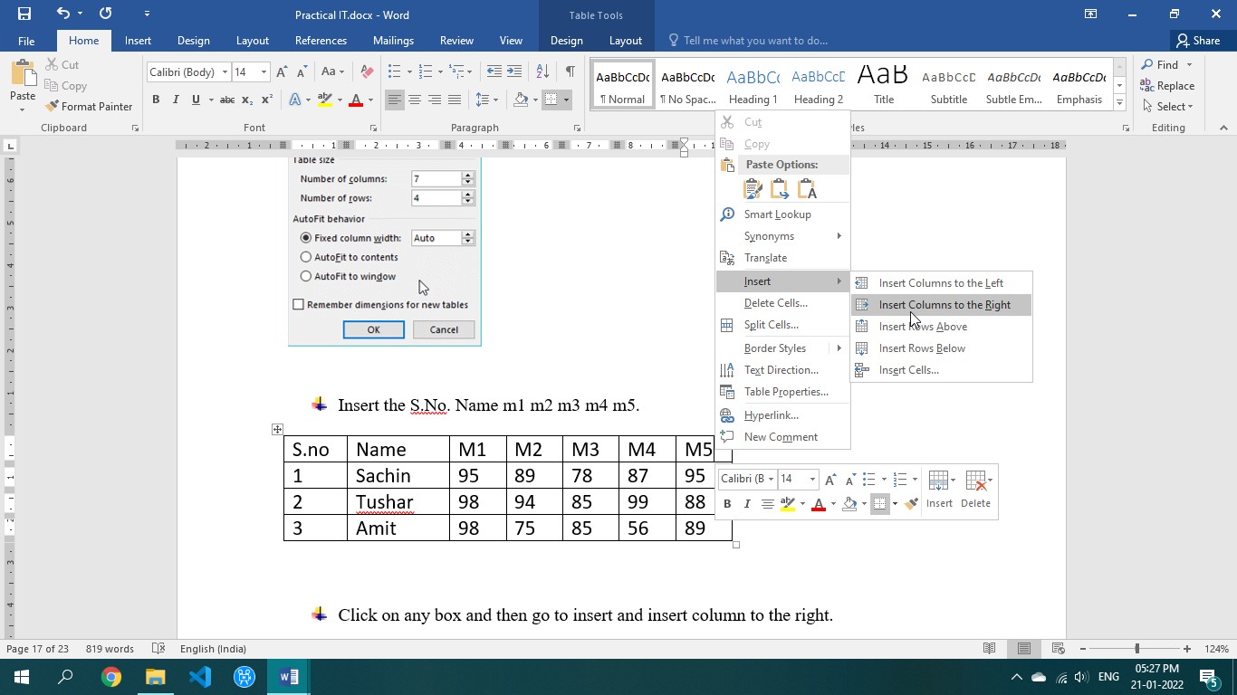

* Go to min box and then go to layout tab
* Go to formula in data ribbon.
* Then use min for minimum, max for minimum, sum for sum of the total in paste function.

|  |  |  |  |  |  |  |  |  |  |  |
| --- | --- | --- | --- | --- | --- | --- | --- | --- | --- | --- |
| S.no | Name | M1 | M2 | M3 | M4 | M5 | Min | Max | Sum | Grade |
| 1 | Sachin | 95 | 89 | 78 | 87 | 95 | 78 | 95 | 444 |  |
| 2 | Tushar | 98 | 94 | 85 | 99 | 88 | 85 | 99 | 464 |  |
| 3 | Amit | 98 | 75 | 85 | 56 | 89 | 56 | 98 | 403 |  |

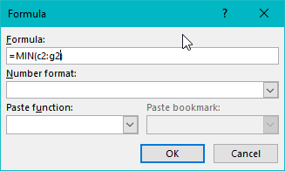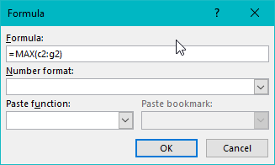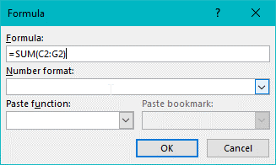

Practical 8

Q: CREATE A 5PAGE DOCUMENT.USE HYPERLINK

1. Go to insert tab.

2. Select Link in links group.

Steps:

* [MY SELF](My%20Self.docx)
* [MY FAMILY](My%20Family.docx)
* [EDUCATIONAL QUALIFICATION](Educational%20Qualification.docx)
* [HOBBIES](Hobbies.docx)
* [ACHIEVEMENT](Achievements.docx)

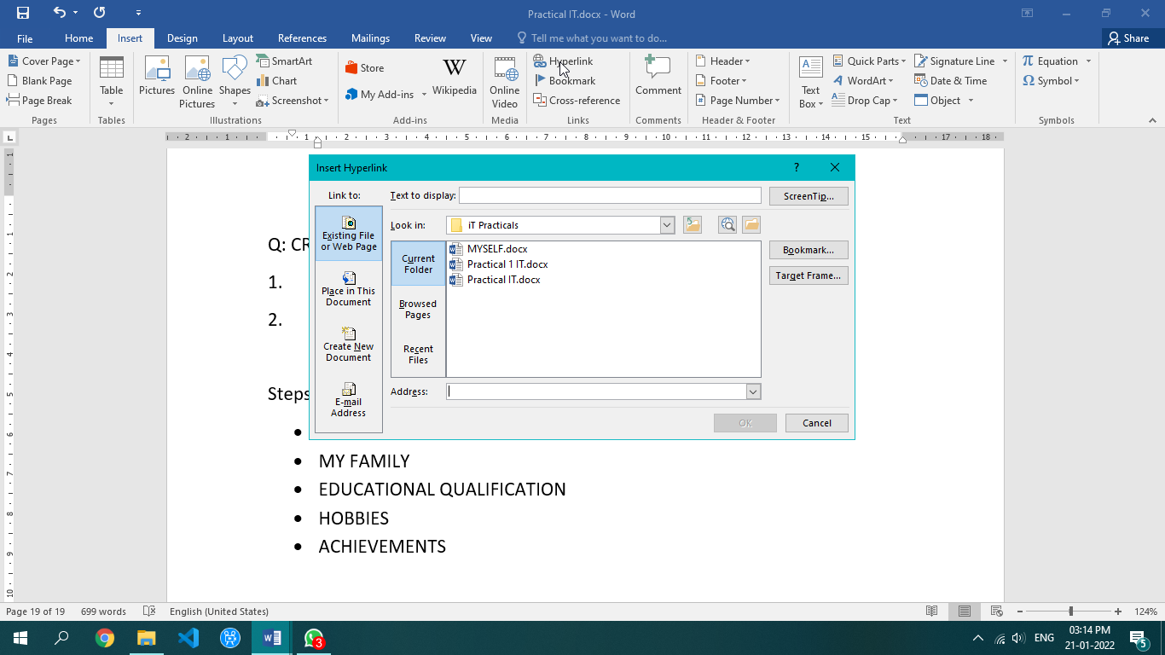

My Self

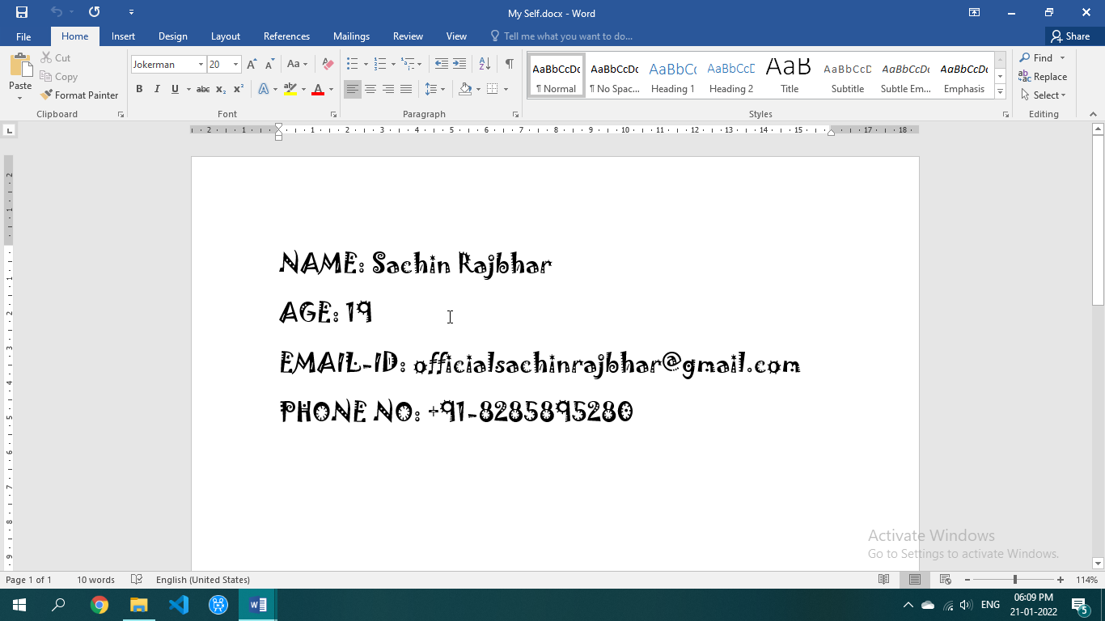

My Family

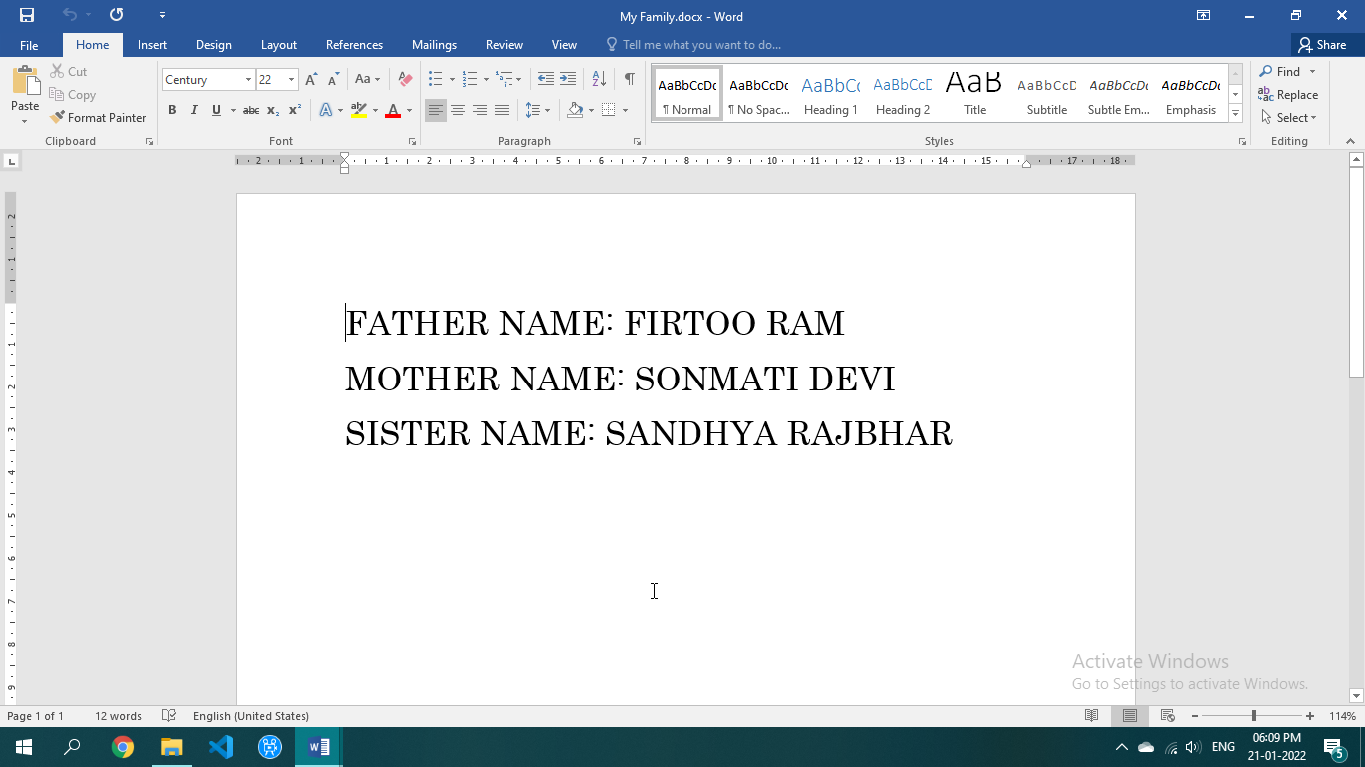

Educational Qualification

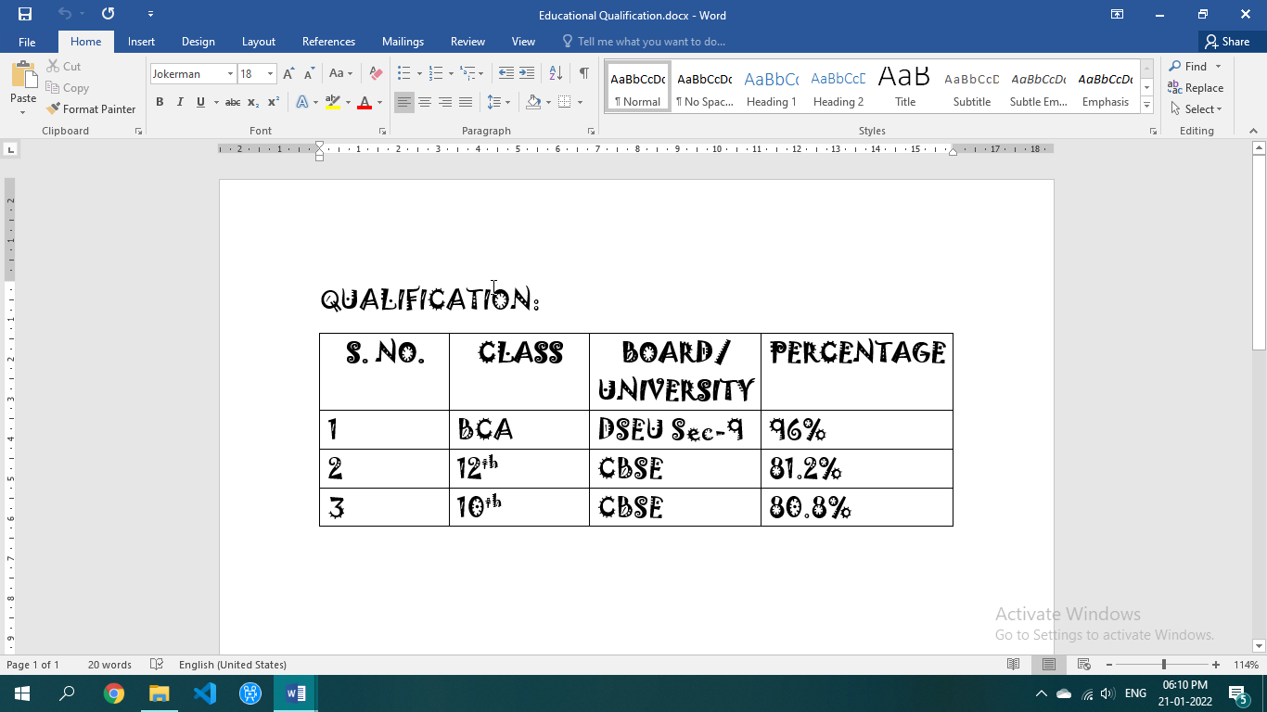

Hobbies

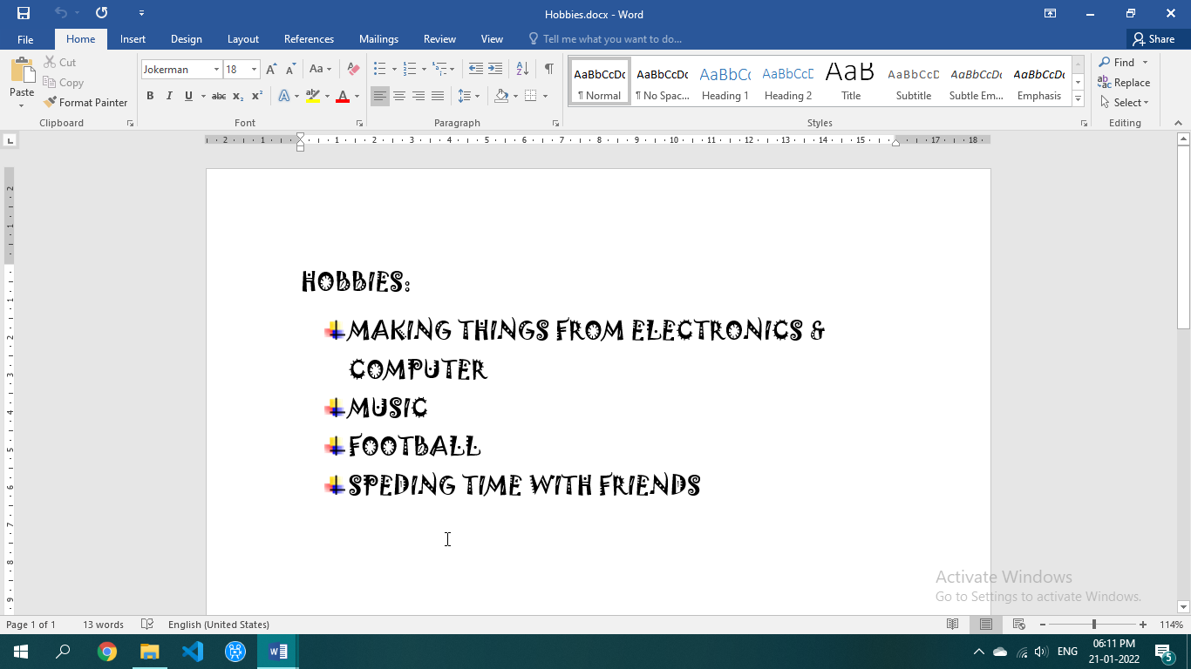

Achievement

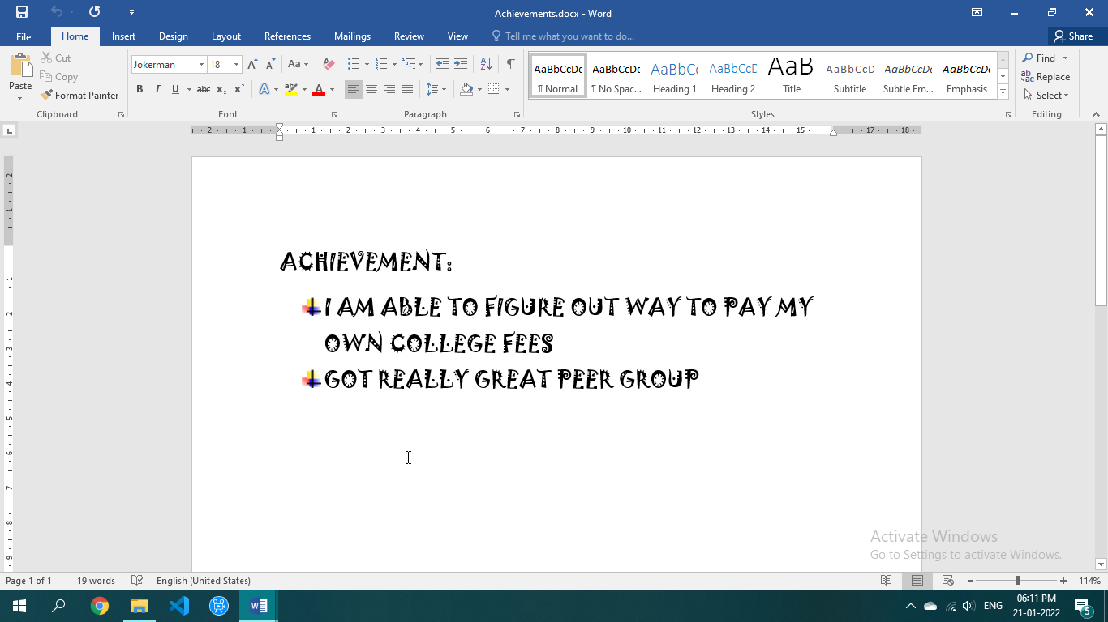

Practical 9

Q: WRITE 8 MATHEMATICS EQUATIONS.

1. Click on equations option in symbols menu.

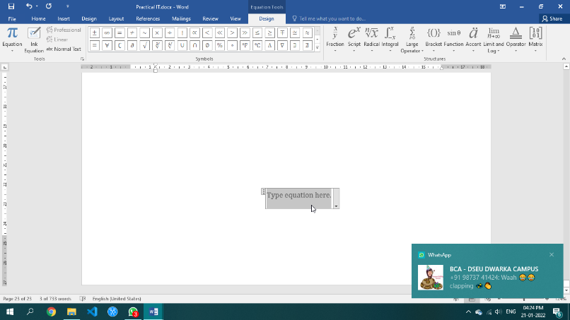 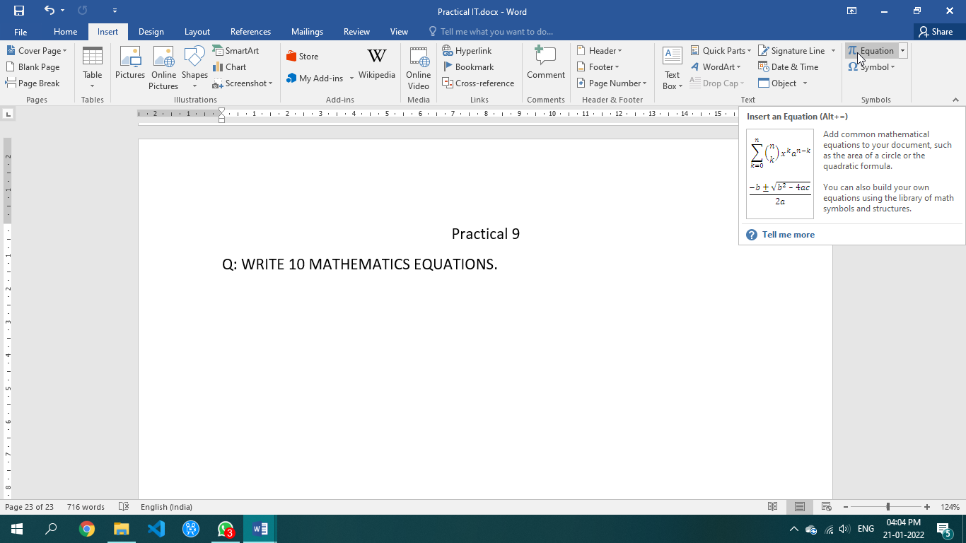

1. Enter the equations.

$A=πr^{2}$

${(x+a)}^{n}=\sum_{k=0}^{n}{\left({n \atop k}\right)}x^{k}a^{n-k}$

${(1+x)}^{n}=1+ \frac{nx}{1!}+\frac{n(n-1)x^{2}}{2!}+…$

$f\left(x\right)=a_{0}+ \sum_{n=1}^{∞}{( a_{n}}\cos{\frac{nπx}{L}}+ b^{n}\sin{\frac{nπx}{L}})$

$\cos{α+ \cos{β=2\cos{\frac{1}{2}(α+β)}}}\cos{\frac{1}{2}(α-β)}$

$\frac{-b±\sqrt{b^{2}-4ac}}{2a}$

$\sum_{\begin{aligned}0≤i≤m \\ 0<j<n\end{aligned}}{P(i,j)}$

$\lim_{n→∞}{{(1+\frac{1}{n})}^{n}}$

Practical 10

Q: CREATE A RESUME USING THE RESUME TEMPLATE FACILITY & WRITE DOWN THE STEPS FOR THE SAME.

Steps:

1. Click on file button or office button.
2. Go to Resume and CV or search in New 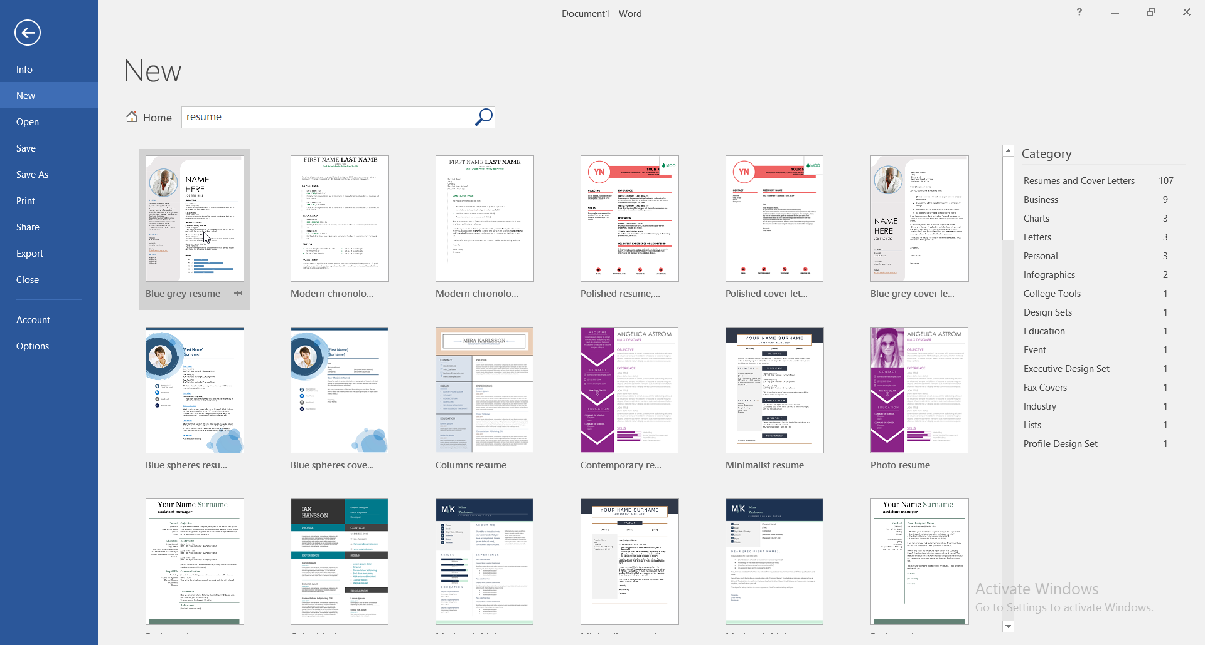
3. Click on Resume (Origin Theme) in Basic resume 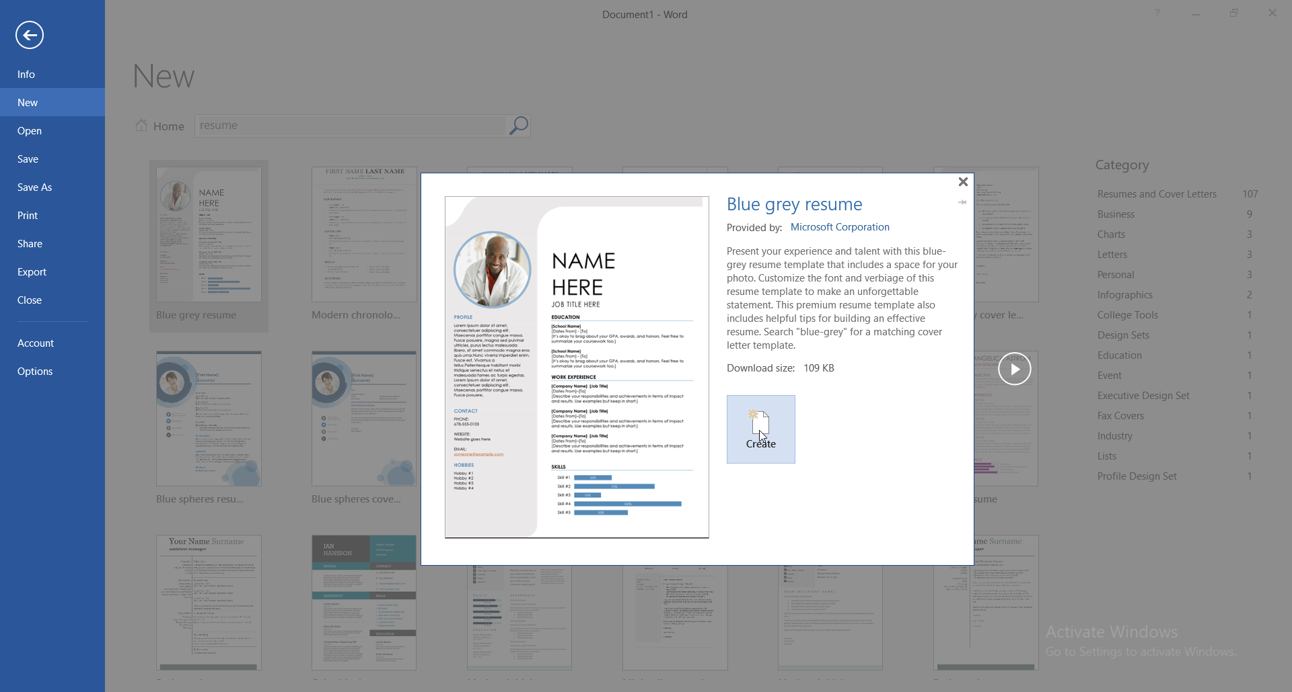
4. Provide appropriate data in the required field. 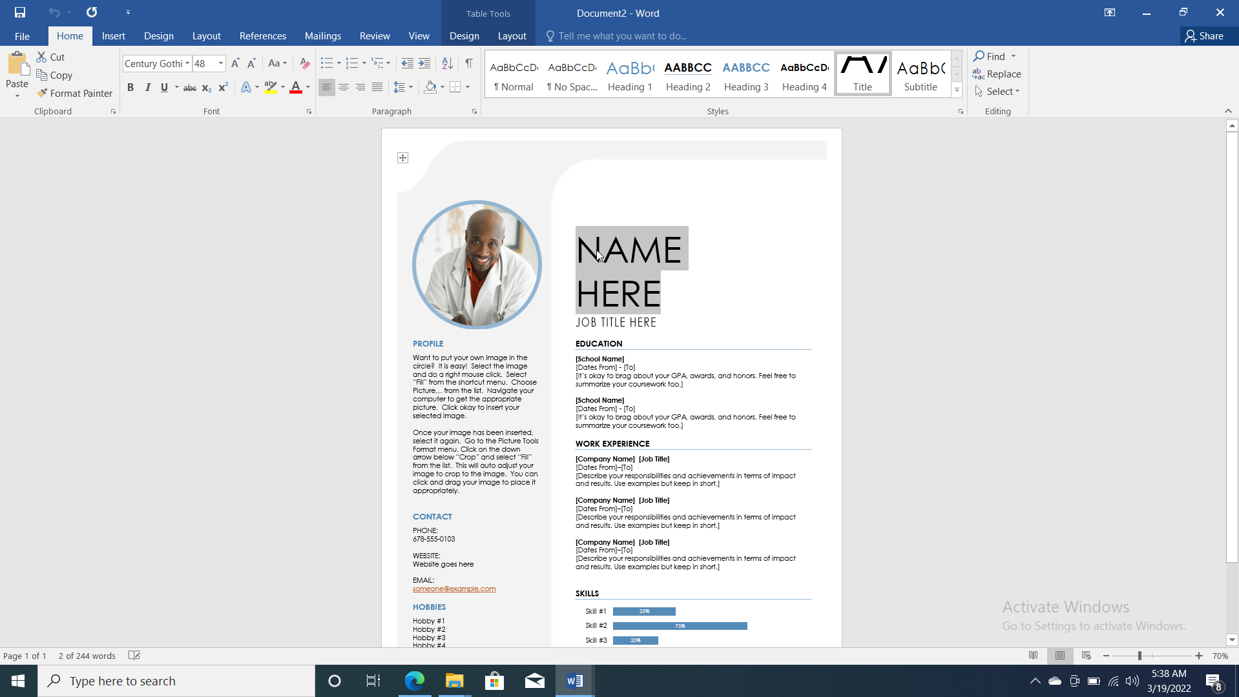
5. Appropriate data being given. 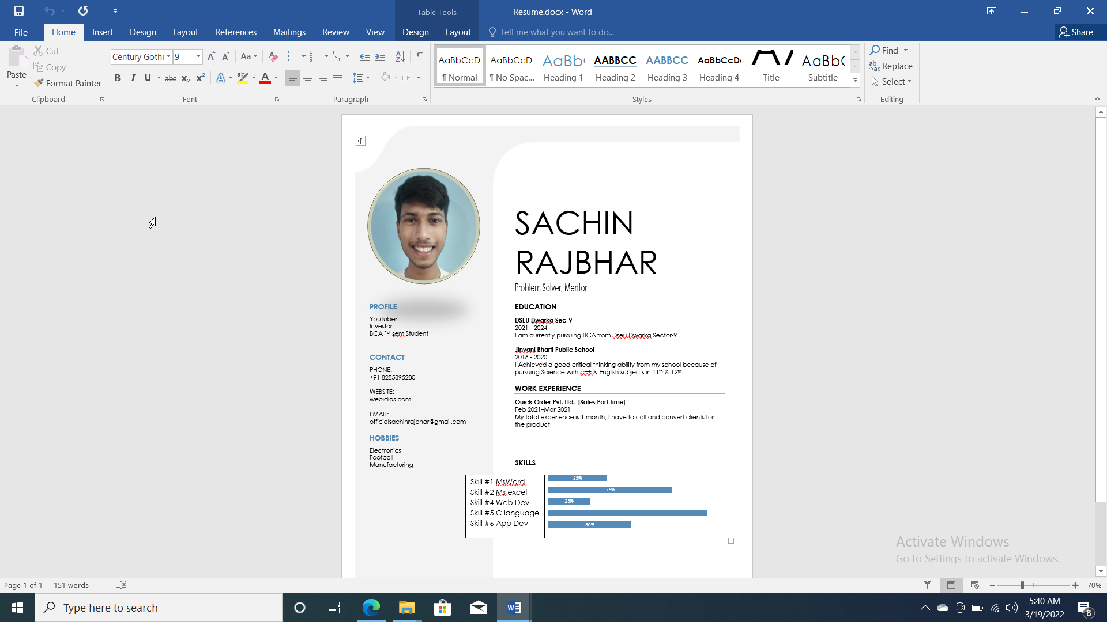

Practical 11

Q: MAKE A TABLE OF CONTENT OF UNIT-1 OF THE SUBJECT INTRODUCTION TO INFORMATION TECHNOLOGY

Steps:

1. Go to References tab.
2. Click on table of content option. 
3. Select manual table of content. 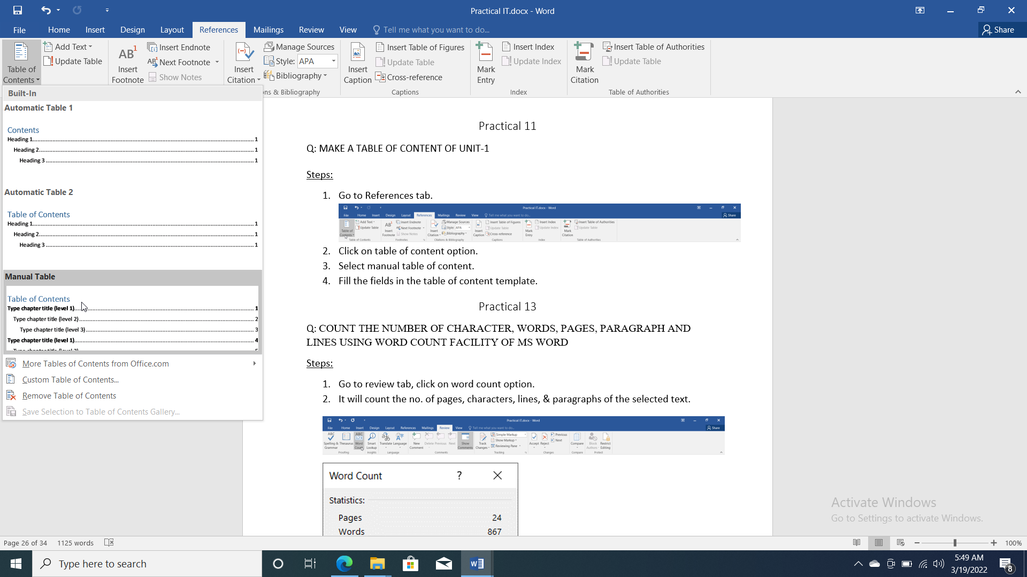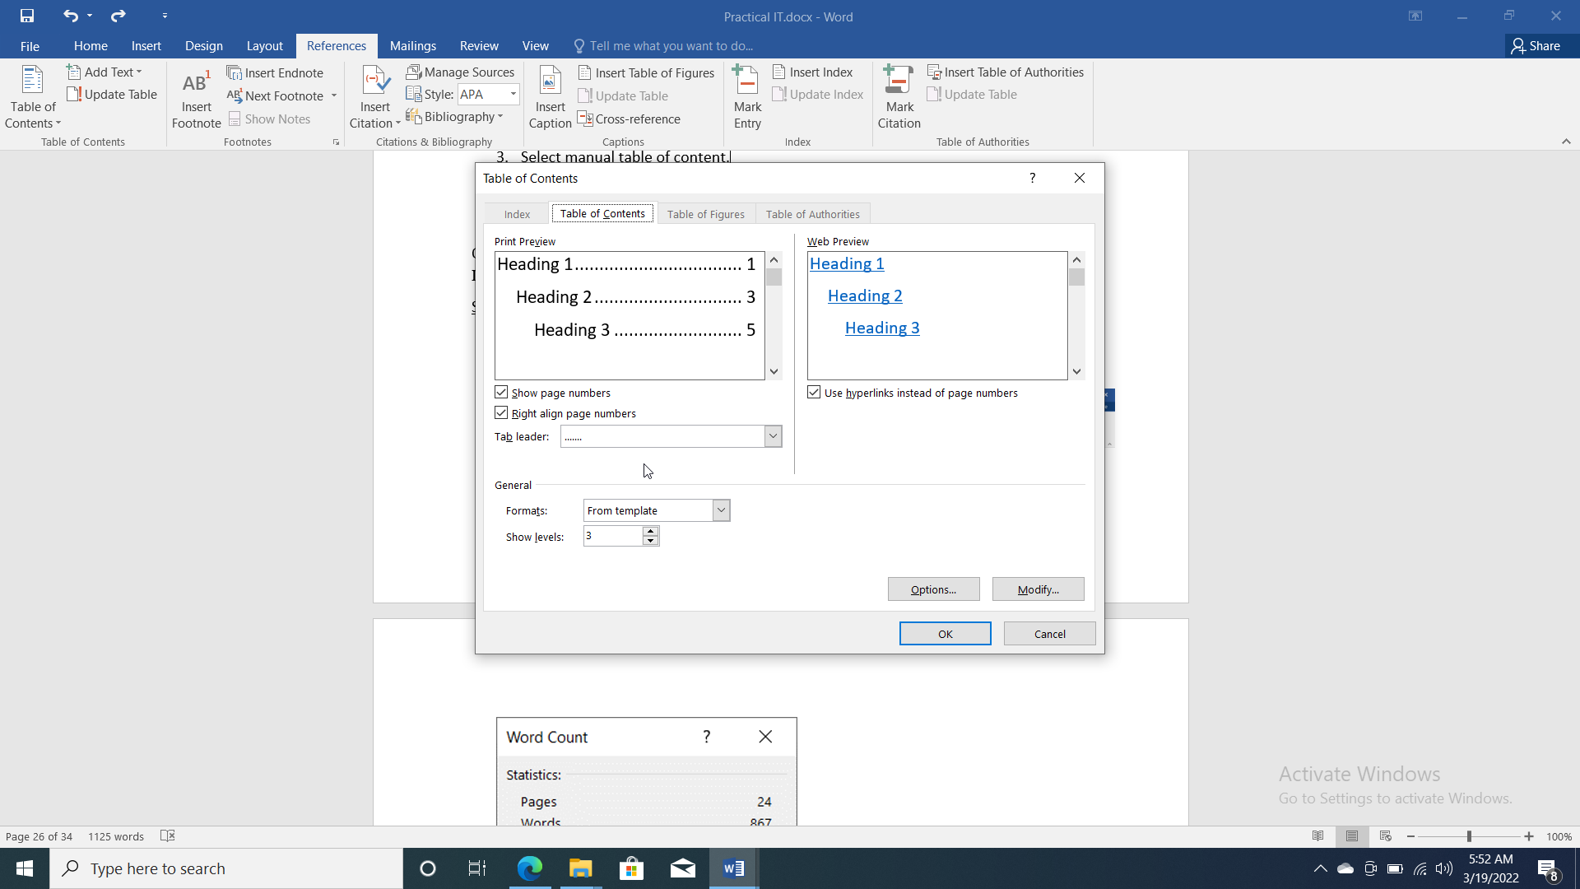
4. Fill the fields in the table of content template. 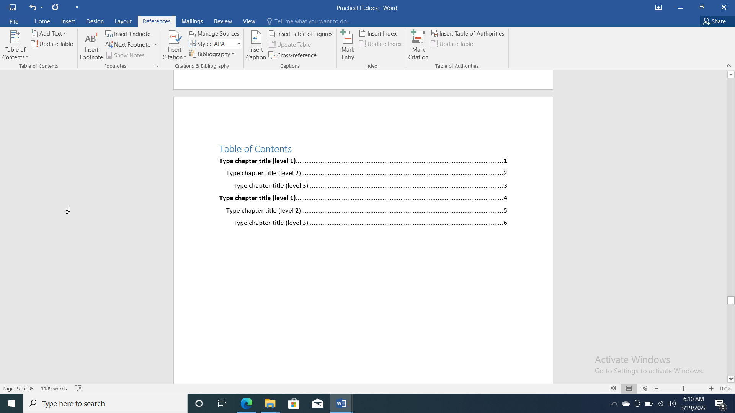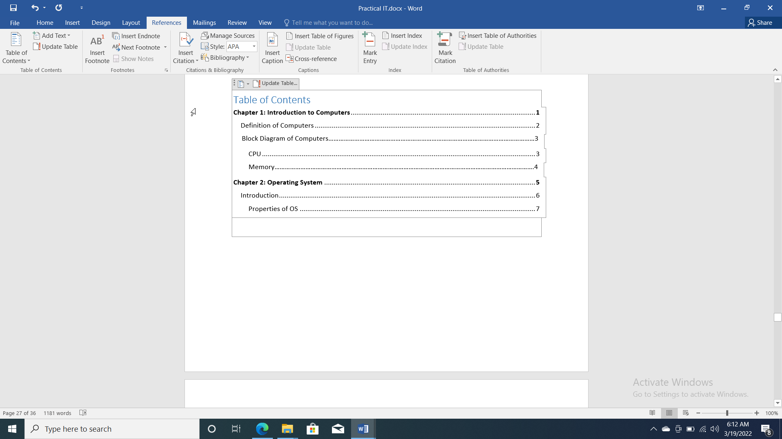

Table of Contents

**Chapter 1: Introduction to Computers1**

Definition of Computers2

Block Diagram of Computers…………………………………………………………………………………………………………3

CPU3

Memory…………………………………………………………………………………………………………………………………….4

**Chapter 2: Operating System5**

Introduction6

Properties of OS7

Practical 12

Q: SEND THE FRESHER’S PARTY INVITATION CARD CREATED ABOVE TO 5 DIFFERENT PEOPLE USING MAIL MERGE. WRITE STEPS CORRESPONDING TO IT.

Steps:

1. Go to mailing’s tab.

2. Select mail merge option in start mail merge group. 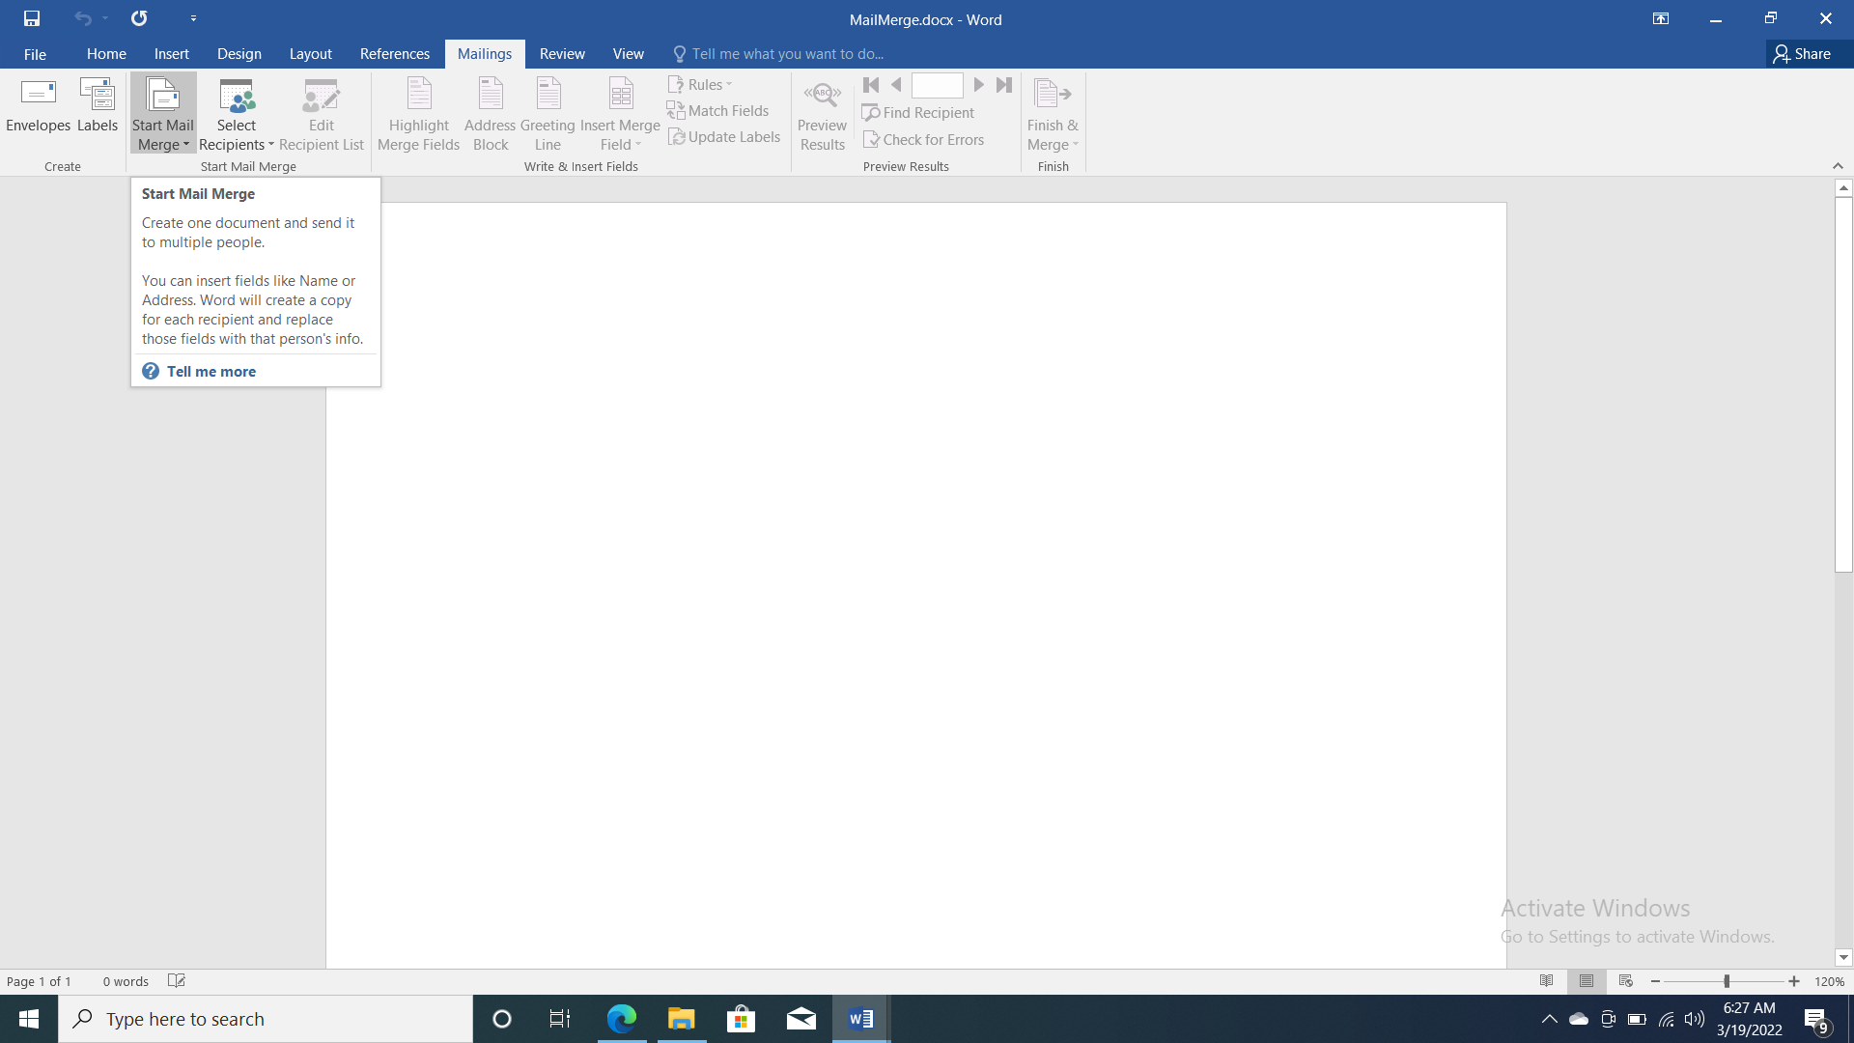

3. Select step by step mail merge wizard in mail merge. 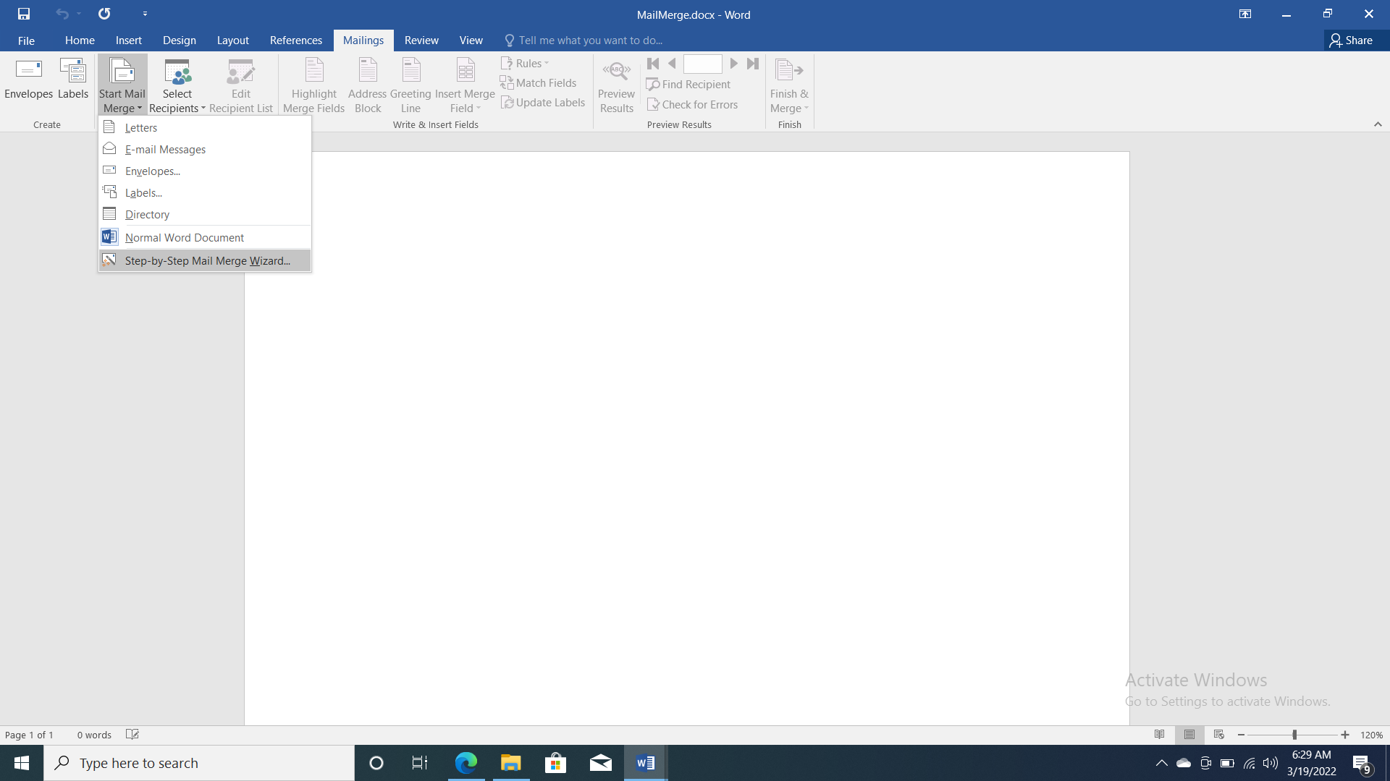

4. Select document type then Select starting document, Select recipients. 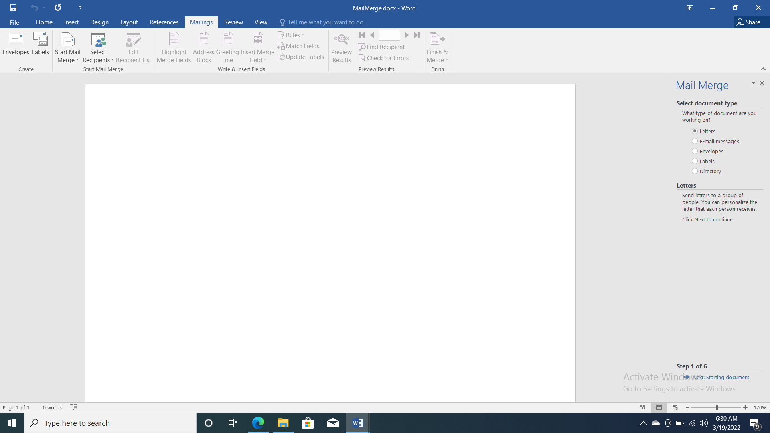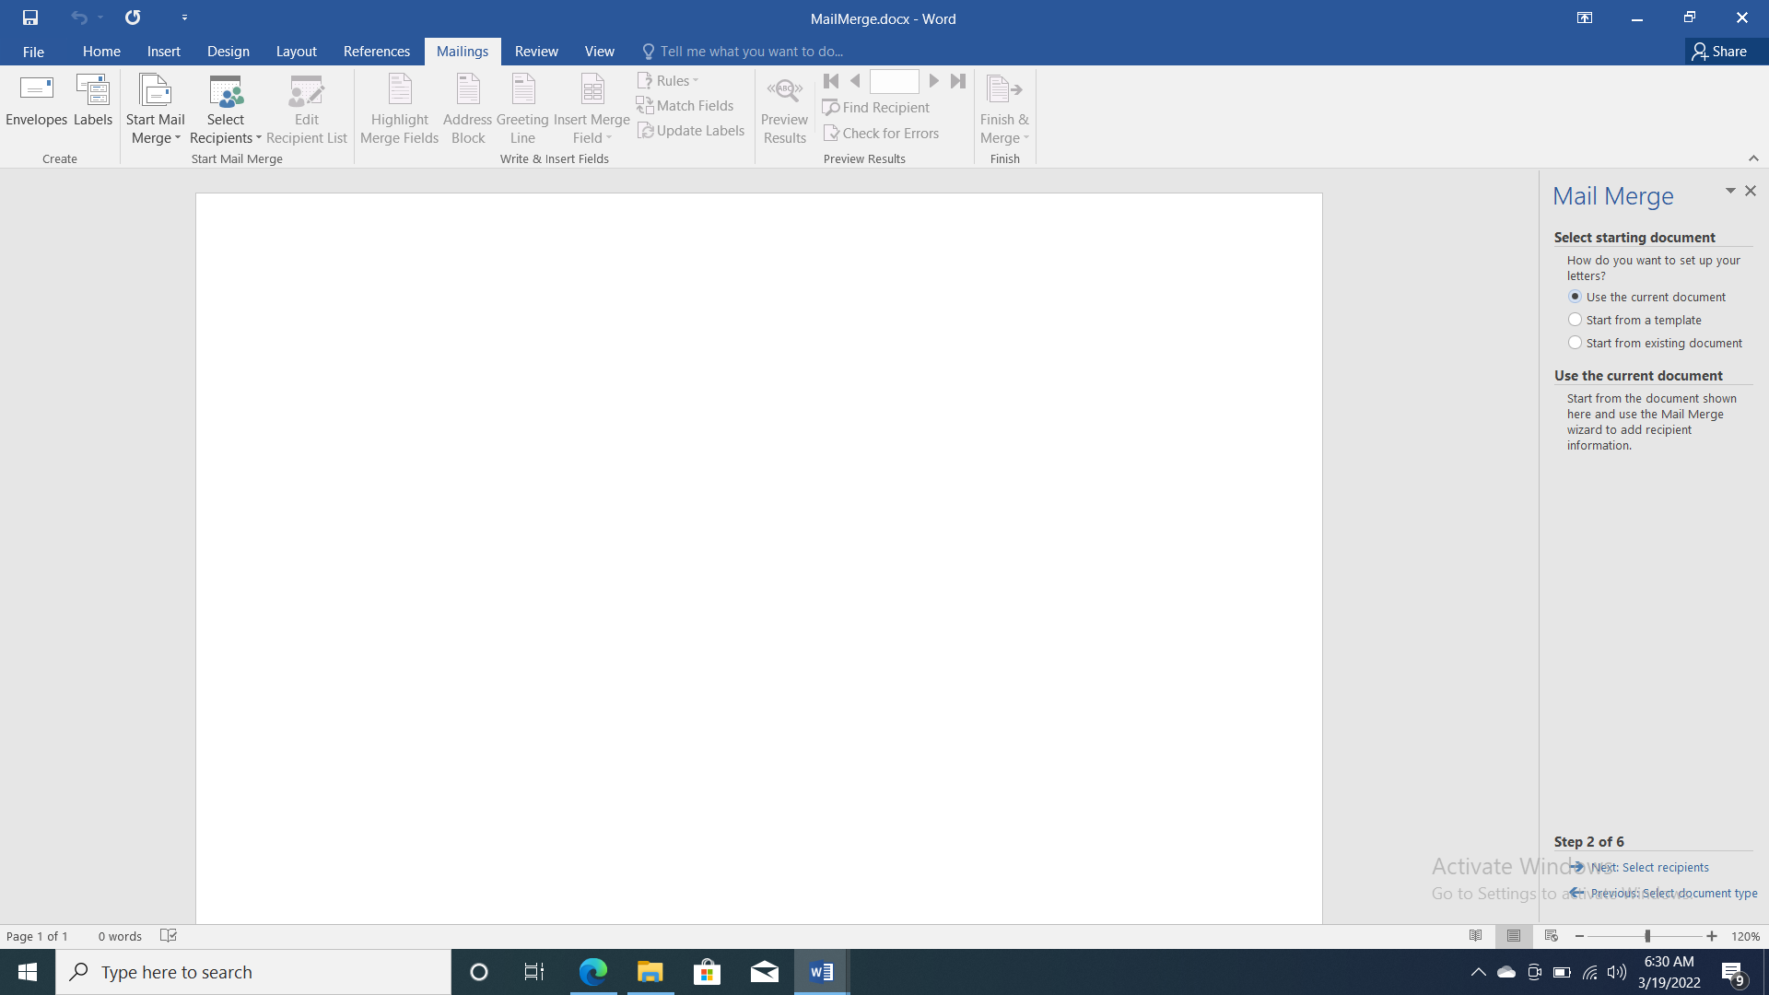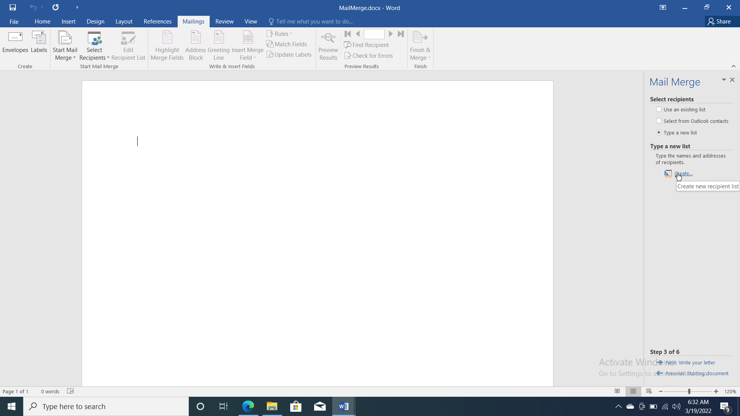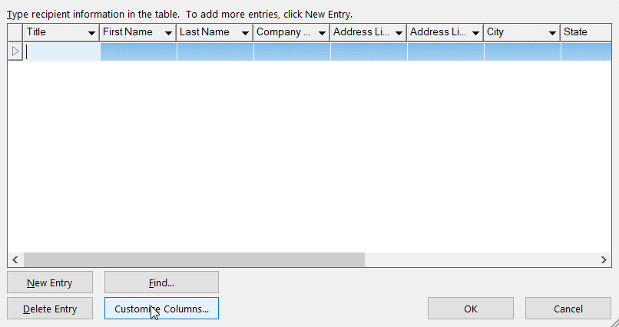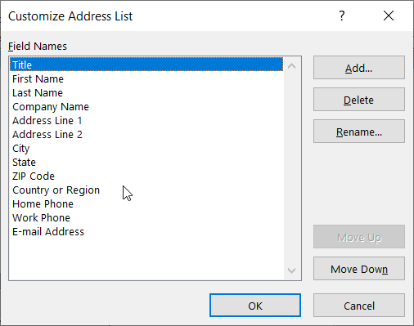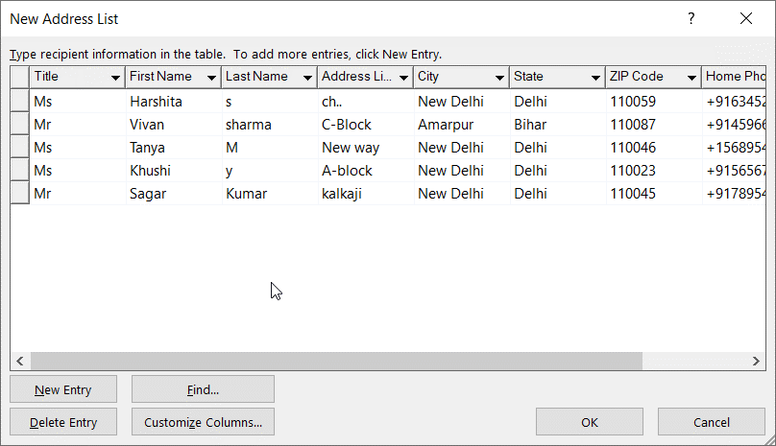

5. Click on next step to write your letter. 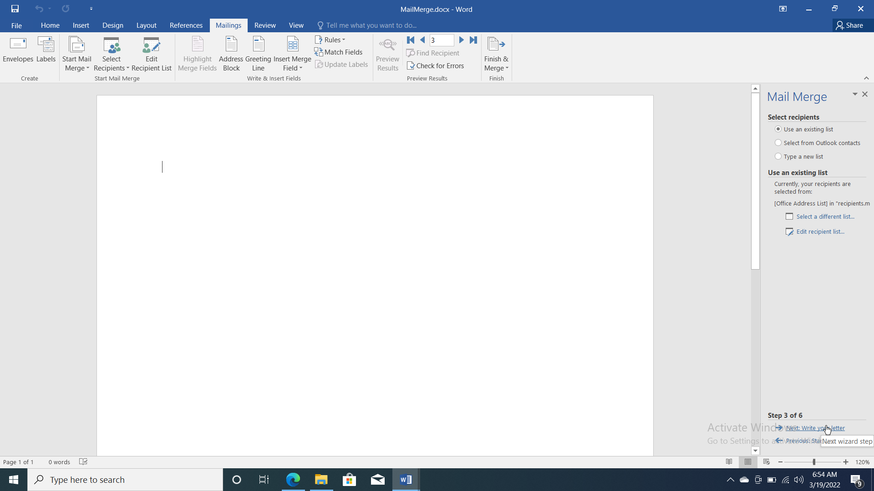

6. Write your letter using Insert Merge Field, Greeting line options. 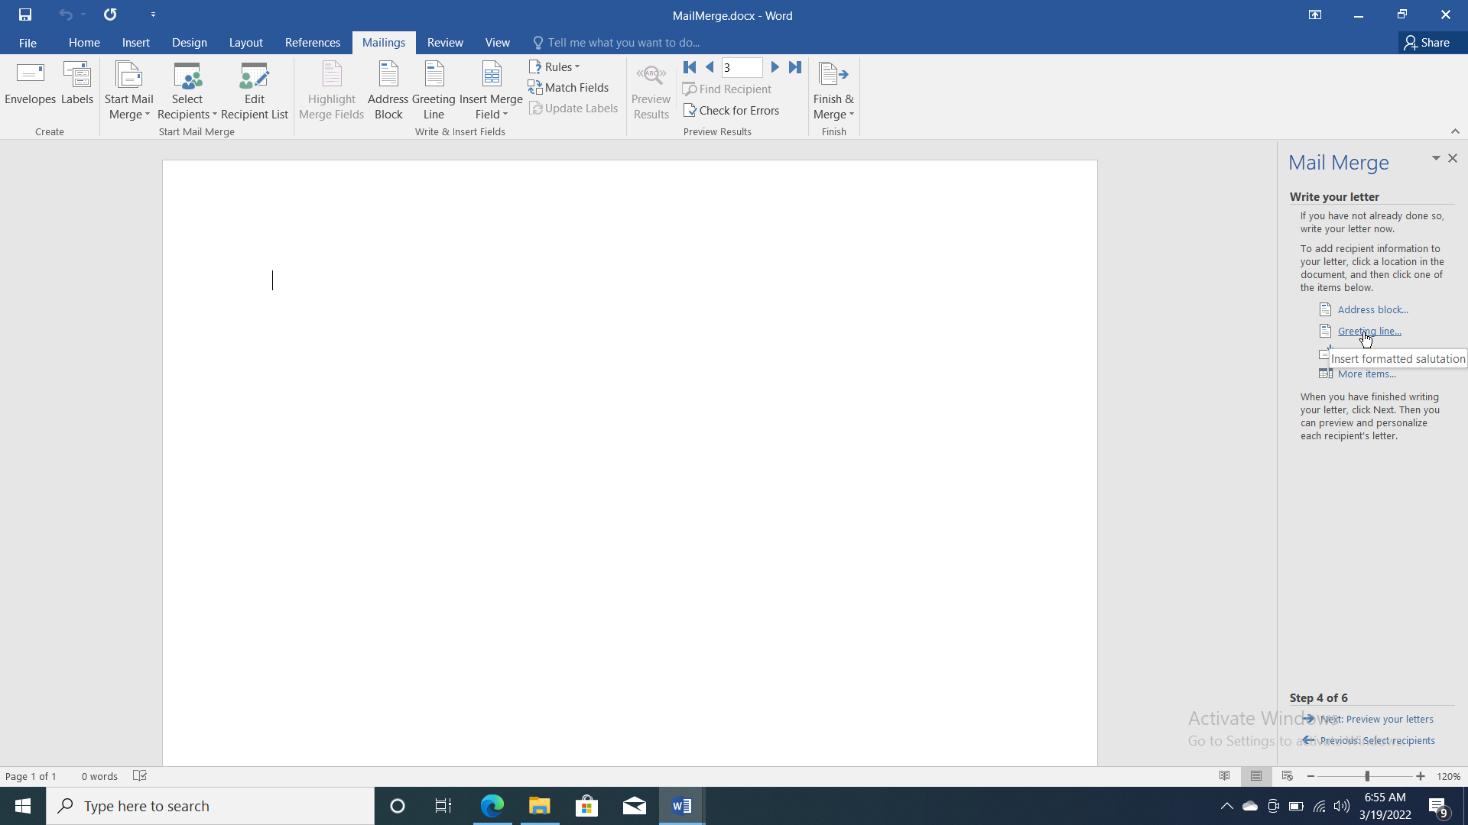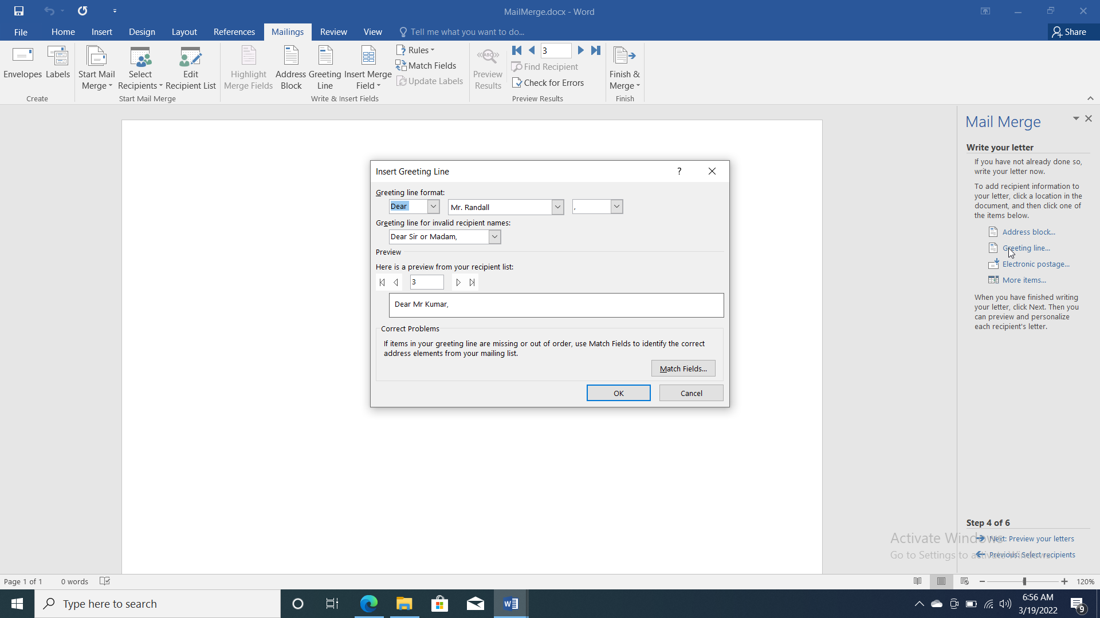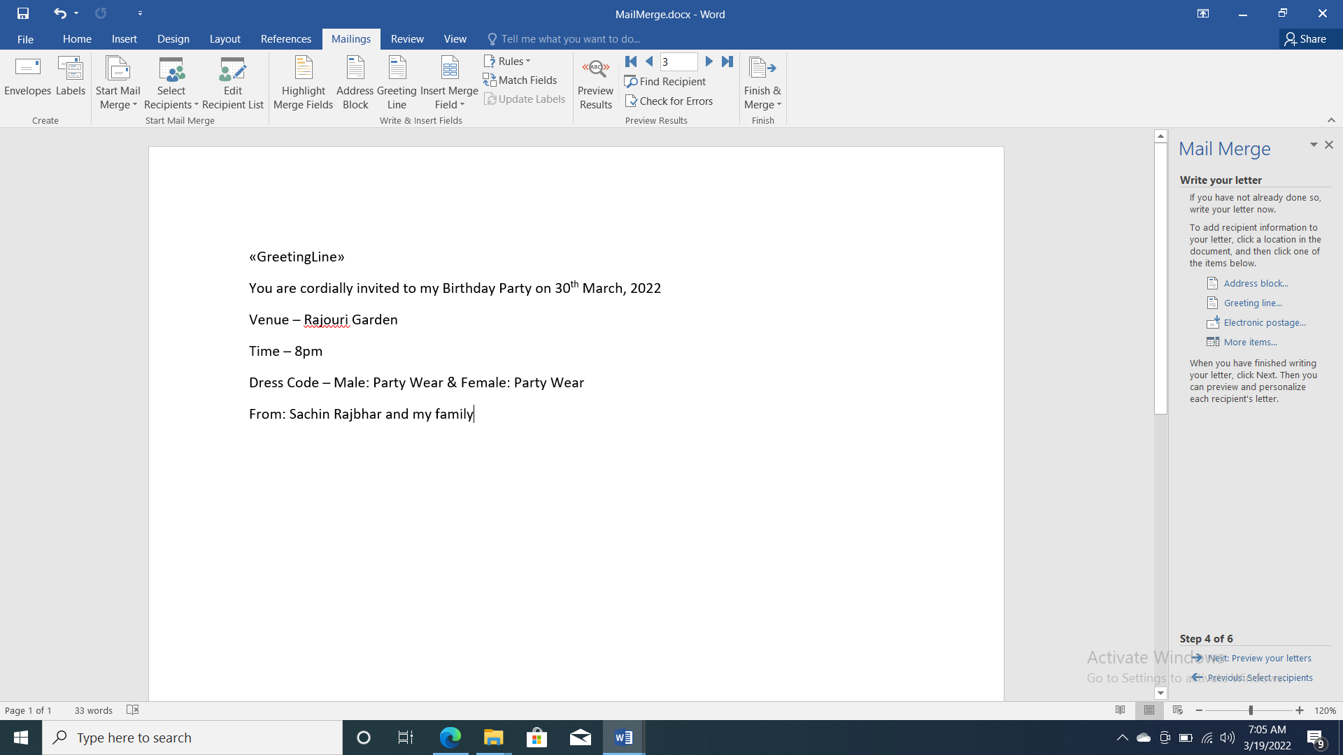

7. Now click on Edit Individual Document’s in Finish & Merge option in Finish Group. 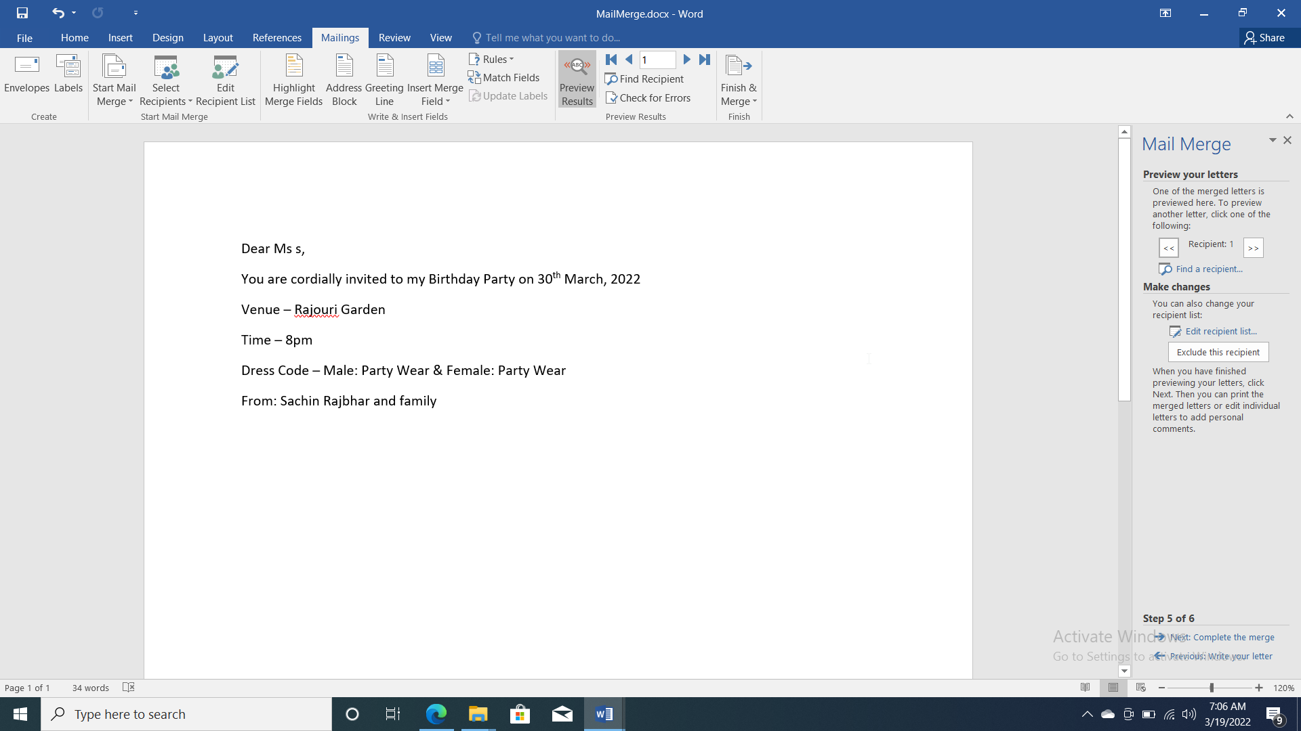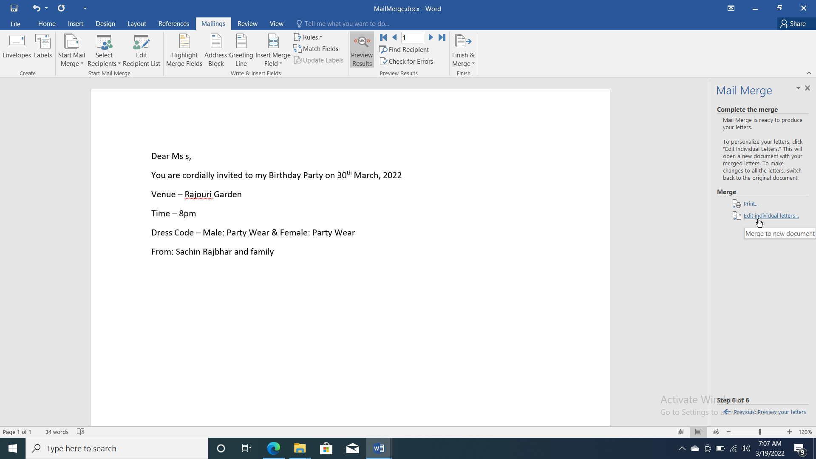

Practical 13

Q: COUNT THE NUMBER OF CHARACTER, WORDS, PAGES, PARAGRAPH AND LINES USING WORD COUNT FACILITY OF MS WORD

Steps:

1. Go to review tab, click on word count option.
2. It will count the no. of pages, characters, lines, & paragraphs of the selected text.



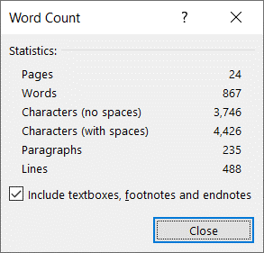

Practical 14

Q: CREATE A MACRO USING TOOLBAR. WRITE THE STEPS FOR THE SAME.

Steps:

1. Go to View tab.
2. Select macros in macros group.
3. Click on Record macros.

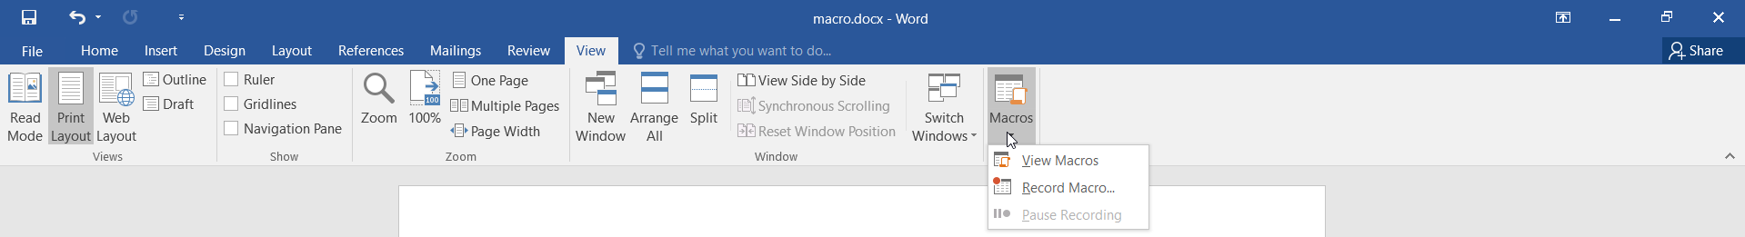

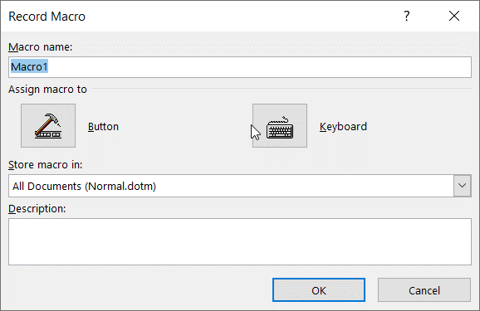

1. Select the macro name and then press Button.
2. Select the setting to quick access toolbar.
3. Record all the changes you want to do.

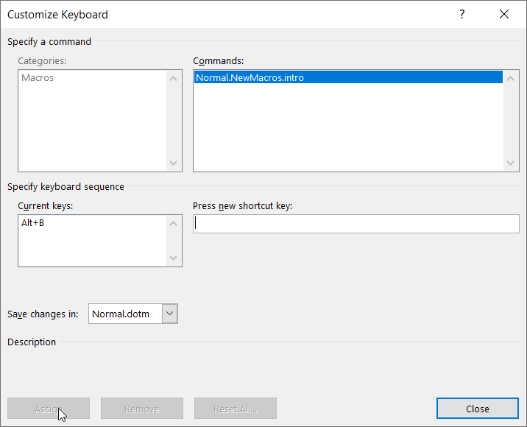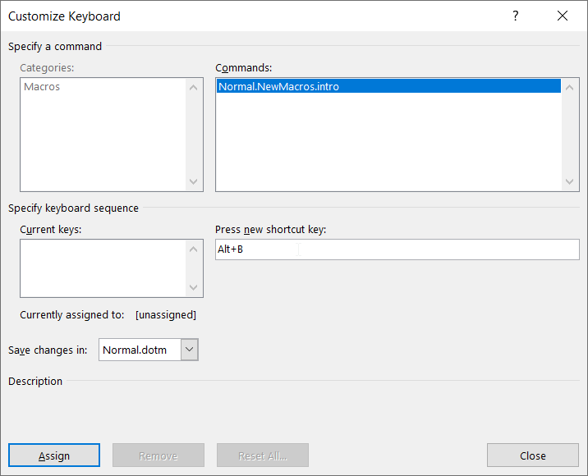

1. Type some text and Select you macros in quick access toolbar.

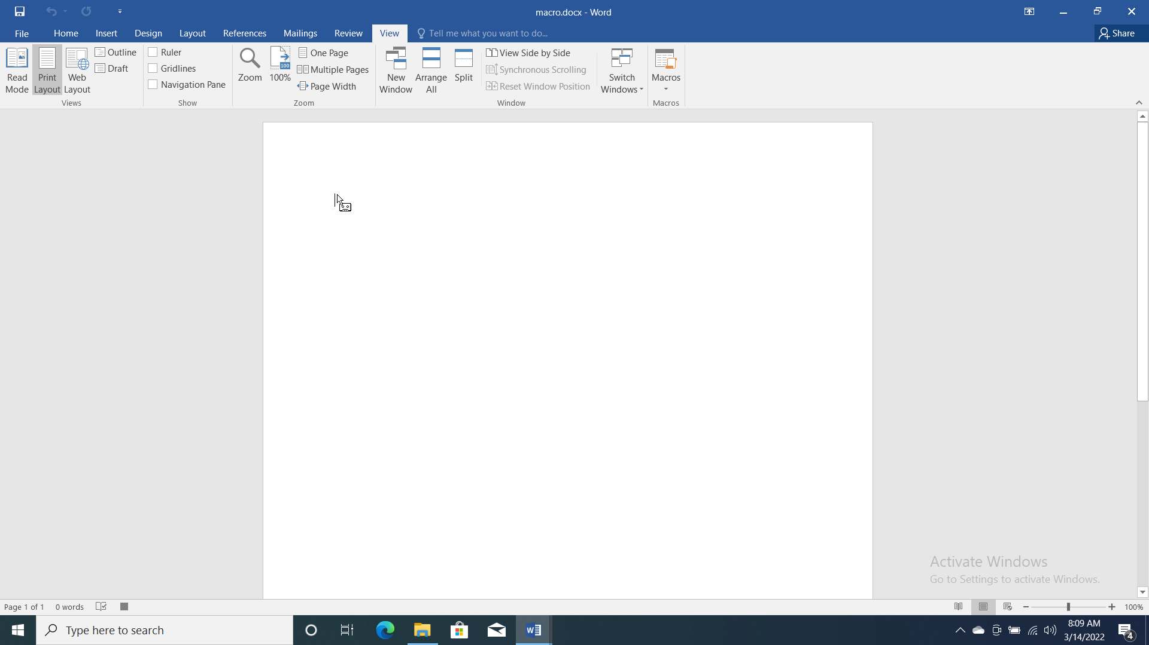

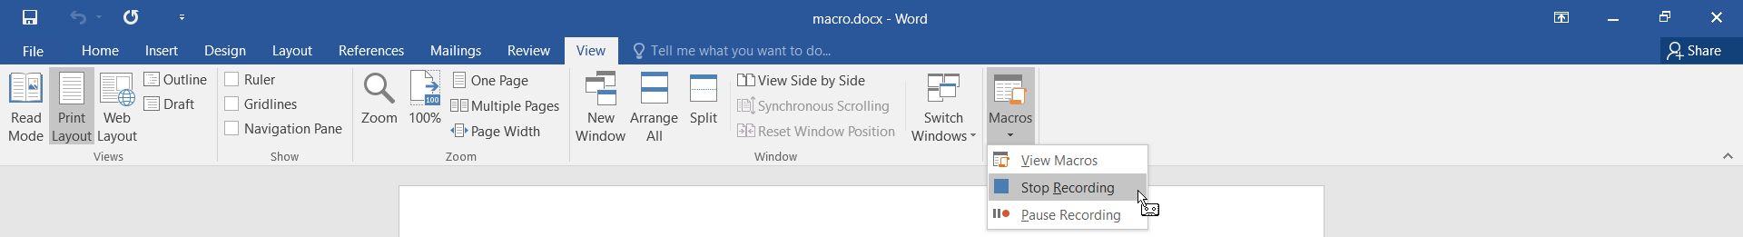

Practical 15

Q: CHECK THE SPELLING AND GRAMMAR IN AN EXISTING DOCUMENT AND IT SHOULD BE PROPERLY ALIGNED.

Steps:

1. Select some text.
2. Click on review tab.
3. Click on spelling and grammar option in proofing group



1. Click on change all to correct the paragraph
2. Now click on next sentence after correcting all sentence and then on OK.
3. After completion the result box show with the result of all wrong sentence

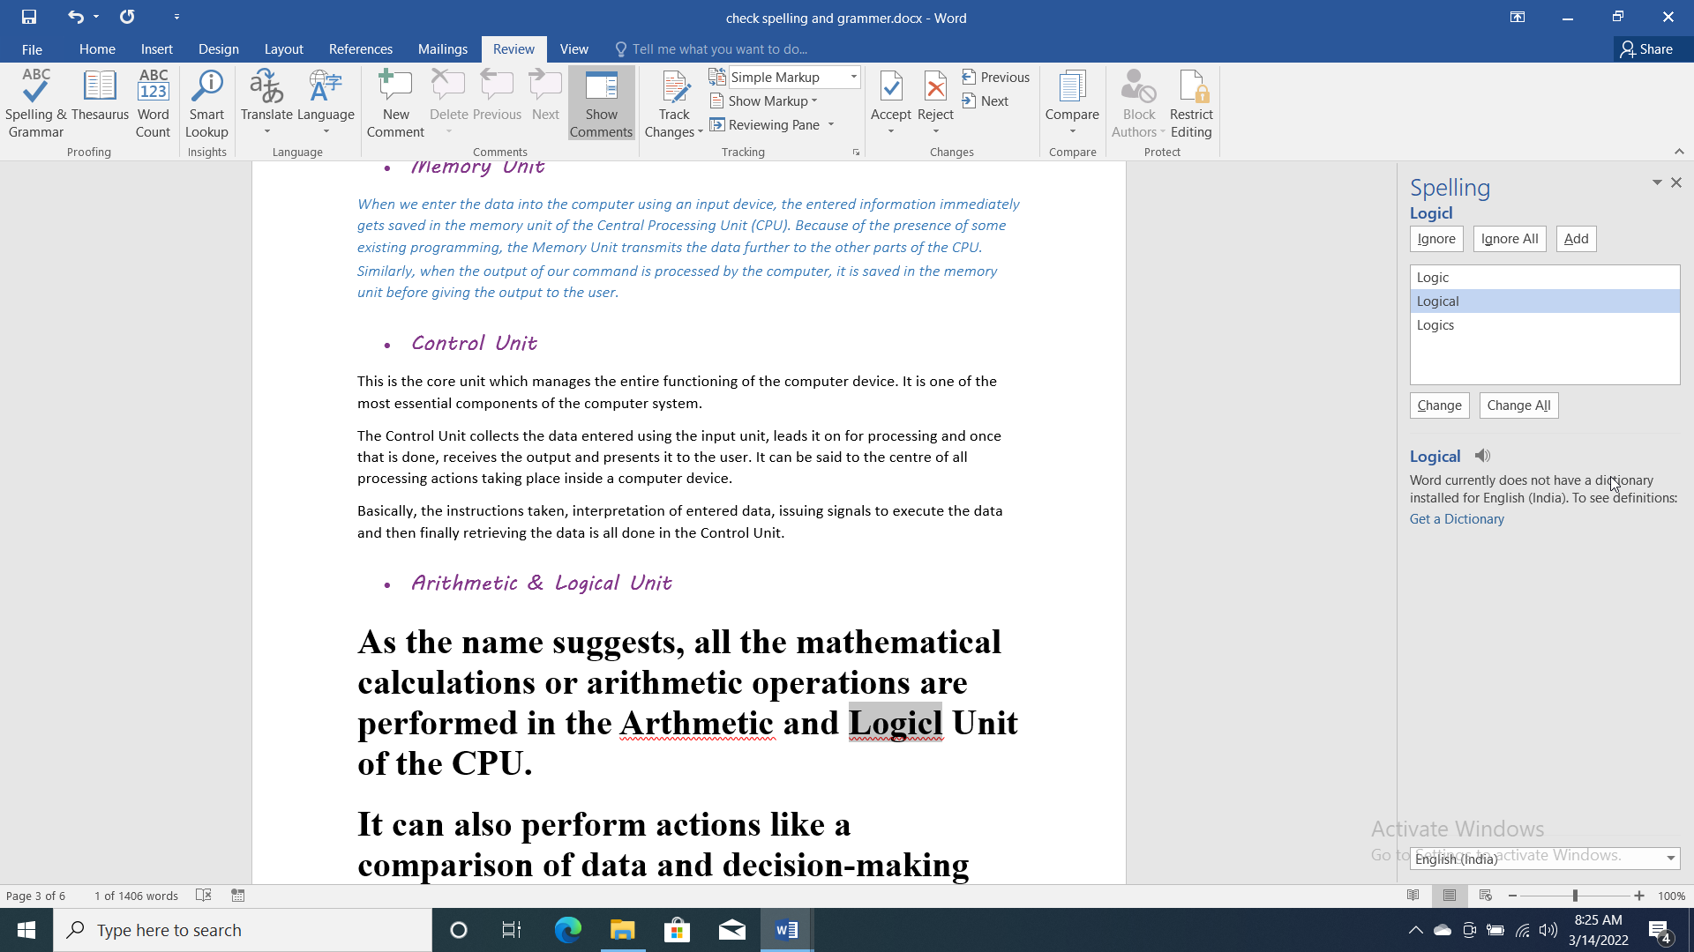

Practical 16

Q: CREATE A SPREADSHEET OF THE PURCHASES MADE BY A CUSTOMER IN A SUPER MART HAVING THE FOLLOWING FIELDS:

* S.NO
* PRODUCT ID
* PRODUCT NAME
* PRODUCT TYPE (FOOD, CLOTHES, TOYS ETC)
* QUANTITY
* PRICE PER UNIT

Note: All the field names should be bold and underlined. Also Insert Borders to the spreadsheet.

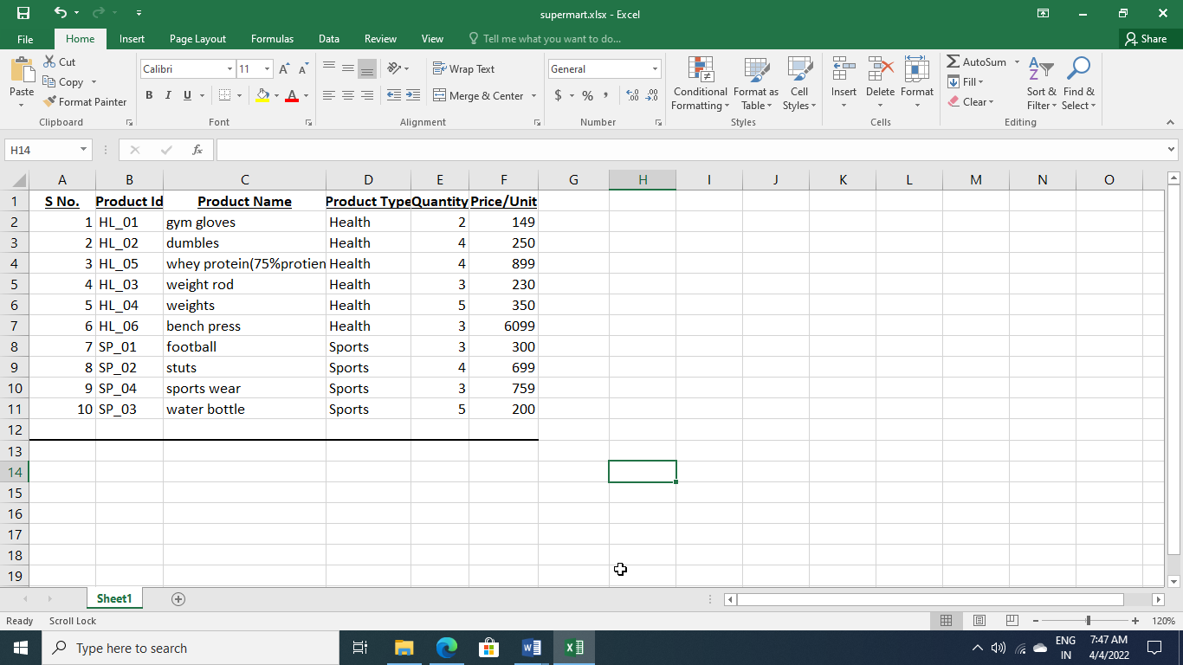

Practical 17

Q: For the spreadsheet created above, find the total bill, using the auto sum facility of Ms Excel.

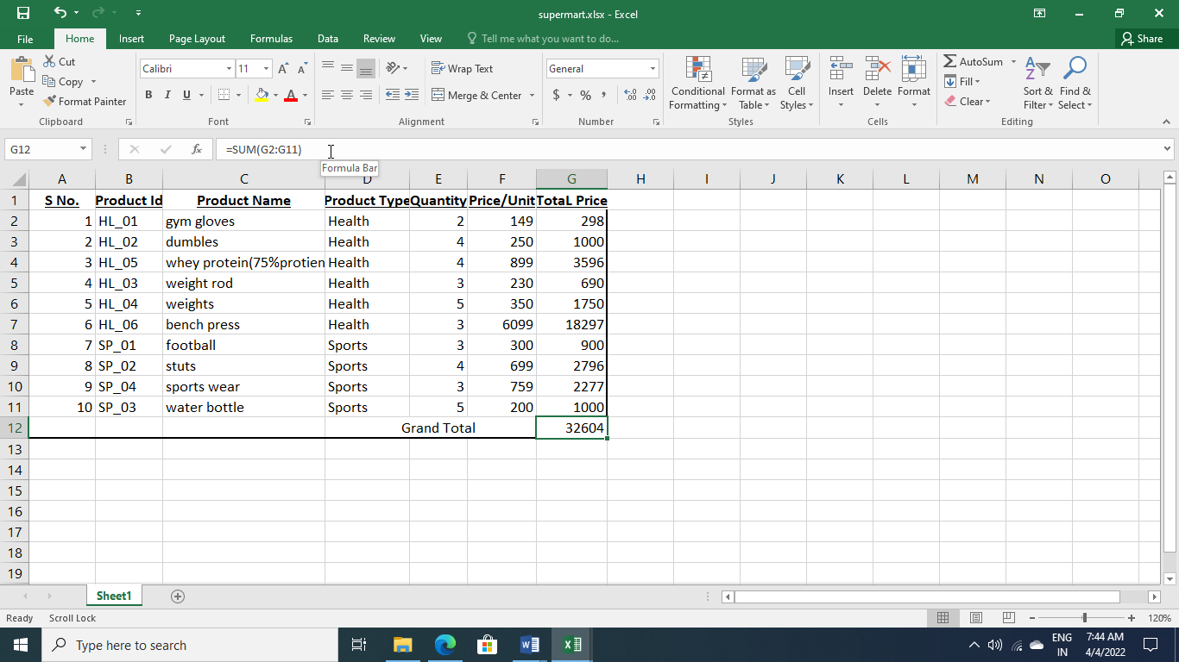

Practical 18

Q: CREATE A STUDENT PERFORMANCE REPORT USING CONDITIONAL FORMATTING IN M.S. EXCEL OF THE FOLLOWING SPECIFICATIONS:

* GREATER THAN
* LESS THAN
* EQUAL TO
* BETWEEN
* DATA BAR
* COLOUR SCALES

Steps:

1. Fill the S.No, Name M1, M2, M3, M4, M5 with all the detail.
2. In 1st we will use Greater then option available in conditional Formatting, Highlight cells rules.

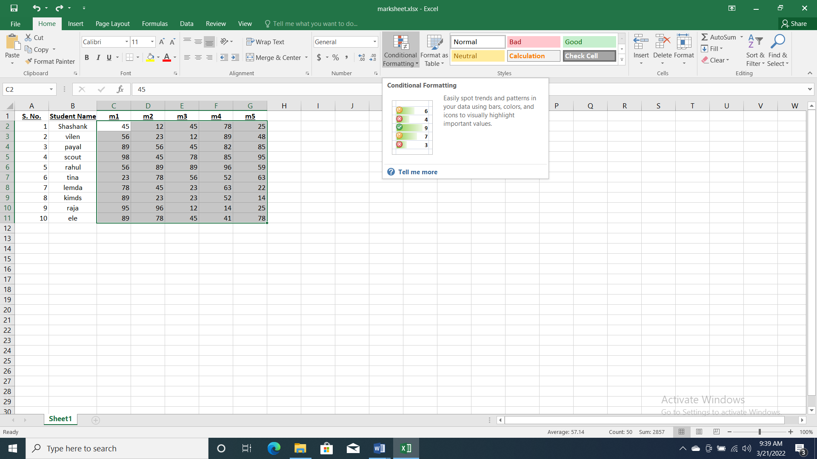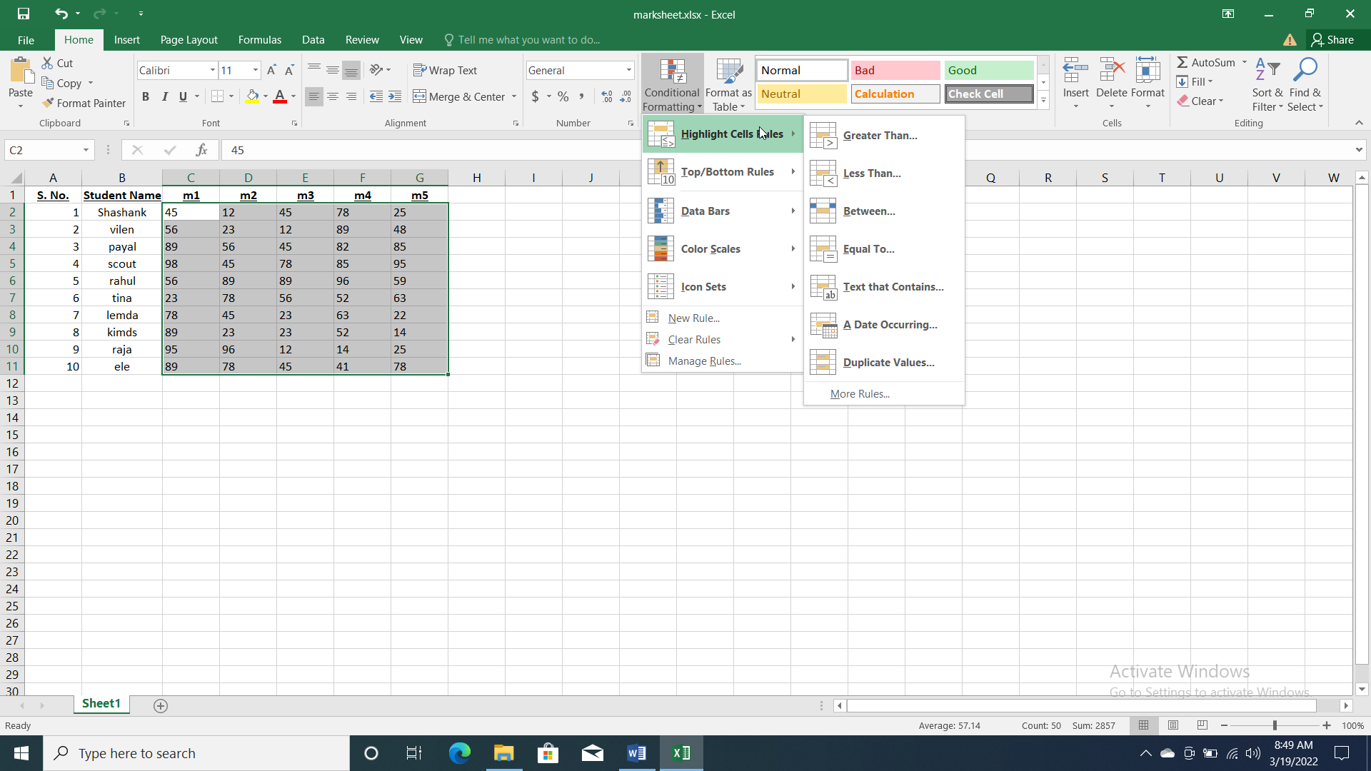

1. Less Then 4. Greater Than

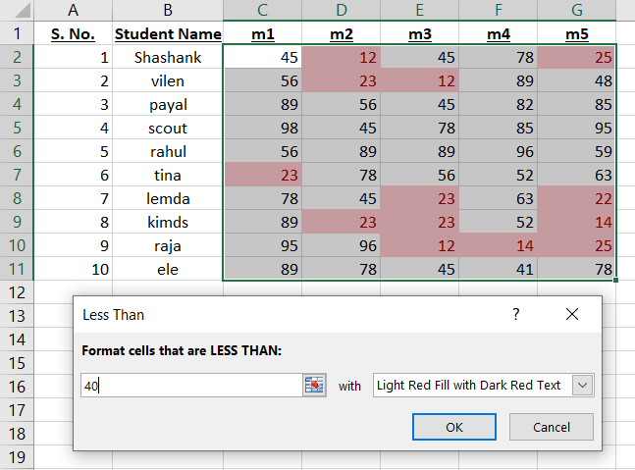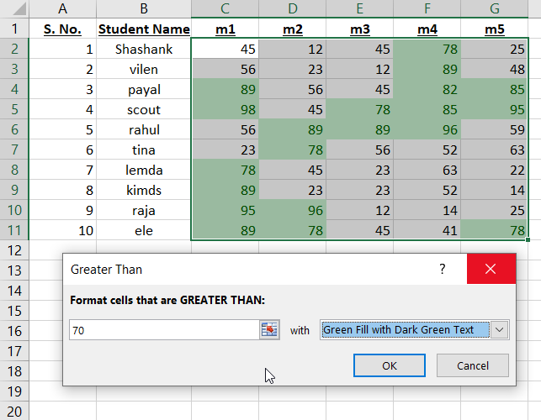

1. Equal to 6. Between

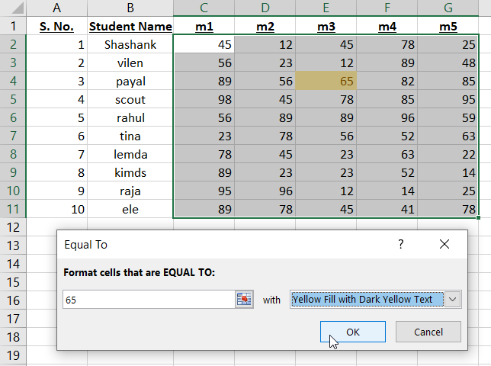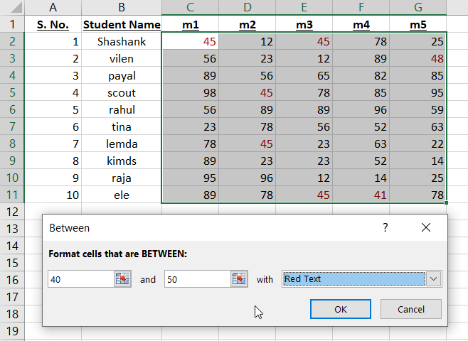

1. Data Bar

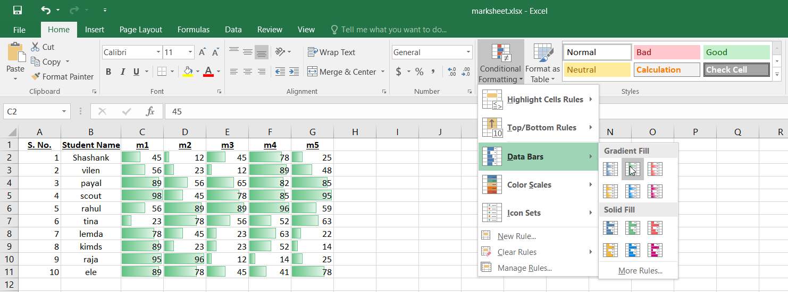

1. Color Scales

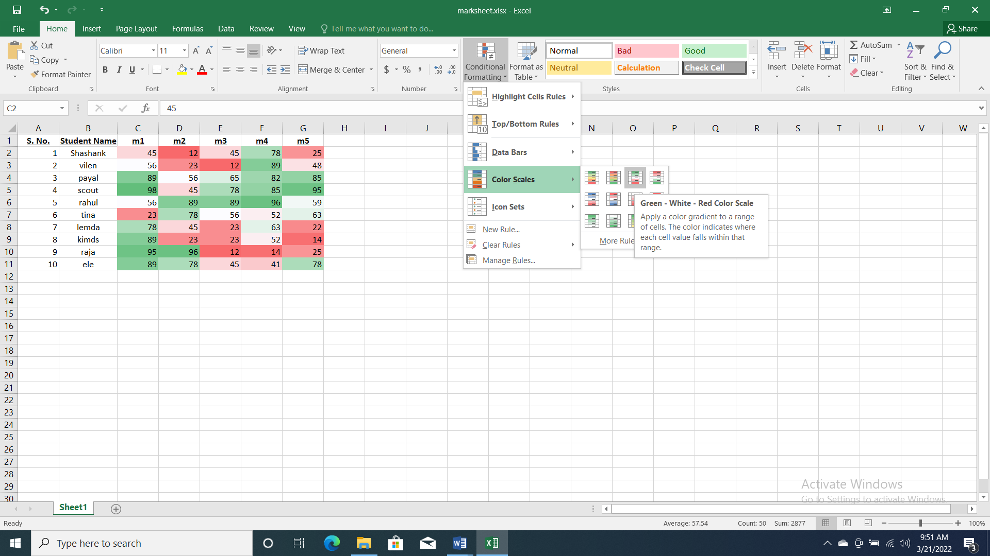

Practical 19

Q: CREATE A RECORD OF TEN STUDENTS CONSISTING OF S.NO, NAME AND MARKS IN TWO SUBJECTS (M1, M2) AND PERFORM THE FOLLOWING OPERATIONS:

* Sort the records in ascending order of marks M1
* Sort the records in descending order of marks M2
* Sort the record according to descending order of names
* Find the minimum marks and replace it by the text “put more efforts”.

Steps:

1. Fill The S.No, Name M1, M2 With All The Detail.

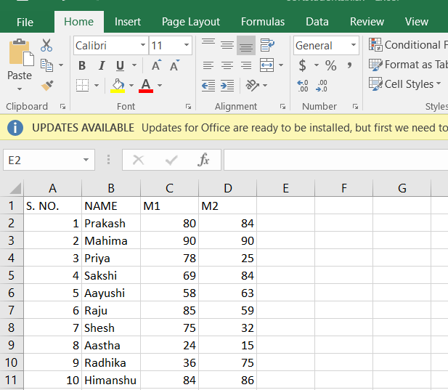

1. Select the marks of M1.

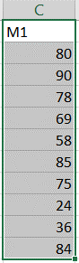

1. Click on Sort and filter in Editing and Sort them into smallest to largest.

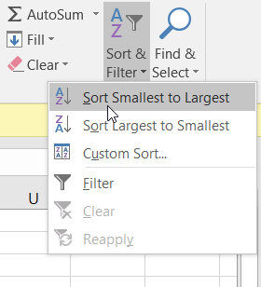

1. M1 is sort in ascending order.

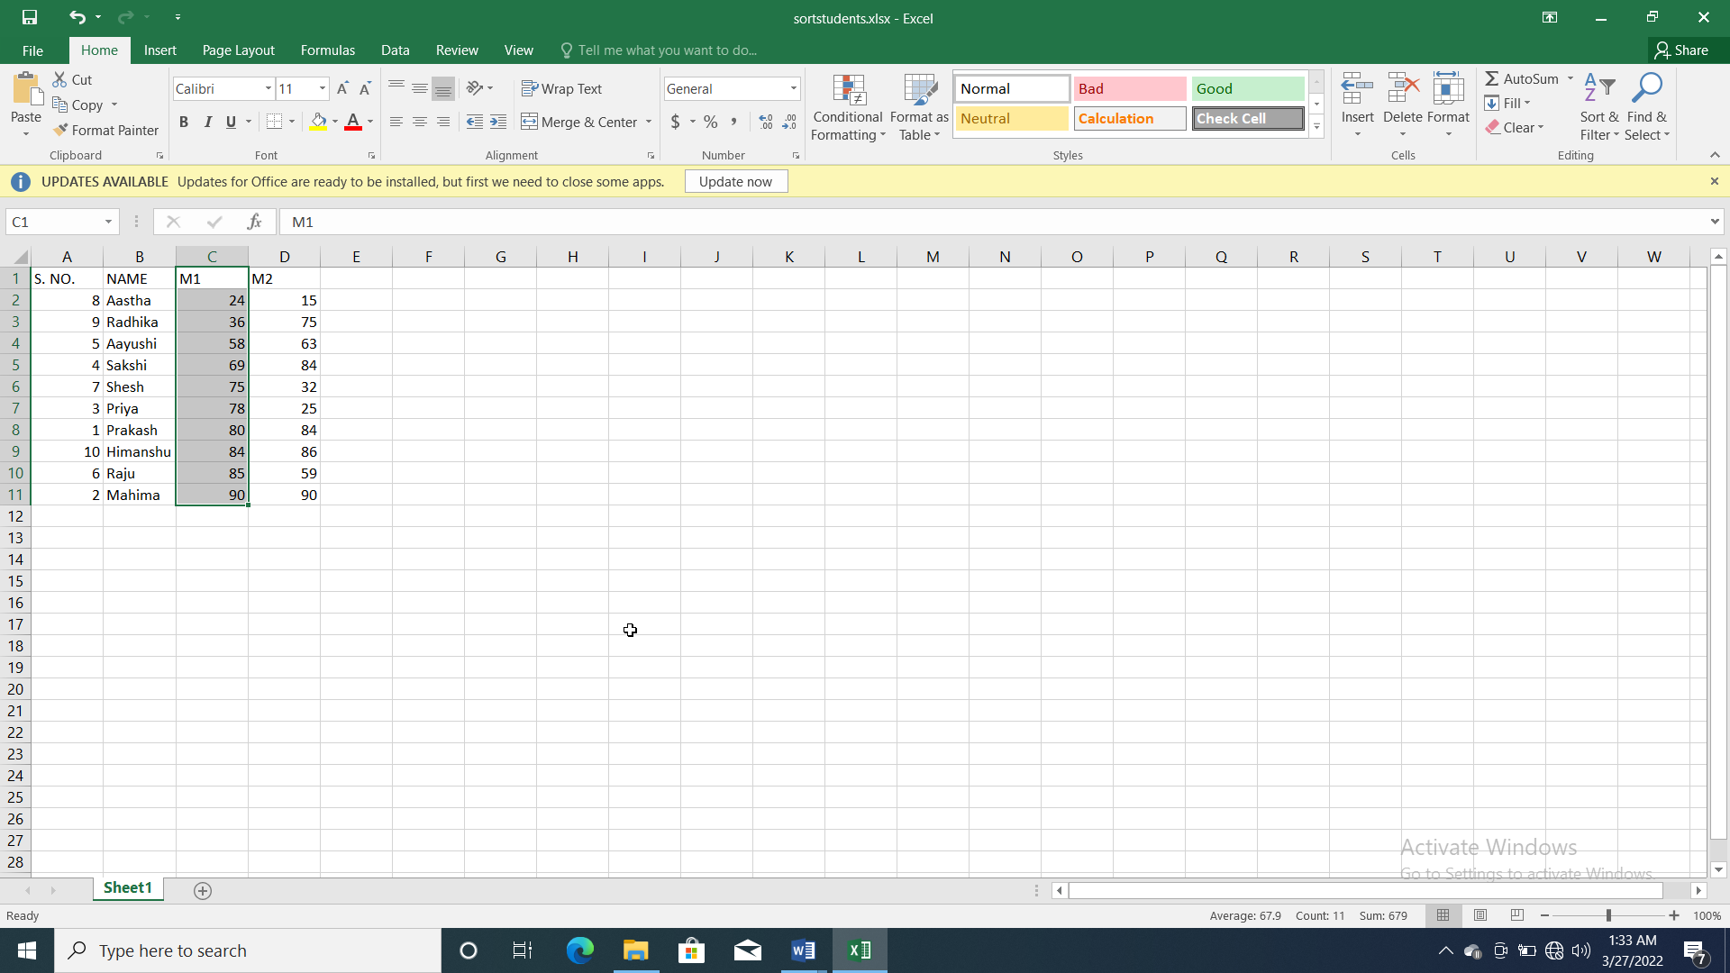

1. Select the mark of M2.

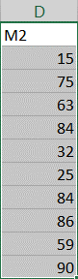

1. Click on Sort and filter in Editing and Sort them into largest to smallest.
2. M2 is sort in Descending Order.

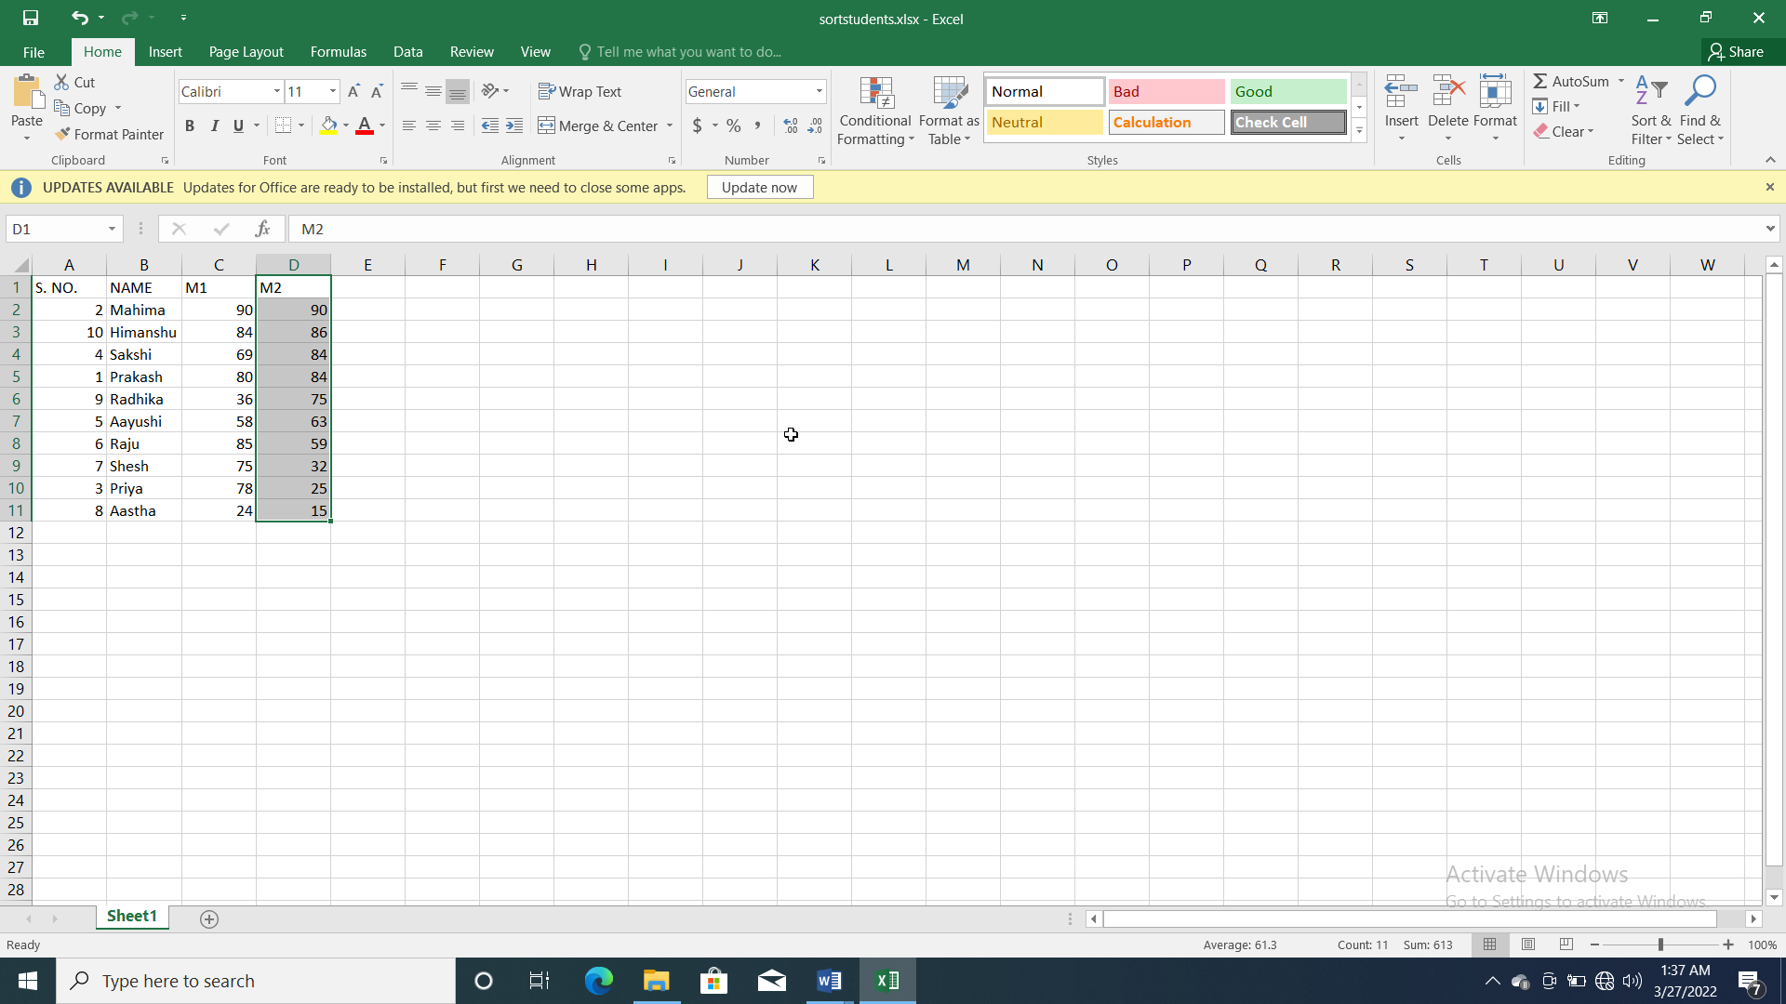

1. Sort the record according to descending order of names.

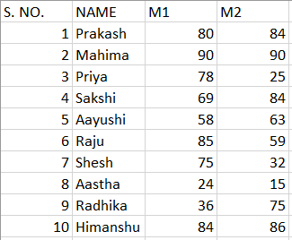

1. Click on Sort & Editing and sort them into Descending order.

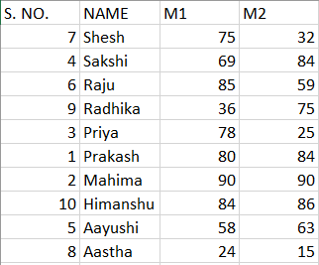

1. Find the minimum marks and replace it by the text “put more efforts”.

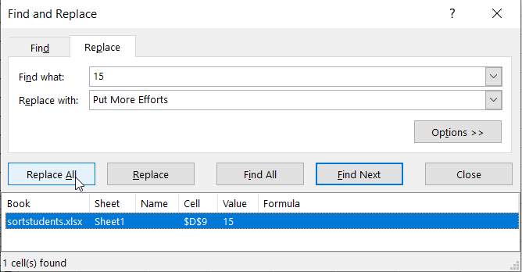 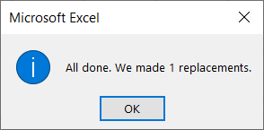

1. Minimum marks were converted to Put More effort.

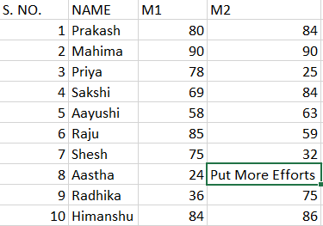

Practical 20

Q: CREATE THE COLUMN CHART FOR THE SALES REPORT OF THE ABC PVT LTD. APPLY THE FOLLOWING PROPERTIES OF COLUMN CHART SUCH AS:

* Fill Color
* Border color
* Border Style
* Size

Steps:

1. Select the data which you want to show in column
2. Select the insert tab and click on column option in chart group
3. Select the chart
4. On home tab click on fill color in front group
5. After that go to format tab and select different style, size color, etc.

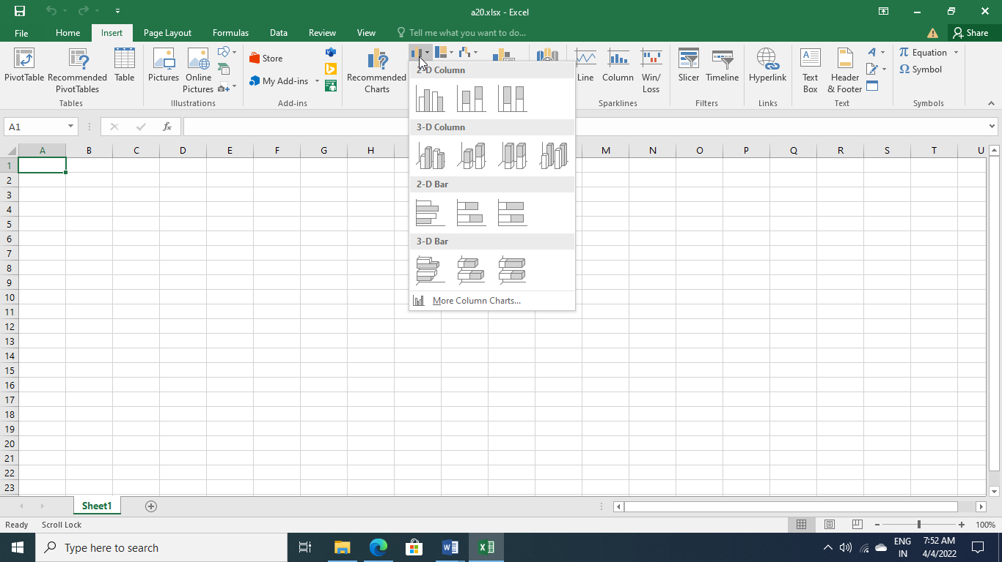

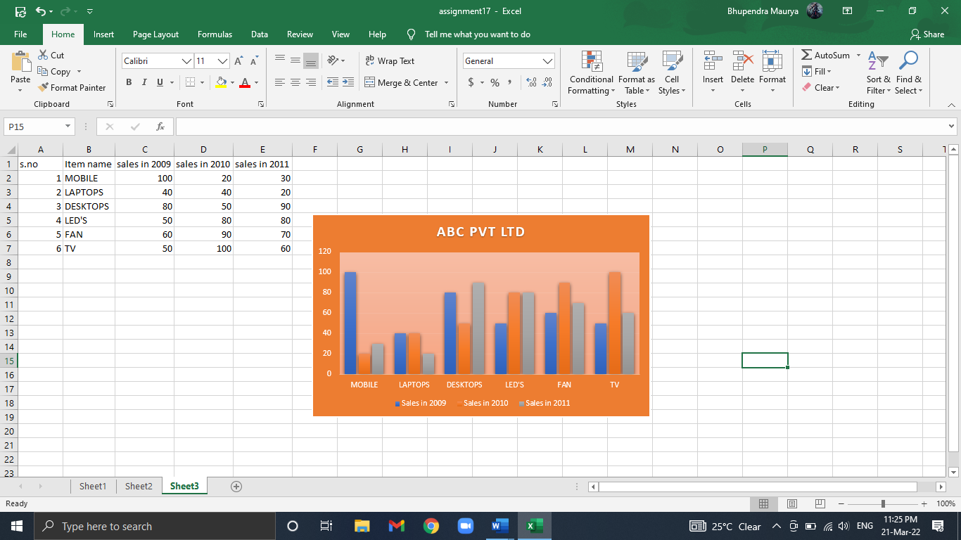

Practical 21

Q: CREATE THE COLUMN CHART FOR THE SALES REPORT OF THE ABC PVT LTD. APPLY THE FOLLOWING PROPERTIES OF COLUMN CHART SUCH AS:

* Fill Color
* Border color
* Border Style
* Size

Steps:

1. Fill The S. No. Item Name Sales in 2009, 2010 and 2011 With All The Detail.
2. Select the data.
3. Click on Insert Tab.
4. Click on Column Chart.

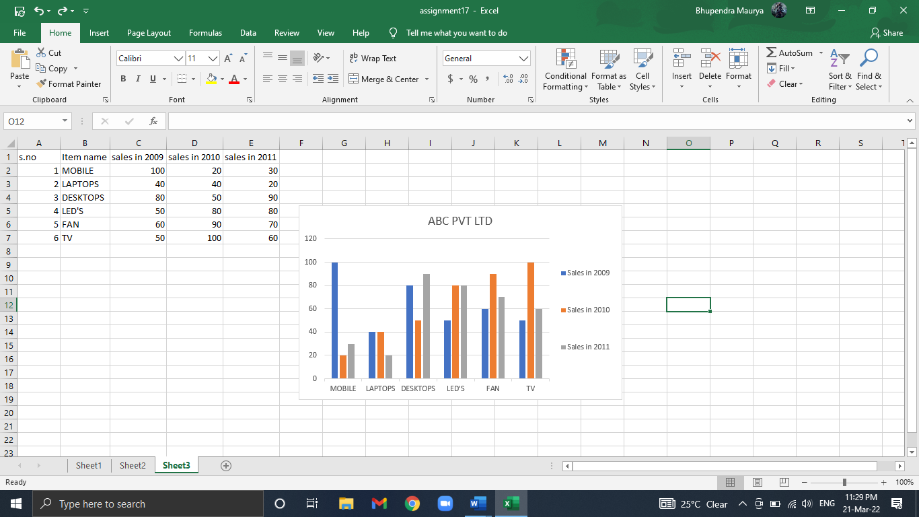

Practical 22

Q: Create a pie chart for the sales report of the ABC Pvt. Ltd. For last 3 years. Explore various properties such as add label, color etc.

Steps:

1. Fill The S.No, Item Name, Sales in 2009, 2010, 2011 and Net profit With All The Detail.
2. Select the data.
3. Go to insert tab.
4. Click on pie.

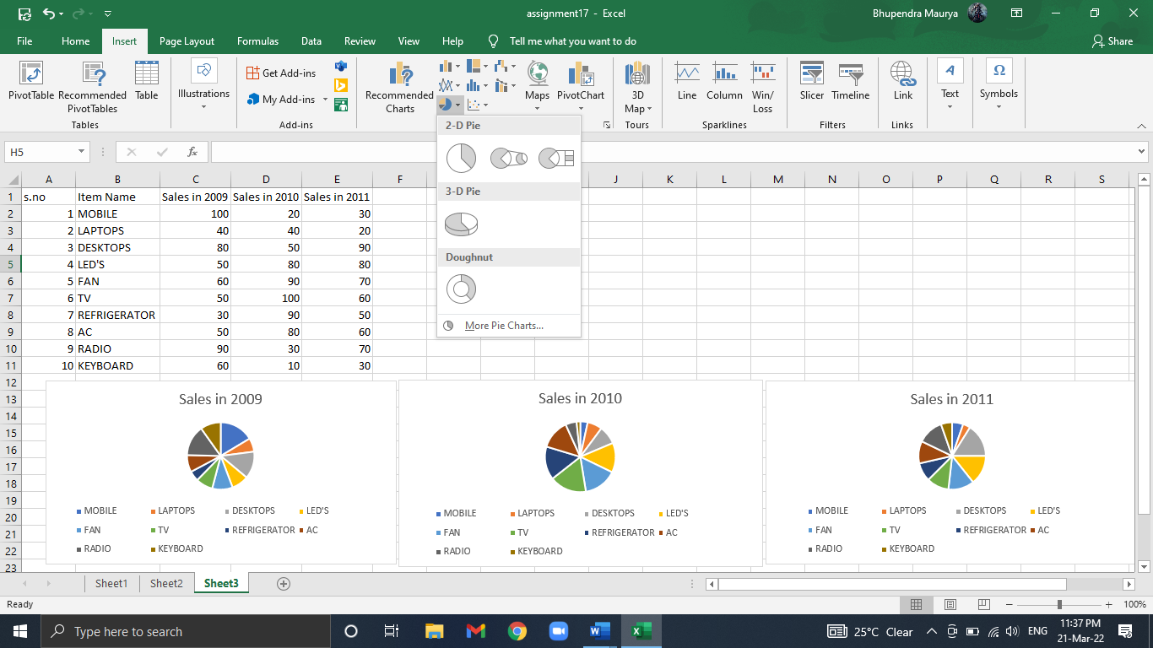

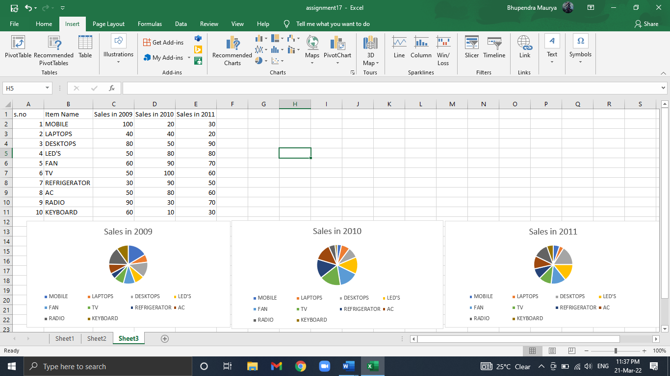

Practical 23

Q: Create a Bar graph for 5 states for 3 years depicting the literacy rate.

For the graph created above perform the following

* Switch Row/column,
* fill color
* add borders
* change size

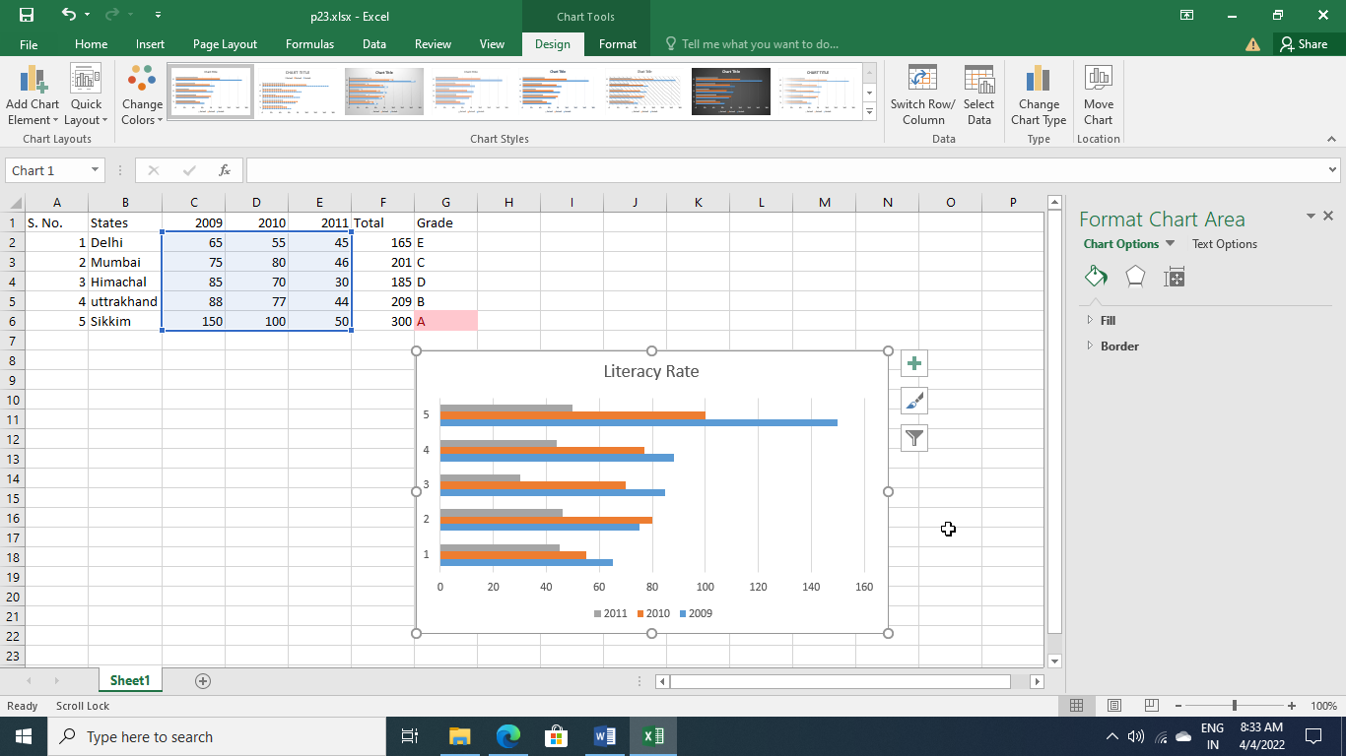

Practical 24

Q: Now using the conditional formatting fill the A grade as –pink, B grade as blue, C grade as yellow and D grade as Red.

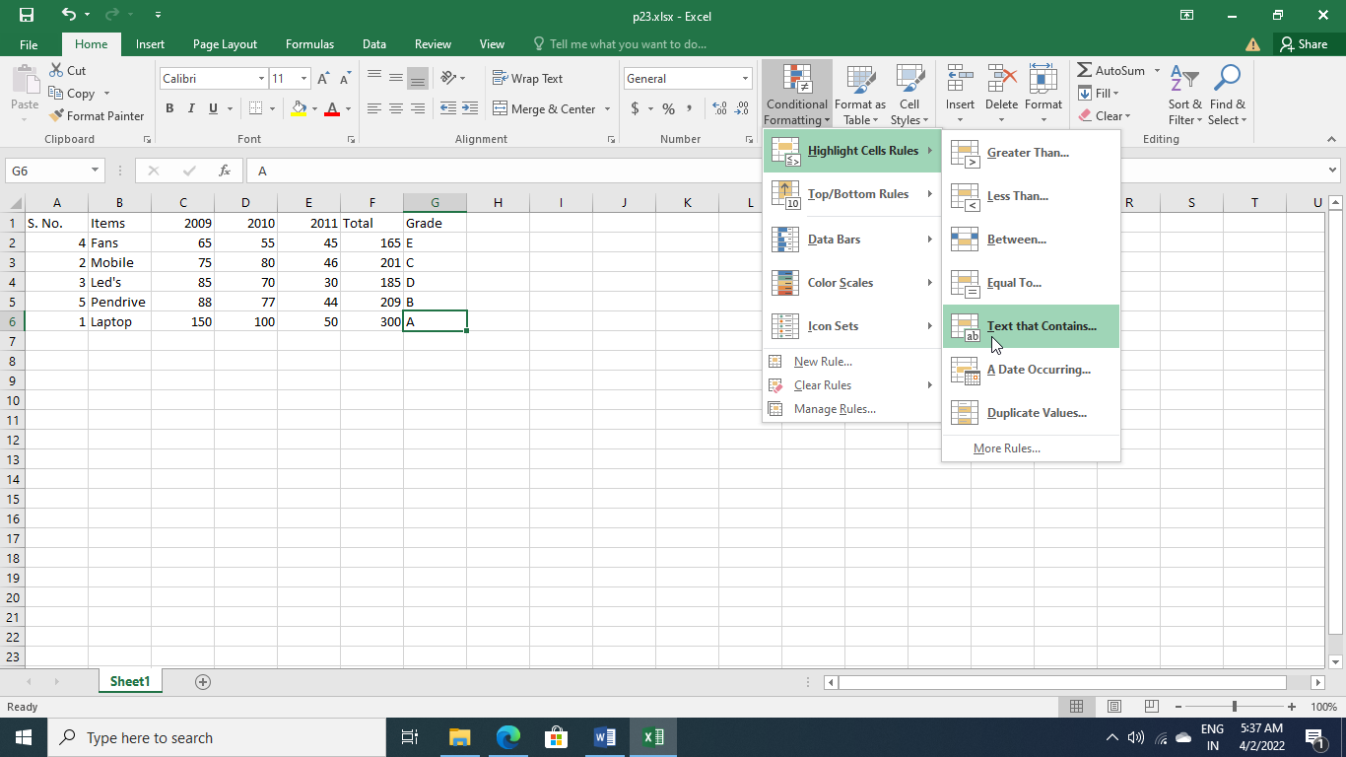

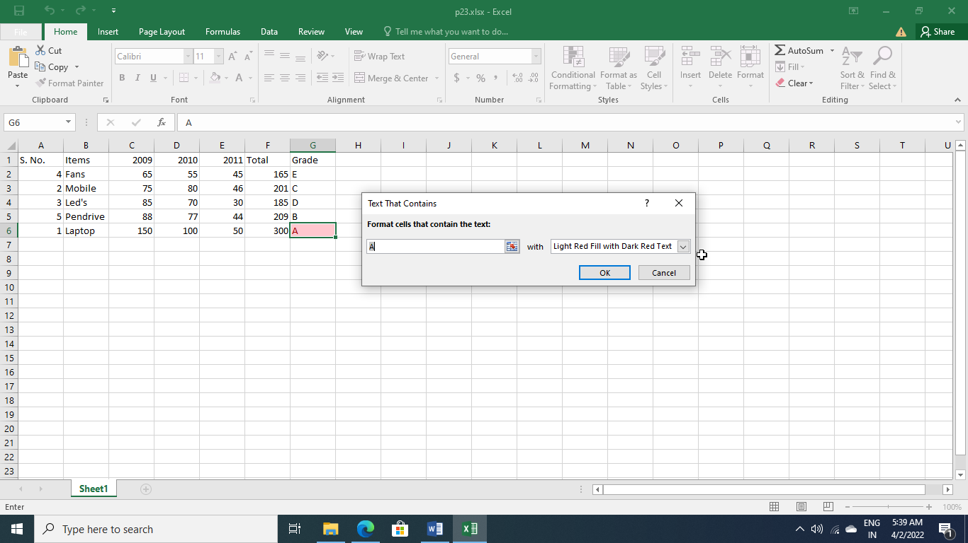

Practical 25

Q: Create the student record consisting of the following entries

* s.no
* name
* marks in M1, M2, M3, M4, M5

Now for the table perform the following functions:

* Find the maximum marks in M2
* Find the minimum marks in M5
* Find the total marks obtained by each student
* Find the average marks of each student
* Sort the table according to total marks.

Create a new field named "percentage" and calculate it.

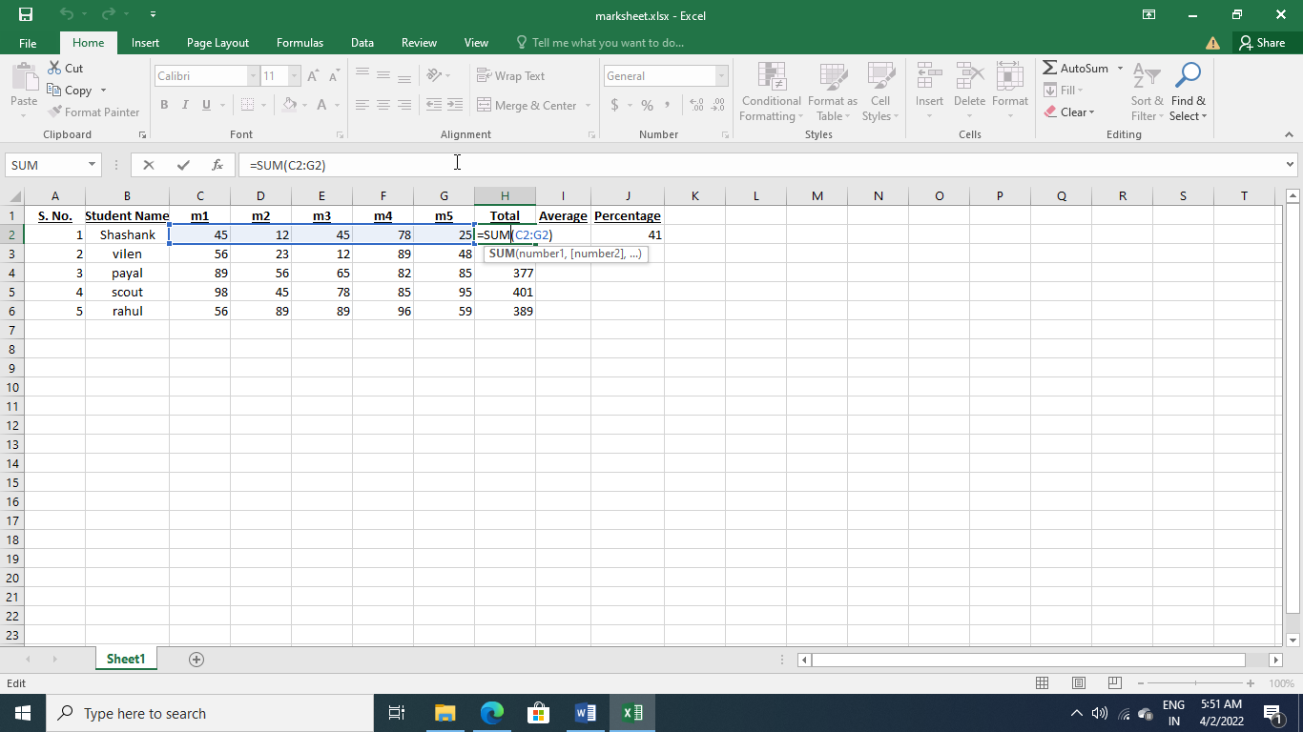

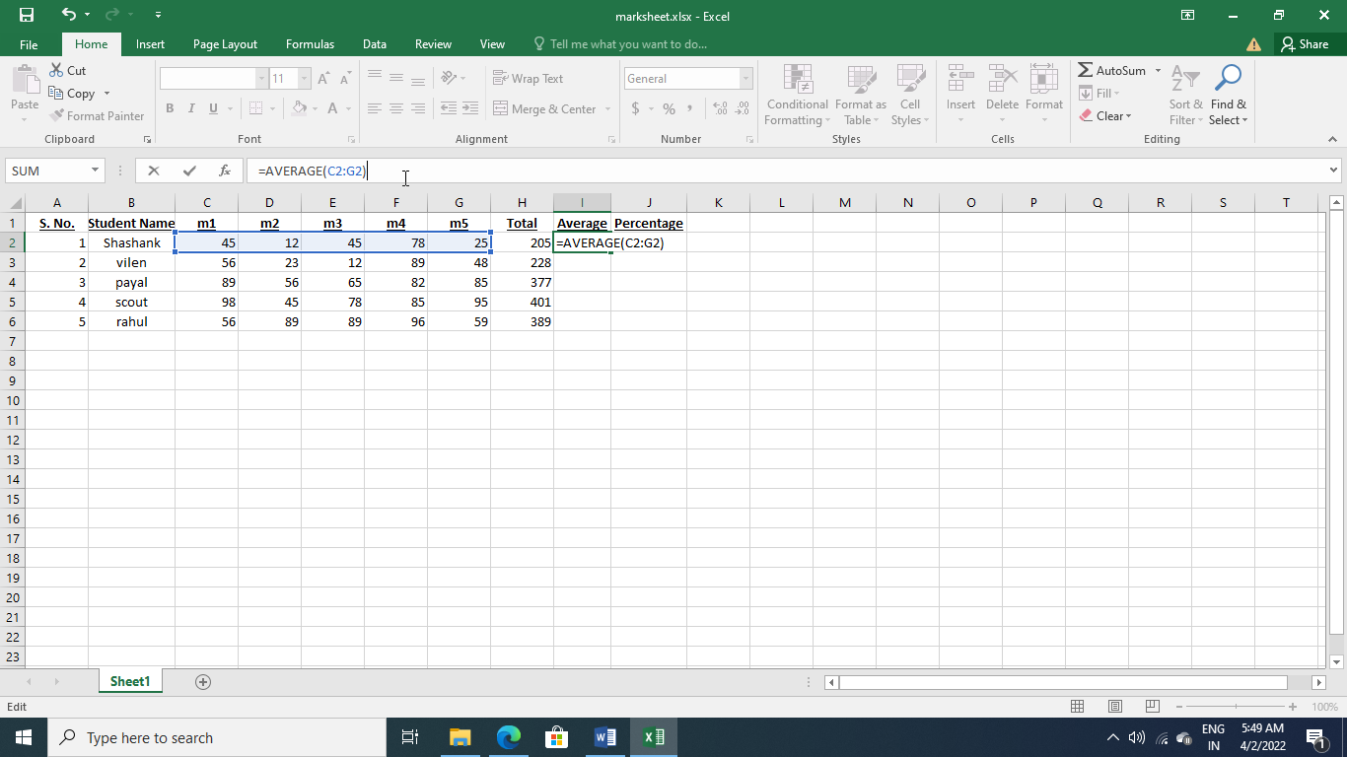 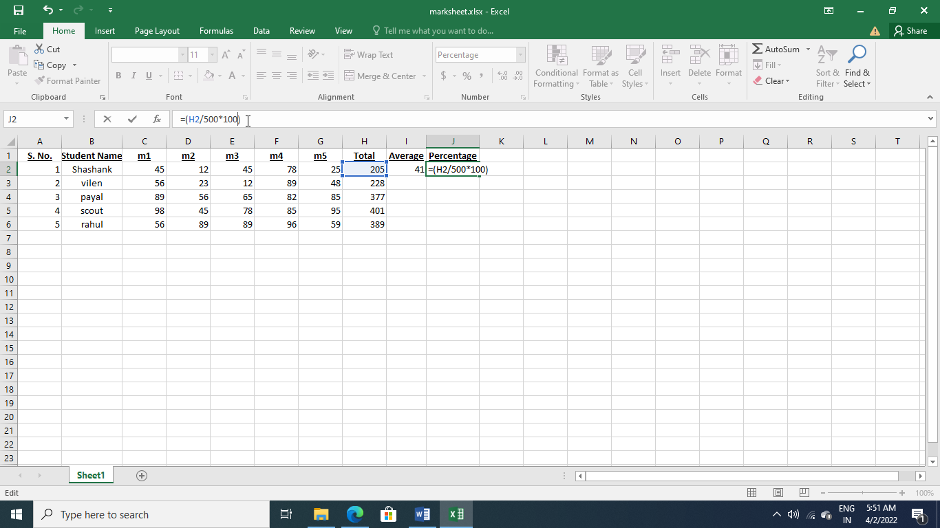

Practical 26

Q: Create a record of BBA (1ST Sem) consisting of the following fields:

* S.no
* Name
* Date of birth
* Age
* Marks
* Remarks

For the above record, apply the appropriate data validation.

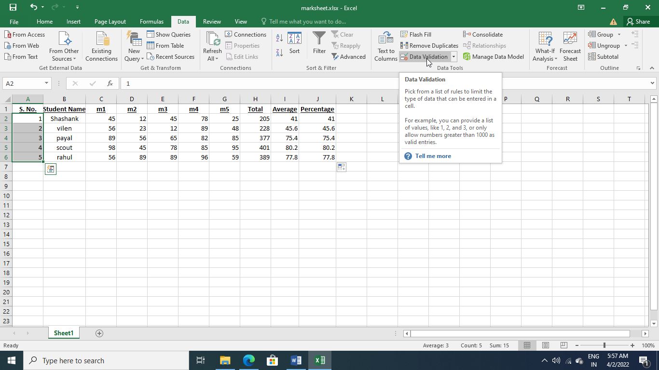

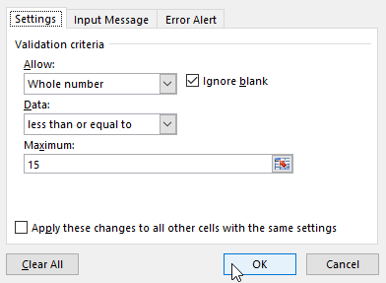 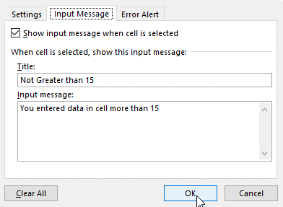 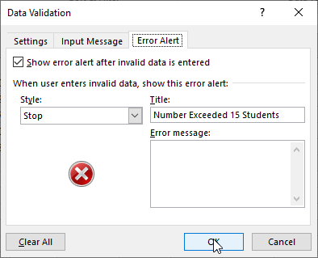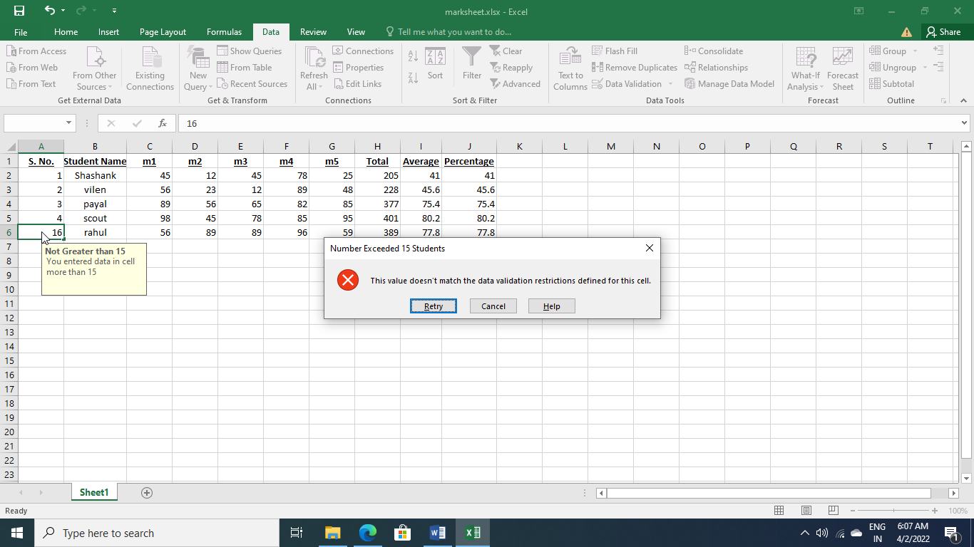

Practical 27

Q: To illustrate the use of internal commands like: Date/Time, VER, VOL, CLS, Copy con, TYPE, Rename, CD, MkDIR, Copy, Del, RMDIR, EDIT, DIR,)

* Display current date and time.
* Create a directory by your course name
* Create a file by your name in this directory
* Create a duplicate of this file by your Last name
* Delete your first file
* Change the name of your file as IIT.
* Remove the directory

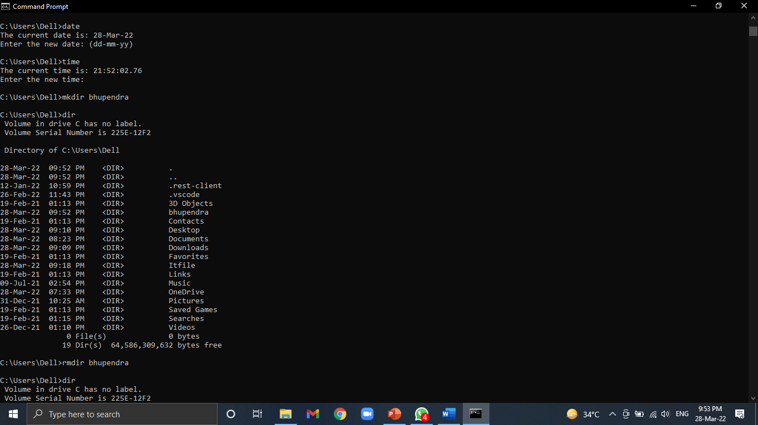

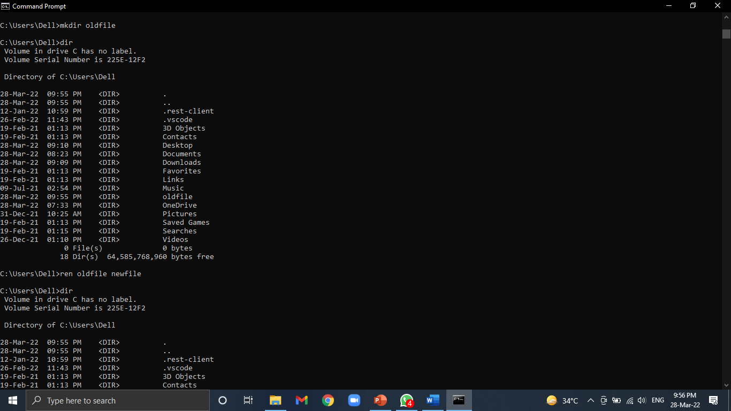

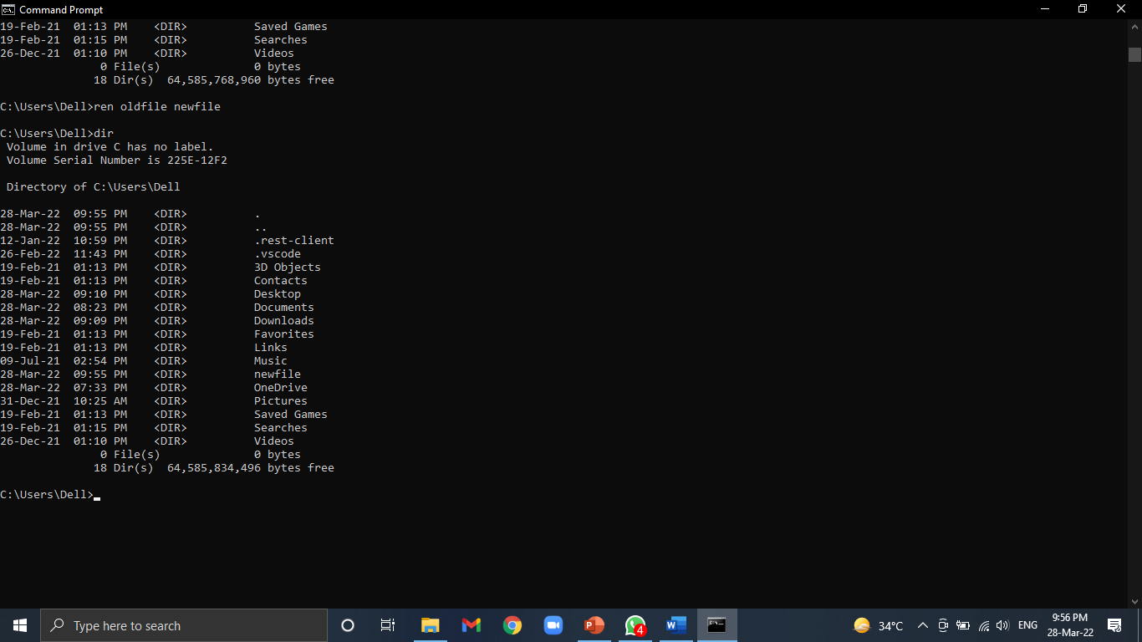

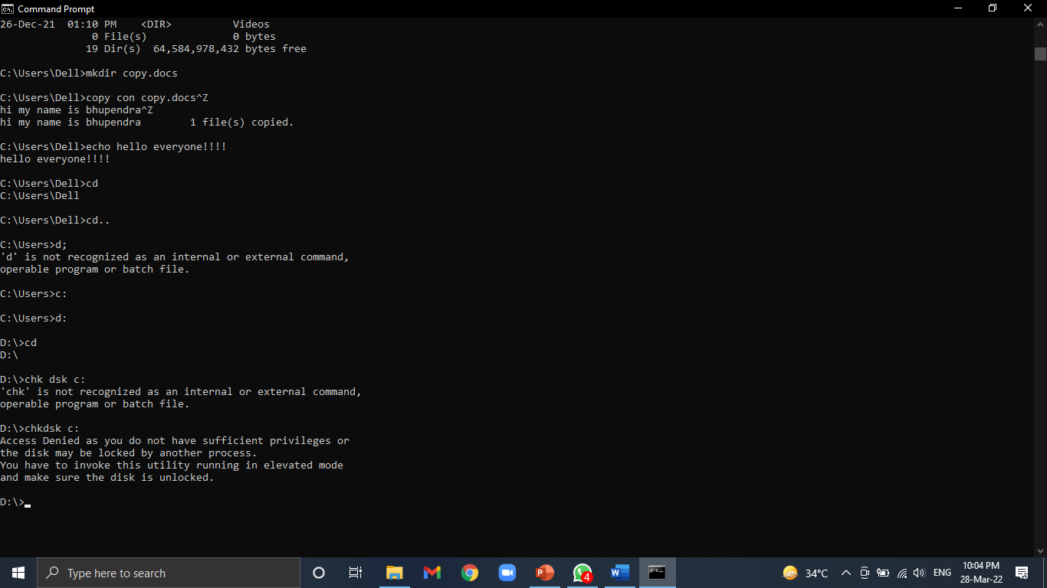

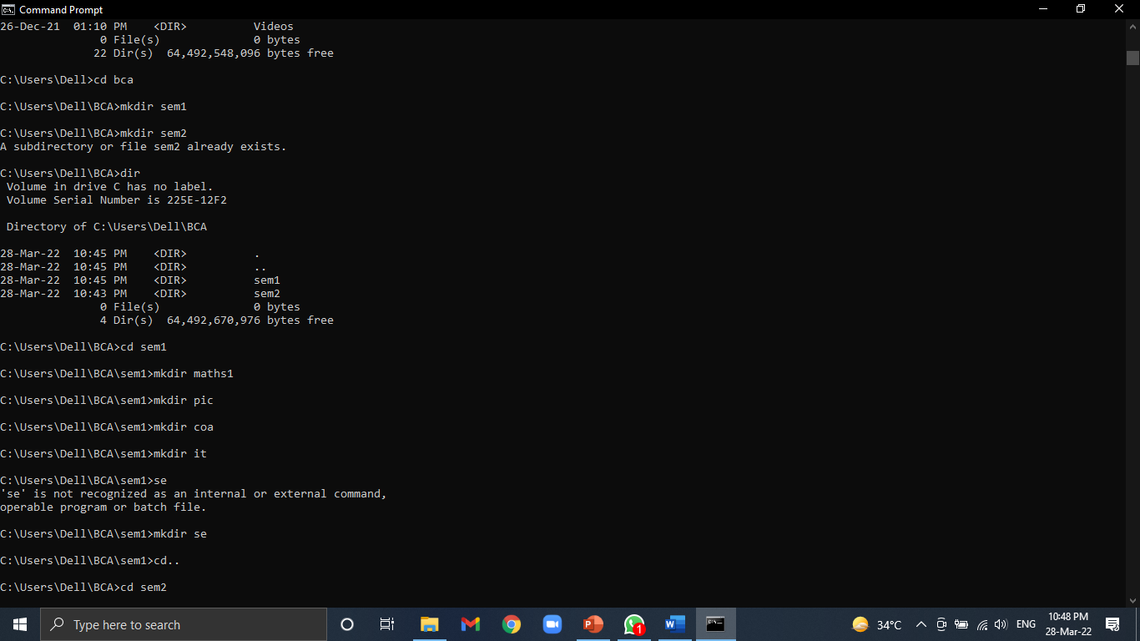

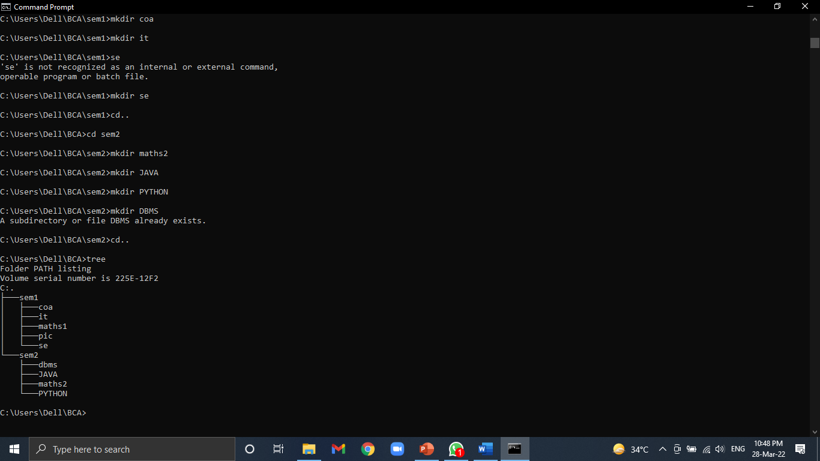

Practical 28

Q: Create a presentation on Types of Memory having a table for the Types of Memory and then create hyperlinks on the types of Memory in the master slide that opens new slides for it.

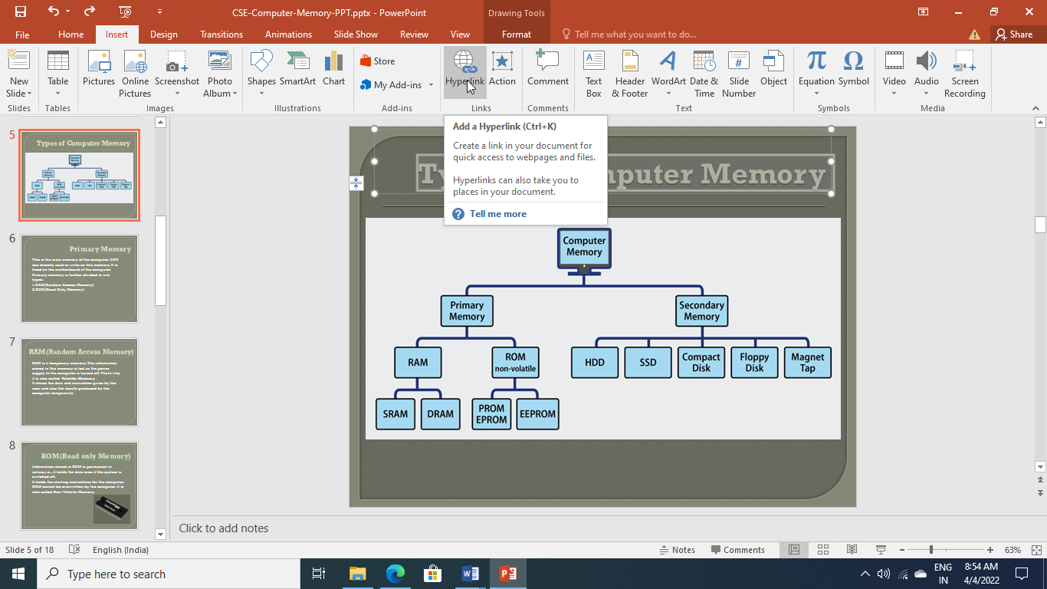 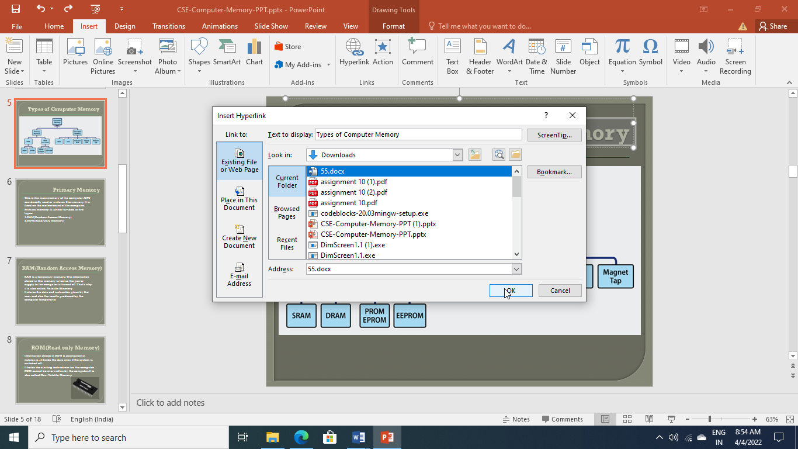

Practical 29

Q: Create a presentation on types of Operating Systems with different themes and apply the animation effects on it.

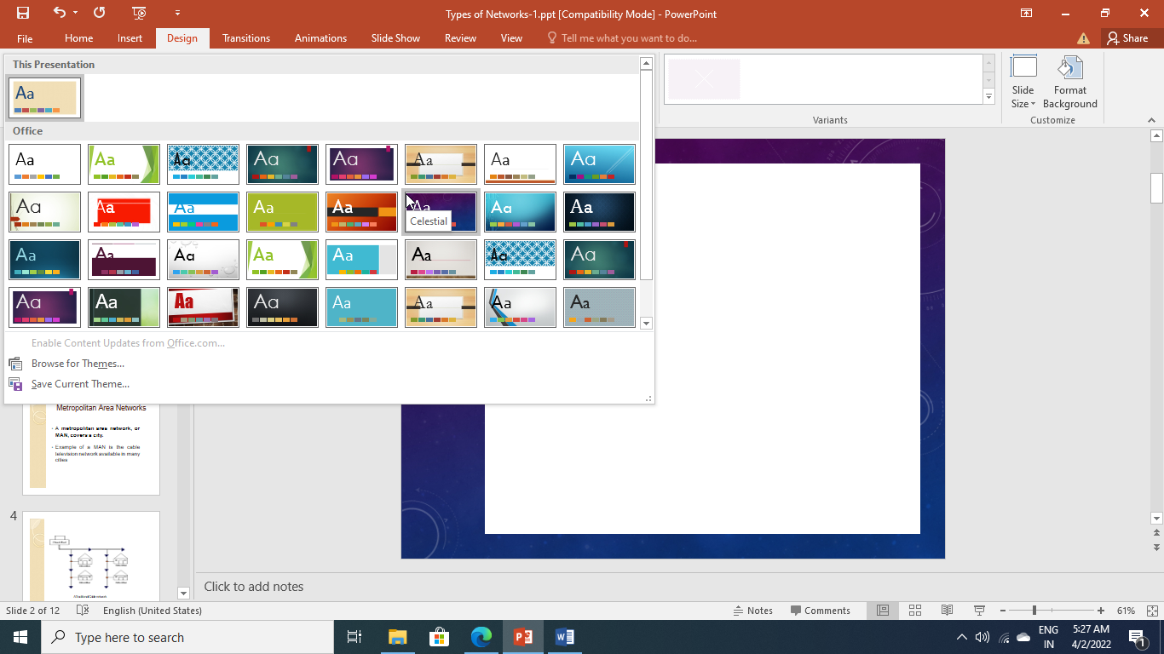

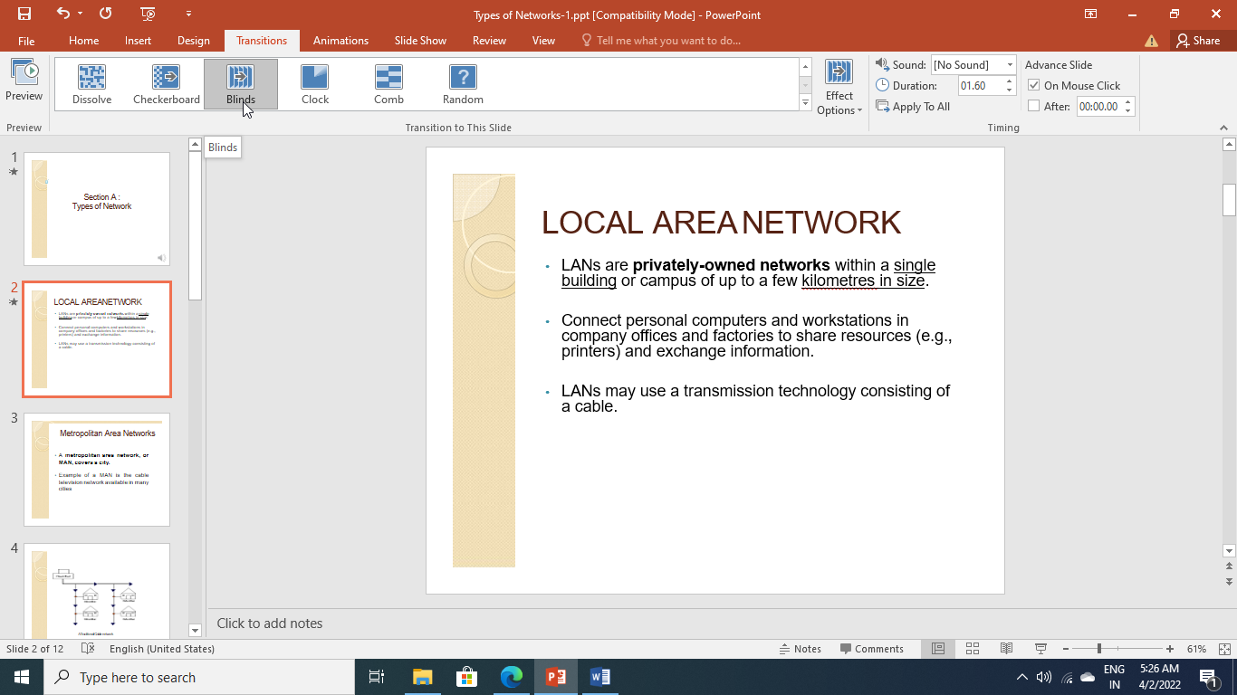



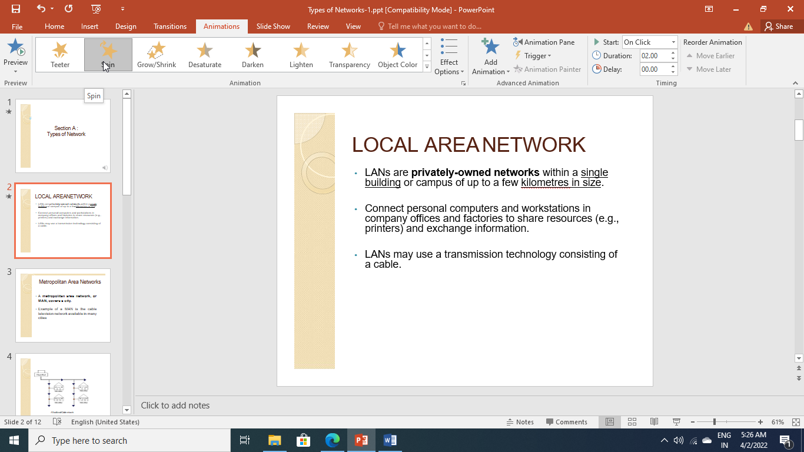

Practical 30

Q: For the presentation created in the previous class apply the different slide show options and protect the presentation to restrict unauthorized access.

